Onion dehydration

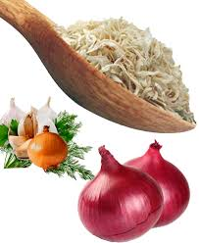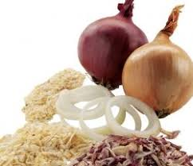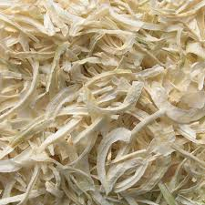

Introduction
Fast urbanization in India and improved purchasing power of the middle-income group can be expected to create a large demand for convenience foods of which dehydrated Onions form the constituent in many cases. The entries of ready to eat meals in the market and the thrust given to exports will boost the potential of dehydrated onions.
Usage/Application
Dehydrated Onions are used for
- As condiment for cooking
- For vegetable and instant food
Other application where true Onion color and flavor are required.
Products
Dehydrated Onion Flakes/ Powder available in Bulk and Retail Packaging.
Objective
The primary objective of the model report is to facilitate the entrepreneurs in understanding the importance of setting up unit of Fruit & Vegetable Powder. This model report will serve as guidance to the entrepreneurs on starting up such a new project and basic technical knowledge for setting up such a facility.

Critical Success Factors
Increased demand of raw food due to ever growing population has resulted in greater requirement of dehydrated products. Sales orders are key to success especially when food prices are sky high. Apar from this Per capita consumption of onions across all of India has been increasing due to many reasons including lifestyle changes. In last 10 years consumption of onions boosted to 40% in rural India and 20% in urban India. Increasing per capita consumption and high demand of dehydrated products is the success factors for the proposed business.
Raw Material
Basic Raw Material required for Proposed unit is Onion.
Capacity
The capacity of the project is1000 TPA, assuming the working capacity of the machinery is 8 Hrs per day for 300 working days.
Manufacturing Process
Raw onions are collected from market at the most economic prices. The onions should be ripe, matured and are kept in storage. The storage rooms and godowns are airy, well ventilated, dry and at low temperature. The cold storage is kept at 0-40C and RH 50 – 55%. The onions are then cleaned. Spray washers are used for cleaning the onions. The cleaned onions are surface dried by hot air and then the onions are peeled. Abrasion peeling method is used for peeling the onions. The peeled onions are then sliced by rotating blade slicers. The sliced onions are then dried or dehydrated. Drying is done in tunnel drier.
Land Area Requirement
Land should be located near to the growing Agri-cluster area easily connected with the Road and Rail. The Project Land should also have easy availability of the water and electricity. The ideal land require for the project is 1.00 Acre
Implementation Schedule
It will take Eighteen (18) months to complete all the formalities before starting the commercial production.

Financial Aspects
S.No. | Particulars | Cost (Rs. in Crore)
1. | Civil Infrastructure | 1.50
2. | Plant & Machinery | 1.00
3. | Other Expenses | 1.50
Total Project Cost |  | 4.00
Means of Finance

S.No. | Particulars | Cost (Rs. in Crore)
1 | Equity Contribution (30 %) | 1.20
2 | Bank Finance (70 %) | 2.80
Cost of Project |  | 4.00
- Estimated Turnover of the project will be around Rs. 10 Crore with Positive IRR of 24.54%.
Government Incentives
- Government of India has designed a Pradhan Mantri KisanSampada Yojana, In Which Capital Grant from Rs. 5 to 10 Crore is being provided as per the scheme guidelines.
- Considering Agro and Food Processing as a priority sector various state government are also providing Incentives like Capital Investment Subsidy, Interest Subsidy, Labour Subsidy, Tax Benefits etc.
Our firm Provides following Services

- Project Management Services
  - Pre-feasibility Study of the Project and existing market analysis of the product to be manufactured.
  - Conceptualization of the Project and Finalization of Project Components.
  - Bankable/Detailed Project Report
  - Assistance in Grant/ Subsidy
  - Detailed Design and Engineering of the Project
  - Technology Sourcing
  - Project Management Consultancy
  - Supply Chain Management
  - Agriculture Advisory Services etc.
- Food Product Development Services
  - Suitable & Innovative Packaging as per product characteristics
  - Bio-Degradable Packaging
  - Development of range of variant of product with suitable packaging as per the requirement of product.
- Food Safety & Quality Licenses
  - FSSAI
  - APEDA
  - Spice Board of India
  - DGFT

Address : B-303, Swagat Rainforest-2, Kudasan, Gujarat- 382421
Phone : +91 9016448449, +91- 9958000178
Email : aec.jind@gmail.com
Website : www.aecengg.com

