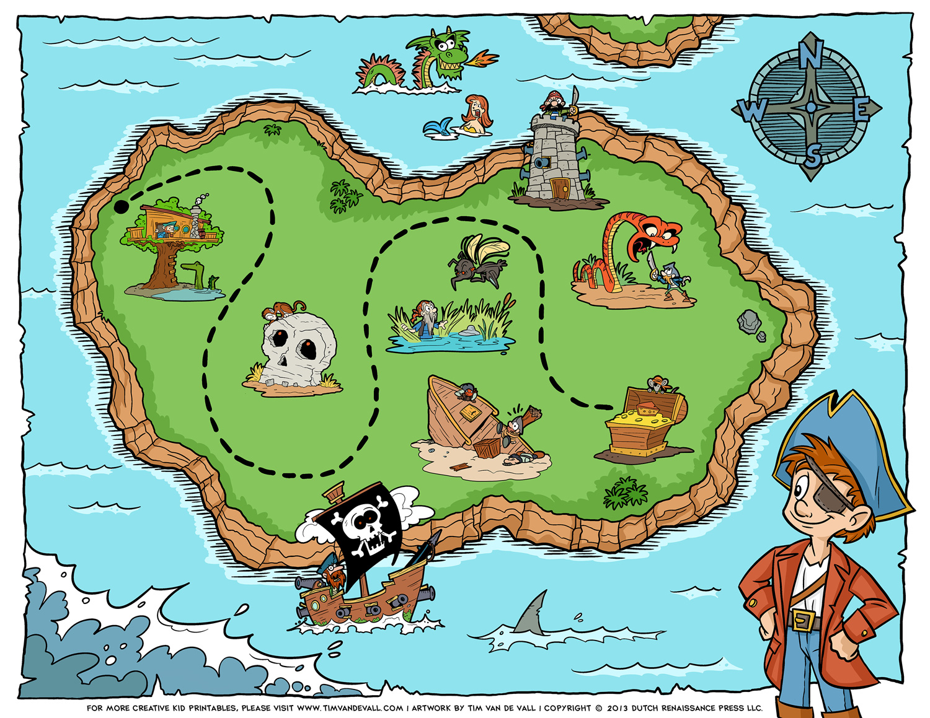

**Cut and glue your 6 tools for escape here:**