## Human Serum Amyloid A1

|  |  |  |  |
| --- | --- | --- | --- |
| **Origin:** | Recombinant | **Cat. No.:** | 41910 |
| **Tag:** | N-terminal 6xHis | **Size:** | 0.1 mg |
| **Source:** | *E.coli* | **Purity:** | >90% |
| **Other names:** | SAA | **Species:** | Human |

### Description

### Expressed in *E.coli* with total 146 AA. Mw: 16.6 KDa (calculated).

### N-terminal 6xHis-tag, EK and TEV cleavage site, 42 extra AA (highlighted).

### Recombinant antigen for research use or manufacturing only.

### Introduction to the Molecule

### SAA is synthesized in the liver and secreted to the blood. When in the blood, SAA proteins form complexes with high density lipoproteins (HDL). It has been suggested that SAA is involved in the recycling of cholesterol from damaged tissues. Similar to C-reactive protein, SAA is a major acute phase protein in human being, it can be used in diagnosis, predicting outcomes and assessing the efficacy of treatment in patients with inflammation. SAA is a sensitive biomarker of acute renal allograft rejection and it can be used to monitor SAA in kidney transplant patients for the early detection of acute rejection episodes. In patients with myocardial infarction, SAA concentration is elevated to extremely high values and correlates with postinfarction complications and the mortality rate.

### Amino Acid Sequence

**MRGSHHHHHHGMASMTGGQQMGRDLYDDDDKDRWGSENLYFQ**RSFFSFLGEAFDGARDMWRAYSDMREANYIGSDKYFHARGNYDAAKRGPGGAWAAEVISDARENIQRFFGHGAEDSLADQAANEWGRSGKDPNHFRPAGLPEKY

### Applications

Standard ELISA test, Western Blot.

**Formulation**

Lyophilized at 1 mg/mL in PBS.

**Reconstitution**

Add deionized water to prepare a working stock solution of approximately 1 mg/mL and let the lyophilized pellet dissolve completely.

**Storage**

Store lyophilized protein at –20°C. Aliquot reconstituted protein and store at –80°C. Avoid repeated freezing /thawing cycles.

### Quality Control Test

BCA to determine quantity of the protein.

SDS PAGE to determine purity of the protein.

### SDS-PAGE gel

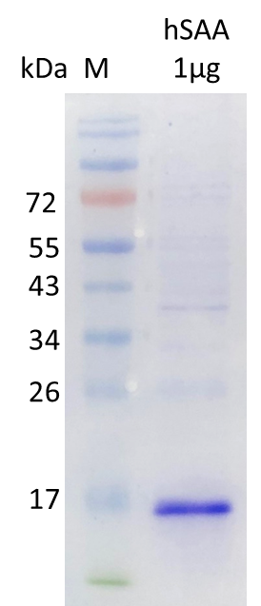

**Contact Us**

* Website: www.immunodiagnostics.com.hk
* E-mail: info@immunodiagnostics.com.hk
* Tel: (+852) 2831 5526; 2831 5508
* Fax: (+852) 2816 2095