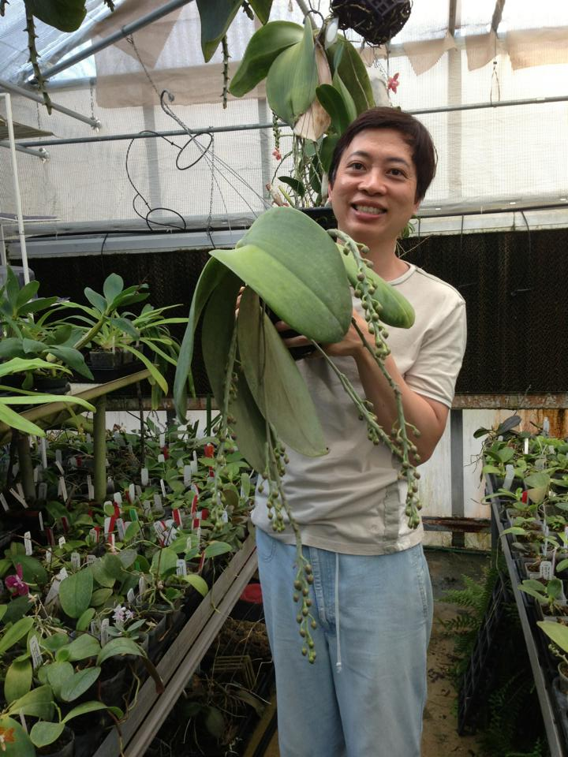

**Peter Lin (Big Leaf Orchids) - Bio**

Every Phalaenopsis enthusiast knows Peter Lin, an avid hobbyist and hybridizer, owner of Big Leaf Orchids in North Texas.

Peter started growing orchids over 30 years ago, enhancing his Phalaenopsis growing hobby by creating new hybrids. Big Leaf Orchids, formed in 1996, now houses over 5000 species and hybrids. He’s been the recipient of a multitude of American Orchid Society awards to his Phalaenopsis.

As a result of his annual trip to Taiwan to see some of the newest results in Phalaenopsis breeding, he hand-selects many of the most up-to-the minute varieties to incorporate into his hybridizing program. He specializes in Phalaenopsis for their long-lasting flowers, diverse sizes, brilliant colors, patterns and fragrance. A recipient of numerous AOS awards, he says his interest in Phalaenopsis is the artistry of breeding by maintaining the finest in his selection of Phalaenopsis. He’s always looking to take his breeding to the next level, to create something better and different to breed on with, to offer to his clients and to share with the orchid world at large.

Peter has also served the IPA as our Newsletter Editor, has written numerous Phalaenopsis articles for several orchid publications and has been a featured Guest Speaker at orchid societies, at the IPA Symposiums and at the annual Taiwan International Orchid Show. Although his focus is on Phalaenopsis, he also grows Cattleyas, Vandaceous and Paphiopedilums.

Peter will be sharing with us the newest in cutting-edge directions in breeding for Novelty Phalaenopsis and will be bringing select plants from his collection for sale.