LAWS OF MOTION
1. In which of the following cases, the body can be considered as a point object? Give reason. 1M
i) A bottle cap when it is unscrewed ii) A planet in a complete revolution.
2. State triangle law of vector addition. 1M
3. Electric current has direction, but it is scalar. Explain. 1M
4. A book is at rest on a table. Does it mean that no force is acting on the book? 1M
5. What is the principle of shock absorbers? 1M
6. Why copper is preferred to prepare thin wires? 1M
7. Mention the SI units of 1M
i) coefficient of viscosity ii) coefficient of static frication
8. In what aspects viscous force is different from friction? 2M
9. State with reasons, whether the following algebraic operations are meaningful. 2M
i) Adding any two vectors ii) Adding a scalar to a vector of same dimensions.
10. Obtain an expression for stopping distance. 2M
11. Is it possible for an object to have zero acceleration but non-zero velocity? Give an example. 2M
12. Draw the free body diagram for a vehicle moving on a banked road. Write the expression for its
safe velocity neglecting friction. 2M
13. “Action is the cause and reaction is the effect”. Comment. 2M
14. The speed time graph of a particle moving along a fixed direction is show in the figure. 3M
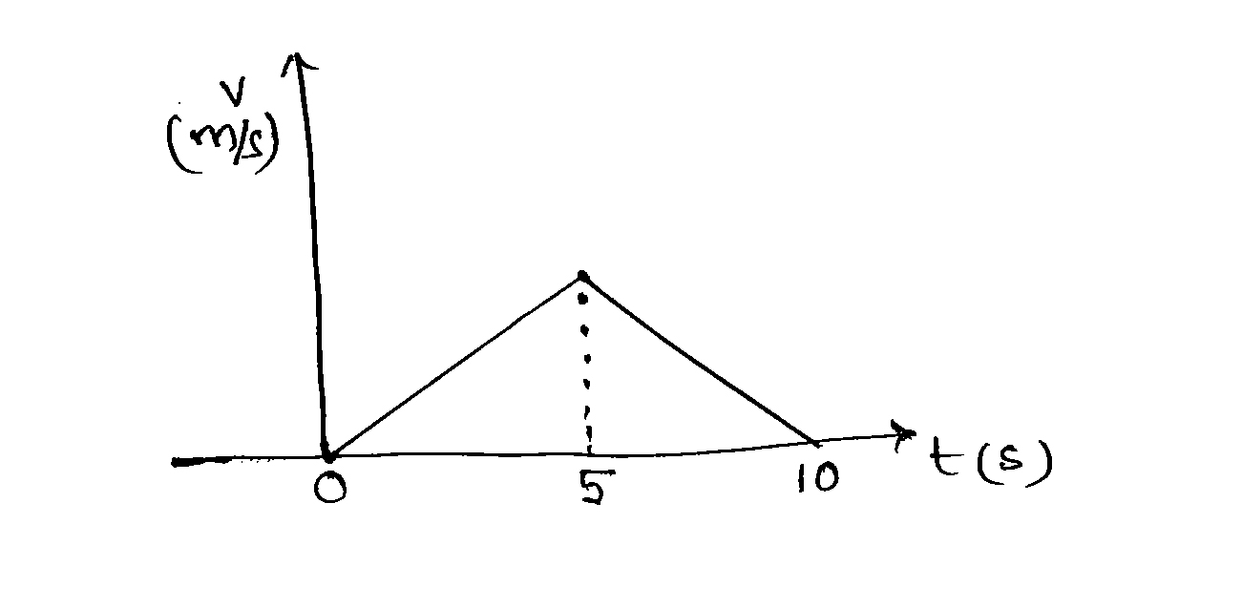

Find the distance traversed by the particle between
i) 0 to 10 seconds ii) 2 to 6 seconds
15. Obtain equations of motion for constant acceleration. 3M
16. The position of a particle is given by$\vec{r}=3i−2t^{2}j+4k m$ 3M
Where all quantities are in their SI units. What is the magnitude and direction of velocity at t=2 s.
17. Ten one-rupee coins are put on top of each other on a table in stable equilibrium. Each coin has a
mass m. Give the magnitude and direction of 3M
i) The force on 7th coin due to all coins on its top. [Counted from bottom]
ii) The force on 7th coin due to 8th coin
18. A man of mass 70 kg stands on a weighing scale in a lift. What would be the readings on the
scale if the lift moves 3M
i) Upwards with a uniform speed of 10 ms⁻¹
ii) Downwards with a uniform acceleration of 5ms⁻²
iii) Downwards with a uniform speed of 10 ms⁻¹
19. State and prove law of conservation of momentum. 3M
20. Explain the behavior of a wire under stress. 3M
21. Two towns A and B are connected by a regular bus service with a bus leaving in either direction
every T min. A man cycling with a speed of 20 km h⁻¹ in the direction A to B notices that a bus
goes past him every 18 minutes in the direction of his motion, and every 6 min in the opposite
direction. What is the period T of the bus service and with what speed do the buses fly on the
road? 5M
(Or)
i) Obtain an expression for range and maximum height reached by a projectile
ii) A bullet fired at an angle of 30º with the horizontal hits the ground 3 km away. By adjusting
angle of projection, can one hope to hit the target 5 km away (with constant muzzle
speed)? 5M
22. i) Mention the methods used to reduce the friction and to increase the friction.
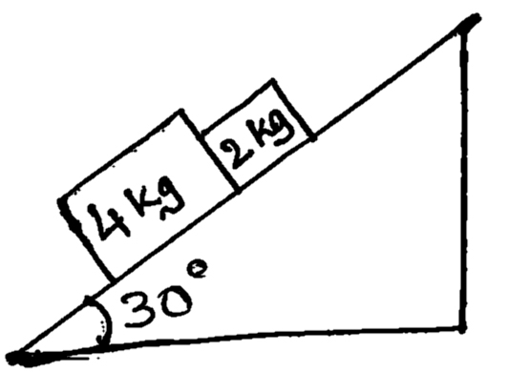
ii) find the acceleration of 2 kg block

given friction coefficient between block of mass 2kg and the incline is $μ_{1}=0\text{.}\text{20}$ and that
between the block of 4kg and the incline is $μ_{2}=0\text{.}\text{30}$ 5M
(or)
i) A turn of radius 20 m is banked for the vehicle of mass 20 kg going at a speed of 10 m/s.
Find the radius of curvature of the road if angle of banking is 30º
ii) If the road in the previous problem is horizontal, what should be the minimum friction?
coefficient so that a vehicle moves at 20 km/h without skidding 5M

