Electric Charges and Fields
[1 Mark Questions]
- Why do the electrostatic field lines not form closed loop?
- Why do the electric field lines never cross each other?
- Why must electrostatic field be normal to the surface at every point of a charged conductor?
- Why must electrostatic field at the surface of a charged conductor be normal to the surface at every point? Give reason.
- Two point charges q₁and q₂are placed at a distance of ‘d’ apart as shown in figure. The electric field intensity is zero at the point P on the line joining them as shown. Write two conclusions that you can draw from this.
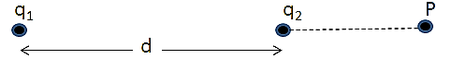
- Define dipole moment of an electric dipole. Is it a scalar quantity or a vector quantity?
- Draw a plot showing the variation of electric field (E) with distance rdue to a point charge Q.
- A proton is placed in a uniform electric field directed along the positive X-axis. In which direction will it tend to move?
- In which orientation, a dipole placed in a uniform electric field is in
    - Stable and
    - Unstable equilibrium?
- Two point charges having equal charge separated by 1 m distance experience a force of 8 N. What will be the force experienced by them if they are held in water at the same distance? (Given K _{water} = 80).
- A metallic sphere is placed in a uniform electric field as shown in the figure. Which path is followed by electric field lines and why?
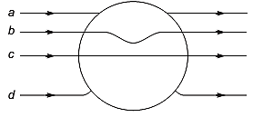
- Point out right or wrong for the following statement.
The mutual forces between two charges do not get affected by the presence of other charges.
- A dipole of dipole moment p is present in a uniform electric field E. Write the value of the angle between p and E for which the torque experienced by the dipole, is minimal.
- Consider two hollow concentric spheres, S₁ and S₂, enclosingcharges2Qand 4Qrespectively as shown in the figure.
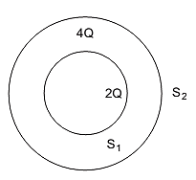
(i) Find out the ratio of the electric flux through them.
(ii) How will the electric flux through the sphere S₁changeif a medium of dielectric constant ‘ε_{r}’ is introduced in the space inside S₁inplace of air? Deduce the necessary expression.
- Two charges of magnitude – 2Q and + Q are located at points (a, 0) and (4a, 0), respectively. What is the electric flux due to these charges through a sphere of radius 3awith its centre at the origin?
- A charge q is placed at the centre of a cube of side l. What is the electric flux passing through each face of the cube?
- Figure shows three point charges, + 2q, - q and +3q. Two charges+2qand – q are enclosed within a surface ‘S’. What is the electric flux due to this configuration through the surface ‘S’?
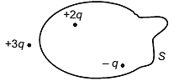
- Define electric flux. Write its S.I. units.
- A charge q is enclosed by a spherical surface of radius R. If the radius if reduced to half, how would the electric flux through the surface change?
- State the Gauss law of electrostatics.

