**Gideon Model****↕for Elder Abuse Prevention**

**Introduction**

Elders "R" Us abuse prevention training program is anchored on the Gideon Model↕for elder abuse prevention whose premise is:KNOWLEDGE + UNDERSTANDING = WISDOM. In other words, if caregivers have the necessary knowledge and understanding, it follows that they will have the wisdom not to abuse elders. Elders “R” Us envisions a world free of elder abuse—the synergy of knowledge and understanding.

**Gideon Model**↕ **Explained**

Gideon Model↕ is illustrated by a right triangle and two intersecting circles.

1. The right triangle’s sides represent Knowledge, Understanding, and Wisdom. As in Pythagorean Theorem the square of the hypotenuse (the side opposite the right angle) in this case Wisdom, is equal to the sum of the squares of the other sides, Knowledge and Understanding (Fig.1). Mathematically, this is Knowledge²+Understanding²=Wisdom². According to the Gideon Model↕, wisdom or a world free of elder abuse is synergy (a whole that is greater than the simple sum of its parts).

Since it is impossible to assign numerical values to the knowledge imparted on trainees (caregivers), the understanding achieved by trainees, and the wisdom gained by the trainees, Gideon Model↕ quantifies knowledge, understanding, and wisdom in terms of “more” “less” or “equal.” Thus, more knowledge and more understanding lead to more wisdom. The reverse is true.

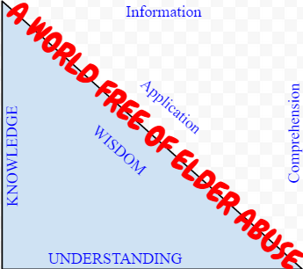Gideon Model↕

Fig. 1.

1. Two intersecting circles (Fig.2). The points of intersection of the circles are W and M joined to form a radical line/axis. The radical line/axis formed in Gideon Model↕ is **W**isdo**M**, as shown in Fig.5.

The overlapped section (i.e., red area) represents Wisdom, a world free of elder abuse, and a state of positive attitudes where elders are us. In other words, A world free of elder abuse lies at the intersection of caregivers' knowledge and understanding of elders—a state of Wisdom and Positive Attitudes where elders are ‘actually’ us and are treated as we want to be treated.

An increase in caregivers’ knowledge and understanding of elders leads to an increase of the overlapped section (red area) which means increased wisdom, positive attitudes, increased ‘world free of elder abuse’ area, and a better understanding of elders (elders are us).

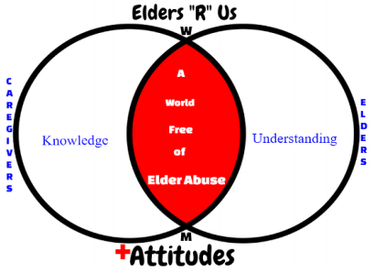Fig. 2.

**Some Observations on Gideon Model↕**

**Observation 1**

Zero incidences of elder abuse occur when the two circles completely overlap each other to form or become one circle (Fig.3). One circle marks the ideal world free of elder abuse possible in two settings:

1. In the caregiver’s mind referring to a conscious or unconscious inclination NOT to abuse elders.
2. In a specific location such as long-term care facility, county, state, or country.

**Deduction**

A complete circles’ overlap is more likely to occur in the caregiver’s mind than in the other setting (in A than in B above). The reason is caregiver’s mindset (attitudes) on elder abuse can be influenced through elder abuse prevention training to be consciously or unconsciously inclined NOT to abuse elders. Training reinforces caregivers’ propensity not to abuse elders. Training develops positive attitudes in caregivers that in turn, create powerful personal resolve NEVER to abuse elders. The caregiver’s resolve leads to a complete circle overlap depicting zero incidences of elder abuse.

Attaining a complete circles’ overlap in a specific long-term care facility, county, state or country setting is possible but remains a tall order as it is affected by a myriad of factors such as the prevalence of numerous elder abuse incidence reports. Most important, organizations by their very nature are incapable of making the key resolve NEVER to abuse elders.

All the eight components of the Gideon Model↕ are found inside the overlapped circles (Fig. 3). Note that Fig. 3 shows only six components as the knowledge and understanding components are merged into the wisdom component.

Fig. 3.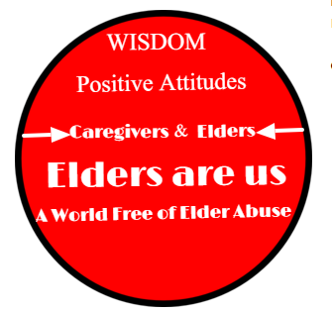

**Observation 2**

When the two circles are disjoined (separated) and distinct, it means caregivers lack knowledge and understanding of elders hence have limited or no wisdom on elders, as shown in Fig.4. Here, caregivers have negative attitudes towards elders and are potential elder abusers. In this case, a world free of elder abuse is nonexistent. See Fig.4. Disjoined circles depict a world replete with elder abuse possible in two settings:

1. In the caregiver’s mind referring to a conscious or unconscious inclination to abuse elders
2. In a specific location such as long-term care facility, county, state, or country.

**Deduction**

A world replete with elder abuse denoted by two completely separated circles is more likely to occur in the caregiver’s mind than in the other setting (in A than in B above). The reason is simple, thoughts are secrets of the mind, and there’s no way of unraveling the secret thoughts of an elder abuser. A caregiver could be consciously or unconsciously inclined to abuse elders—a remote possibility for an organization.

To have separate and distinct circles is a state of total anarchy which is extremely unlikely in a long-term care facility, county, state, or country settings as there are systems in place, laws, regulations, supervisors, caregivers of goodwill, and most recently, cameras. Unlike caregivers, organizations such as long-term care facilities may not abuse elders directly.

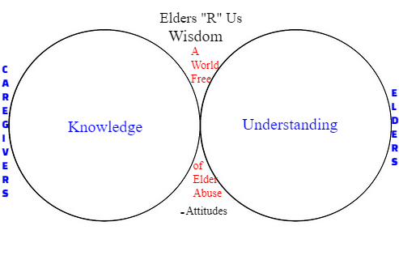Fig. 4.

**Elder Abuse Prevention**

To prevent elder abuse, Gideon Model↕ explores two extreme possibilities. The first extreme possibility is where the two circles completely overlap depicting a state where there are zero incidences of elder abuse, also referred to as the ideal world free of elder abuse. Two completely separated circles represent the second extreme possibility marked by caregivers’ total lack of knowledge and understanding of elders, negative attitudes towards elders, and a nonexistent world free of elder abuse.

Interestingly, both extreme possibilities are more likely to occur in the caregiver’s mind than in the setting of a specific long-term care facility, county, state, or country. After all, it is the caregiver who consciously or unconsciously abuses or does not abuse elders. The Gideon Model↕ fortifies the conviction that elder abuse is a social problem whose solution is not in over-regulating providers or enacting stringent laws. The ultimate solution to elder abuse prevention is training. The Gideon Model↕ is proof that the most effective way to prevent elder abuse is through an **Attitude Change Training Program**—

[Elders “R” Us](http://www.eldersareus.com) is such a program.

**Conclusion**

Elders “R” Us applies the Gideon Model↕ to **Stop Elder Abuse** before it happens. The Gideon Model↕ for the prevention of elder abuse underscores the relationships in eight components namely; elders are us, knowledge, understanding, wisdom, caregivers, elders, attitudes, and a world free of elder abuse. Developing caregivers’ positive attitudes towards elders, eldercare, and the workplace is key to elder abuse prevention. Nurses and nursing aides who develop positive attitudes are at a lower risk of being abusive to the elders under their care. A complete circles’ overlap, a world free of elder abuse is the vision for Elders “R” Us.

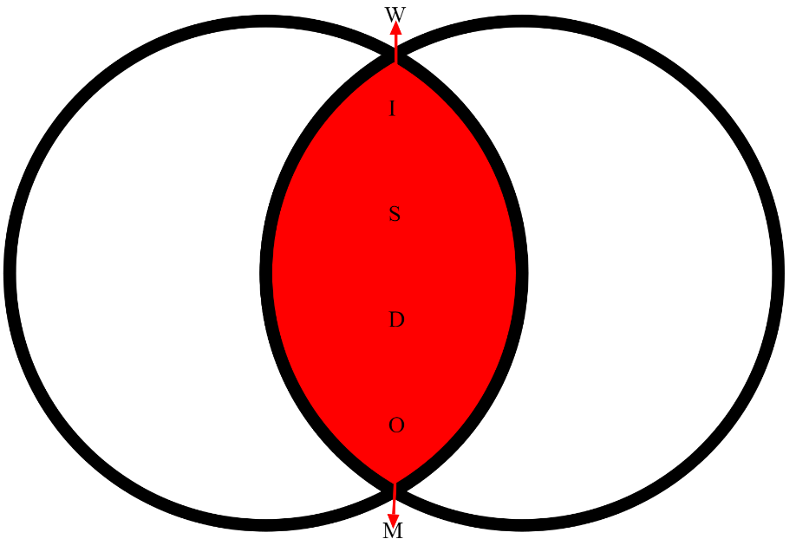Fig. 5.

↕=Radical line/axis=Wisdom