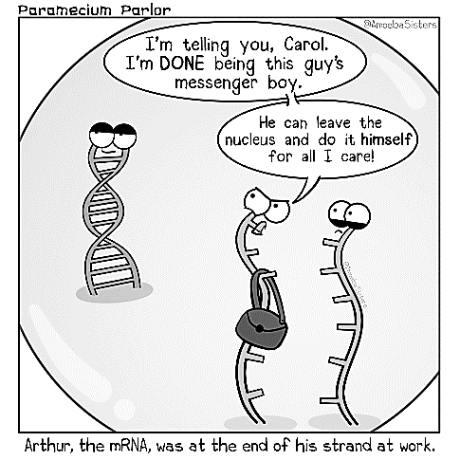#Genetics Social Media Assignment

Memes, Hashtags, and Likes – Oh My!

**Essential Questions:**

1. How does Mendel’s work contribute to our understanding of heredity?
2. How are traits passed from parents to offspring?
3. How are Punnett squares used to predict patterns of inheritance?
4. How is biotechnology used in forensics, medicine, and agriculture?
5. What are some common genetic disorders, and how are they inherited?

***The “Father of Genetics”…***

Genetics is a branch of biology concerned with the study of genes, genetic variation, and heredity in organisms. Though heredity has been observed since prehistoric times, our modern understanding of genetics originated with the work of Austrian Monk Gregor Mendel. Mendel carried out detailed investigations of inheritance using the common garden pea. He kept accurate and detailed records of his work. It is with his data that he was able to formulate the basic principles of inheritance.

Mendel proposed the concept of hereditary units (what we now know to be genes), which are passed down from parent pea plant to offspring pea plant, and that it is the combination of these units which result in the appearance of the offspring. Molecular inheritance mechanisms of genes are still primary principles of genetics in the 21st century, but modern genetics has expanded beyond inheritance to studying the function and behavior of genes. Genetics has given rise to a number of subfields, including the area of biology known as biotechnology.

***Your assignment…***

**You will gain a better understanding of heredity by creating a genetics-focused Instagram account. You may choose how you want to present this information – pictures, captions, friend comments, hashtags, memes etc. Your account will need to address the following…**

1. **Include a genetics-focused Instagram handle (@imalleleawesome) and representative picture**
2. **How does Mendel’s work contribute to our understanding of heredity?**
   1. *Outline Mendel’s experiments with pea plants.*
   2. *Describe his conclusions – Law of Dominance, Law of Segregation, Law of Independent Assortment.*
3. **How are traits passed from parents to offspring?**
   1. *Explain the connection between genes, meiosis, fertilization, and variation.*
4. **How are Punnett squares used to predict patterns of inheritance?**
   1. *Illustrate mendelian and non-mendelian inheritance with Punnett squares.*
5. **How is biotechnology used in forensics, medicine, and agriculture?**
   1. *Give examples of how living organisms are used to develop or alter products for specific use.*
   2. *Discuss GMO’s - Genetically Modified Organisms.*
6. **What are some common genetic disorders, and how are they inherited?**
   1. *Identify common single-gene genetic disorders and discuss their inheritance.*

You must follow @biobykoester by: ________________________________________

#Genetics Social Media Assignment

Memes, Hashtags, and Likes – Oh My!

***Instagram***

* Profile Picture
* Followers - At least 5
  + Can be real people or classmate accounts
* About
  + Student Name(s)
  + The purpose of the account
* Minimum of 15 posts
  + All pictures must have captions
* Minimum of 10 comments on pictures
  + At least 5 different people
* Minimum of 7 different #hashtags
* Minimum of 2 memes
* Minimum of 10 “Likes”

***Information Checklist***

* Mendel’s experiments
  + P, F1 and F2 generations
  + Include the results!
* Mendel’s conclusions
  + Law of Dominance, Segregation, Independent Assortment
* Passing of traits parent 🡪 offspring
  + Meiosis, fertilization
* Punnett Squares
  + Mendelian and Non-mendelian
* Various uses of biotechnology
  + Genetically Modified Organisms (GMOs)
* Genetic Disorders
  + Single gene disorders
  + Form of inheritance