Unit 4 Study Guide – Mitosis and Meiosis Cell Cycle

(Complete the Vocab as part of Unit 4 Packet)

Cell Cycle

Interphase

Gap 1 (G1) Stage

Synthesis (S) Stage

Gap 2 (G2) Stage

Cyclins / Cell Regulators

DNA

Chromatin

Chromosome

Homologous chromosomes

Allele

Loci Point

Chromatid

Centromere

Telomere

Somatic Cells

Mitosis

Prophase

Metaphase

Anaphase

Telophase

Cytokinesis

Somatic Cells

Centriole

Spindle Fiber

Daughter Cells

Cleavage Furrow

Cell Plate

Cancer

Growth Factors

Benign

Malignant

Metastasize

Oncogenes

Tumor Suppressor Genes

Carcinogen

Radiation

Chemotherapy

Apoptosis

Binary Fission

Sexual Reproduction

Asexual Reproduction

Meiosis

Germ Cells

Gametes

Homologous Chromosomes

Haploid

Diploid

Fertilization

Zygote

Embryo

Cell Differentiation

Stem Cells

Meiosis I

Prophase I

Metaphase I

Anaphase I

Telophase I

Meiosis II

Prophase II

Metaphase II

Anaphase II

Telophase II

Oogenesis (egg)

Spermatogenesis (sperm)

Crossing Over

Nondisjunction

Non-sister Chromatids

Understand…

The concerns regarding cell growth.

The overall purpose and process of the cell cycle.

That cells divide at different rates and that the rate is linked to the body’s need for those cells.

Why the surface area-to-volume ratio matters to a cell and what can happen if the ratio is too small.

The terms given to genetic information in different forms (chromatin, chromatid, chromosome, etc).

What happens when the cell cycle goes awry (cancer).

How internal and external factors regulate cell division.

That binary fission is utilized by prokaryotes as method of asexual reproduction.

That some eukaryotic organisms reproduce offspring through asexual, mitotic reproduction.

What it means to describe a cell as “specialized” and how this happens.

When mitosis and meiosis take place and what types of cells are produced by each.

The number of chromosomes in diploid somatic cells (2n) vs haploid gametes (n).

What is meant by “homologous chromosomes.”

The purpose of producing gametes with half the number of chromosomes.

The significance of prophase I of meiosis.

The difference between metaphase I and metaphase II of meiosis.

The difference between anaphase I and anaphase II of meiosis.

Where Mitosis is taking place (on which cells) Where meiosis is taking place (on which cells)

Be Able To…

Describe what occurs in each stage/phase of the cell cycle (interphase, mitosis, cytokinesis).

Identify pictures of cells in each phase of mitosis.

Compare and contrast late telophase/cytokinesis in animal cells vs. plant cells.

Explain why the daughter cells resulting from mitosis are genetically identical to each other and the parent cell.

Discuss the advantages and disadvantages of asexual reproduction.

Describe the importance of stem cells and cell differentiation.

Describe what occurs in each stage of Meiosis I and Meiosis II.

Explain the benefits of crossing over (and identify when it takes place). Watch square dance video online

Identify pictures of cells in each phase of meiosis.

Compare and contrast the processes of mitosis and meiosis.

Discuss the significance of nondisjunction.

MITOSIS

Process used for asexual somatic cell reproduction. DNA duplicates one so that a diploid somatic cell can divide once and produce two genetically identical daughter cells. Diploid 🡪 Diploid

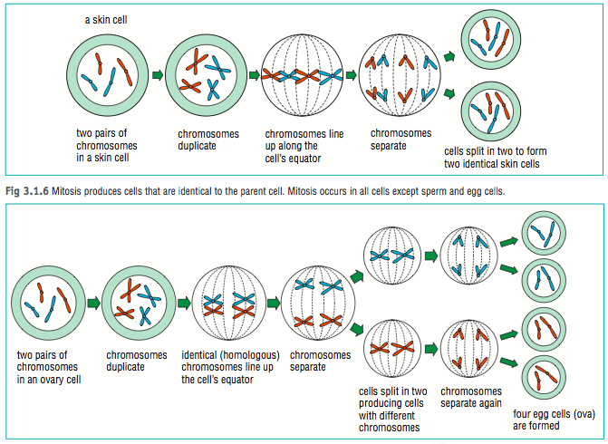

MEIOSIS

Process used for sexual reproduction because it produces gametes – egg and sperm. DNA duplicates one so that a diploid germ cell can divide twice and produce four genetically different, haploid daughter cells. Diploid 🡪 Haploid. Crossing over takes place during prophase 1. This, along with the way chromosomes align in the middle of the cell, create genetic variation.



