**Тема**: Своя игра. Обобщение материала.

**Тип урока**: внеклассное мероприятие. Викторина

**Вид урока:** нетрадиционный

**Цель:** совершенствование навыков устной и письменной речи.

**Прогнозируемый результат**: предполагается, что к окончанию мероприятия, учащиеся в игровой форме повторят и закрепят грамматический и лексический материал по темам.

**Задача:**

Образовательная: создать условия для обобщения и систематизации знаний по теме «Телевидение», «Праздники», «Быть здоровым», «В городе», «На ферме»; содействовать развитию навыков говорения.

Развивающая: способствовать развитию внимания, памяти, мышления, воображения у учащихся, активизировать познавательную деятельность учащихся на мероприятии.

Воспитательная: содействовать повышению мотивации и интереса учащихся к изучению английского языка; воспитывать позитивное отношение к окружающему миру и друг к другу.

Ход урока.

1. Организационно-мотивационный этап.

Be active!  
Be polite!  
Be tolerant!

Respect each other!  
Don’t be shy!  
Don’t be afraid of making mistakes!

1. 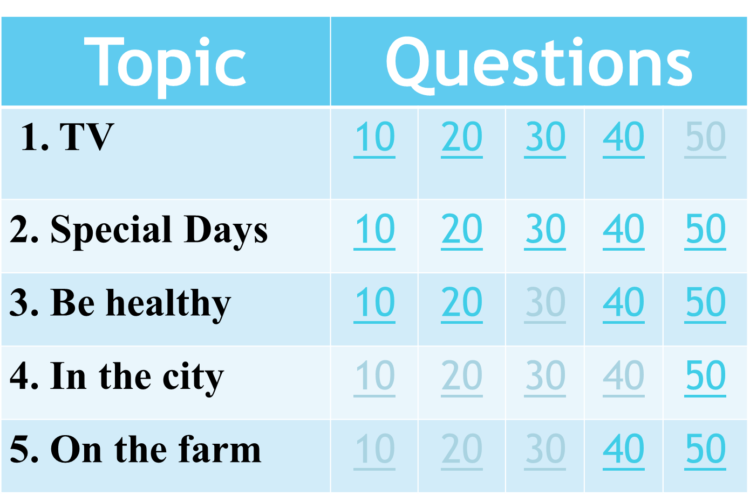

**TV:**

10 points - A story about magic places, princesses, animals that can talk. (a fairy tale)

20 points – Answer. What time is it? It’s quarter to ten. ( 9:45)

30 points - Answer. What time is it now? (It is … past two)

40 points - Name the year. 1937 Nineteen and thirty-seven. The Disney Studio made the first long cartoon. What cartoon is it? Snow White and the seven Dwarfs

50 points - Make sentences. watch/ how often/ you/ do/ science fiction/ films/. (How often do you watch science fiction films).

**Special Days:**

10 points – Answer. What are the symbols of New Year? (New Year tree, ornaments, colored lights, angels, snowflakes, snowmen)

20 points – Finish the sentence. In Belarus people celebrate Victory Day … (In Belarus people celebrate Victory Day on the 9th of May)

30 points – Answer. What holiday do people celebrate on July 3rd? (People celebrate Independence Day on July 3rd)

40 points – Tell the past forms of the verbs: sing, send, get, do, make (sang, sent, got, did, made)

50 points - Translate. Белорусы редко празднуют Хэллоуин. (Belarussian people rarely celebrate Halloween)

**Be healthy:**

10 points – Name the words: lthyaeh - healthy

wstsee - sweets

gerfin – finger

20 points – Moving activity. Do moving activity using parts of body. STAND UP!!!!

30 points – Give the advice. I’ve got a headache. (You should take some pills/ stay in bed/ go to the doctor)

40 points – Choose the correct sentence. My leg hurt. My leg hurts. (b) My leg hurts )

50 points – Correct the mistake. There were some apple juice in the glass. (There was some apple juice in the glass)

**In the city:**

10 points: Match the words with their transcription:

bookshop [sku:l]

museum ['tʃɜ:tʃ]

school ['laibrəri]

church ['bukʃɒp]

library [mju:'zi:əm]

bookshop ['bukʃɒp]

museum [mju:'zi:əm]

church ['tʃɜ:tʃ]

school [sku:l]

library ['laibrəri]

20 points: Choose the right variant of picture

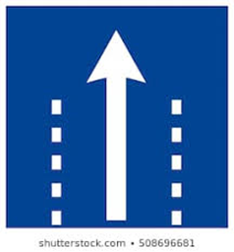 go straight ahead

**a)** b) c)

30 points: Match the place to the rule

In the street … A. you mustn't run

At school … B. you mustn’t feed animals

At the zoo… C. you mustn’t drop litter

1.C, 2. A, 3. B

40 points: Use the right form of adjective

Vatutina Street is … (quiet) than Gagarina Street. (Vatutina Street is quieter than Gagarina Street).

50 points: Open the brackets: We ______ (not/find) the post-office yesterday. (We didn’t find the post-office yesterday.)

**On the farm**:

10 points: Sing the song “The wheels on the bus”

20 points: Say the opposites : a town, clean, big, interesting,

A town – a village

Clean – dirty

Big – small

Interesting - boring

30 points: True or false? Town Mouse lived in a small house (True)

40 points: Answer. What can you do in the country? (5 activity)

Pick berries/ pick mushrooms/ go fishing/ grow fruit and vegetables/ go to the woods/ go on a picnic, milk cows, collect eggs, feed animals, seed carrots, water flower.

50 points: Say negative sentence: Country Mouse gave Town Mouse chocolate cake and ice-cream. (Country Mouse didn’t give Town Mouse chocolate cake and ice-cream)

Results



