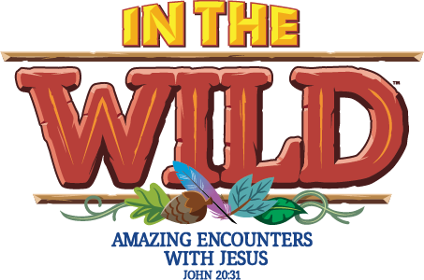
Vacation Bible School 2019

At VBS, we want to help our kids discover the
Invisible Wonders of God. We will turn our kids into
Wilderness Explorers. As the kids focus on different animals
And the amazing creations in the wild made by God,
They will discover the wonder among all wonders -
That the God who created everything there is -
The knowable and the unknowable, the invisible and the Invisible - wants a personal relation with them! Invite your kids into the clubhouse and show them the God who is over the moon in love with them.

Location: Evergreen Valley United Methodist Church
Date: June 24th -28th (Monday - Friday)
Time: 5:30pm -8:45pm
BBQ dinner on June 28th with family! Bring your family! Dinner at 5:30pm.

Parents/Guardians
Parents/Guardians Names:

Address:

Home Phone: Parents/Guardian Cell 1: Cell 2: .

Family Email (Required):

This will be our primary communication tool.

Child 1
Child’s Name:

Date of Birth: Male Female .
Grade Finishing this spring: .
My child has a special teaching need, diagnosis, allergy, or health restriction.
If yes, please describe:
If you have any behavioral/tendencies issues that we should be aware of,
please describe:

Child 2
Child’s Name:

Date of Birth: Male Female .
Grade Finishing this spring: .
My child has a special teaching need, diagnosis, allergy, or health restriction.
If yes, please describe:
If you have any behavioral/tendencies issues that we should be aware of,
please describe:

Child 3
Child’s Name:

Date of Birth: Male Female .
Grade Finishing this spring: .
My child has a special teaching need, diagnosis, allergy, or health restriction.
If yes, please describe:
If you have any behavioral/tendencies issues that we should be aware of,
please describe:

Medical Release
In the event of an emergency where medical treatment is required, and I or named contacts are unable to be reached by phone, I authorize the church staff sponsor of this event to obtain the services of a license physician. Please attempt to notify me immediately concerning any such emergency.

- Parent/Guardian Signature: Date: .

Photo Release (please print names clearly)

I,, parent /guardians of

The minor/s:

- Give permission
- Do not give permission

For images of my child to appear in church publications, on the church website, in church videos, promotional literature, advertisements, and other printed/electronic material.

Signature Date .

(For partial permissions, e.g, permission for child to appear in printed material and VBS recap slideshow shown in worship, but not online media, such as website, please specify below and sign.)

