**Introduction**

The aim of the session was to pool knowledge from professionals about what they understand of [Kimberlé Crenshaw’s framework on intersectionality](https://www.ted.com/talks/kimberle_crenshaw_the_urgency_of_intersectionality)[1] and explore how it can be applied within a youth work setting. Despite dwindling services and greater pressure on workers, youth services continue to play a valuable role in the lives of millions of young people, where workers succeed in supporting them to take their rightful place in society. However, increased pressures still, at times, result in a fragmented service which can lead workers to compartmentalising aspects of young people’s lives rather than adopting a holistic approach.

This session was an invitation for co-workers to explore how we can add to our knowledge about the relationship between different aspects of our identities; how they interact, overlap and, at times, reinforce disadvantage (and/or privilege).

Facilitators posed a key question and then used a variety of activities to try and respond to it, in a solution focused way.

***Q. What is it about the way that some youth provision is structured that renders young people with particular lived experiences as invisible of undermined?*** ***What can the intersectional framework offer to enable our services to be accessible to all young people?***

**The Process**

We interrogated some of the labels we use to define ourselves and explored where they come from, why we use them, when they are useful and/or problematic. We shared where we learned to define ourselves and how that contributed to our sense of Self. The activity illustrated that we often straddle several identities simultaneously and that, whilst we accepted labels serve a purpose in terms of naming our experiences, they can also cause us to oversimplify events we have lived through. We were reminded of the necessity to look beyond labels to connect with the people we work with.

**Looking at the Bigger Picture**

There are systemic factors at a macro level as well as the unique circumstances of an individual’s or community’s lived experience that can lead to a series of overlapping needs being ignored. This diagram is a useful way to understand how macro and micro factors intersect to impact on our lives.

**Intersectionality Displayed in a Wheel Diagram[2]**

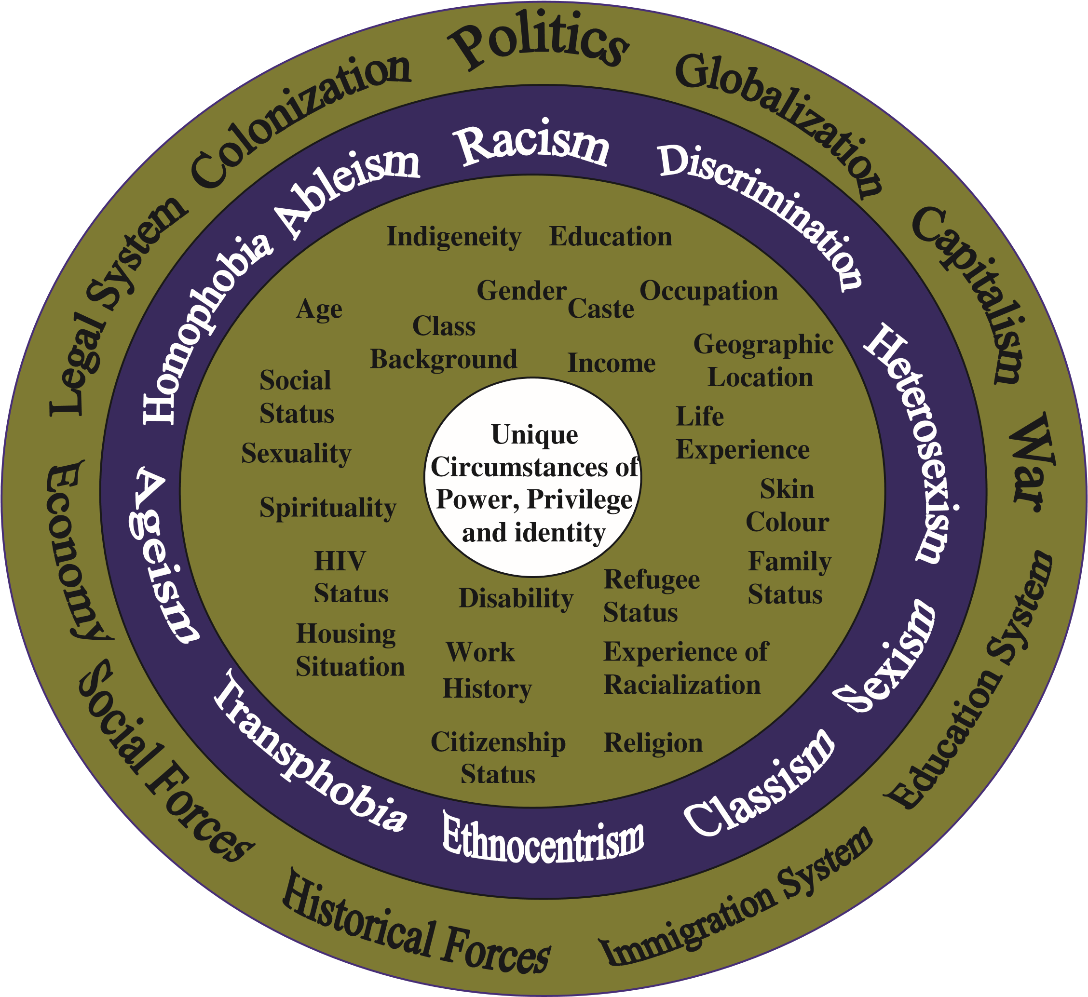

* The innermost circle represents a person’s unique circumstances
* Second circle from the inside represents aspects of identity
* Third circle from the inside represents different types of discrimination/attitudes that impact identity
* Outermost circle represents larger forces and the structures that work together to reinforce exclusion

**Deconstructing Discriminatory Systems**

We must understand the global factors as well as the local and personal factors that affect the young people that we work with. Intersectionality is not essentially about identities but rather the societal structures that systematically ignore the identities and experiences of some communities through policies/practices, which inadvertently or otherwise promote, for example, ableism, sexism, homophobia, racism and transphobia. The Framework was derived by Kimberlé Crenshaw to examine the multiple forms of discrimination African American women face in public and private arenas through racist and sexist practices. However, it can also increase understanding of the experiences and highlight the needs of other disenfranchised, community groups.

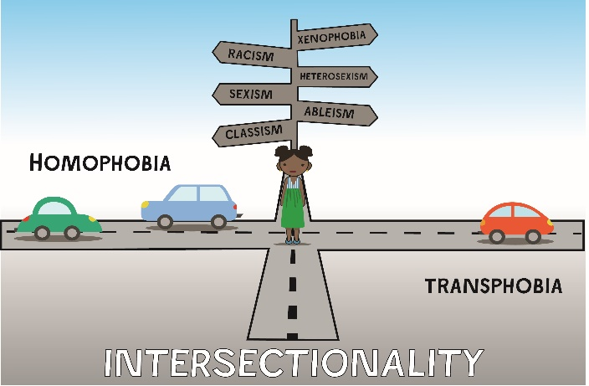

The graphic illustration above is adapted from Crenshaw’s original. The roads represent the way organisations can be structured by race, gender, age etc. The cars on the road represent policies, infrastructure, world views, and internal cultural practices etc. that uphold those structures. Some young people may stand at ‘a junction’ where several ‘roads’ overlap creating a new and unique set of challenges for them, as their different identities intersect. Click here to see view the work sheet[3].

In the session we used the map as a catalyst to review the systems and structures within our own organisations; examining whether our provision allows us to build meaningful relationships with young people where services take account of the overlapping nature of various social dynamics and what occurs at the point of intersection in young people’s lives. What we learnt is that if we fail to create the space within our services to acknowledge and understand the complexities that are created because of multiple forms of subordination impacting simultaneously young people are then left to their find their coping devices.

**How can we make use of the framework within our practice and strategic development?**

An intersectional approach involves using knowledge proactively and maintaining strong leadership. Within your organisations carve out the time to collectively examine how your services are structured and who is involved in the planning at a strategic level to illuminate where you may be over-looking and over simplifying the experiences of young people and therefore, not sufficiently meeting their needs through your service provision.

**Summary – what we learnt and going forward**

**We need to adopt a more nuanced approach to addressing inequality.**

This framework can be used as a prompt for workers to be more enquiring about what is happening in the lives of young people at a global, national, local and personal level. Those most likely to experience multiple forms of subordination may currently be under the radar and require greater levels of outreach to engage with support networks. Workers need greater levels of time and resources to build meaningful relationships with young people to understand how best to respond to their unique needs as well as their universal needs.

All workers need regular opportunities to reflect on their practice, share and apply new learning. This is particularly pertinent; where we working with generations of children and young people whose lives are underpinned by multiple levels of trauma.

1. The term intersectionality was first coined by Kimberlé Crenshaw. It is defined in the English Oxford Living Dictionary as

   The interconnected nature of social categorisations such as race, class, and gender as they apply to a given individual or group, regarded as creating overlapping and interdependent systems of discrimination or disadvantage.

   *‘through an awareness of intersectionality, we can better acknowledge and ground the differences among us’ English Oxford Living Dictionaries*
2. Diagram taken from Everyone Belongs: A Toolkit Exploring Intersectionality

   1st Edition May 2009

   Written by Joanna Simpson, Project Officer

   CRIAW

   Canadian Research Institute for the Advancement of Women
3. Graphic illustration of Intersectionality adapted from Kimberlé Crenshaw’s original idea by Drew Sinclair

   Intro to Intersectionality by Taryn Crenshaw

   <https://www.youtube.com/watch?v=OWeDatP0cv4>