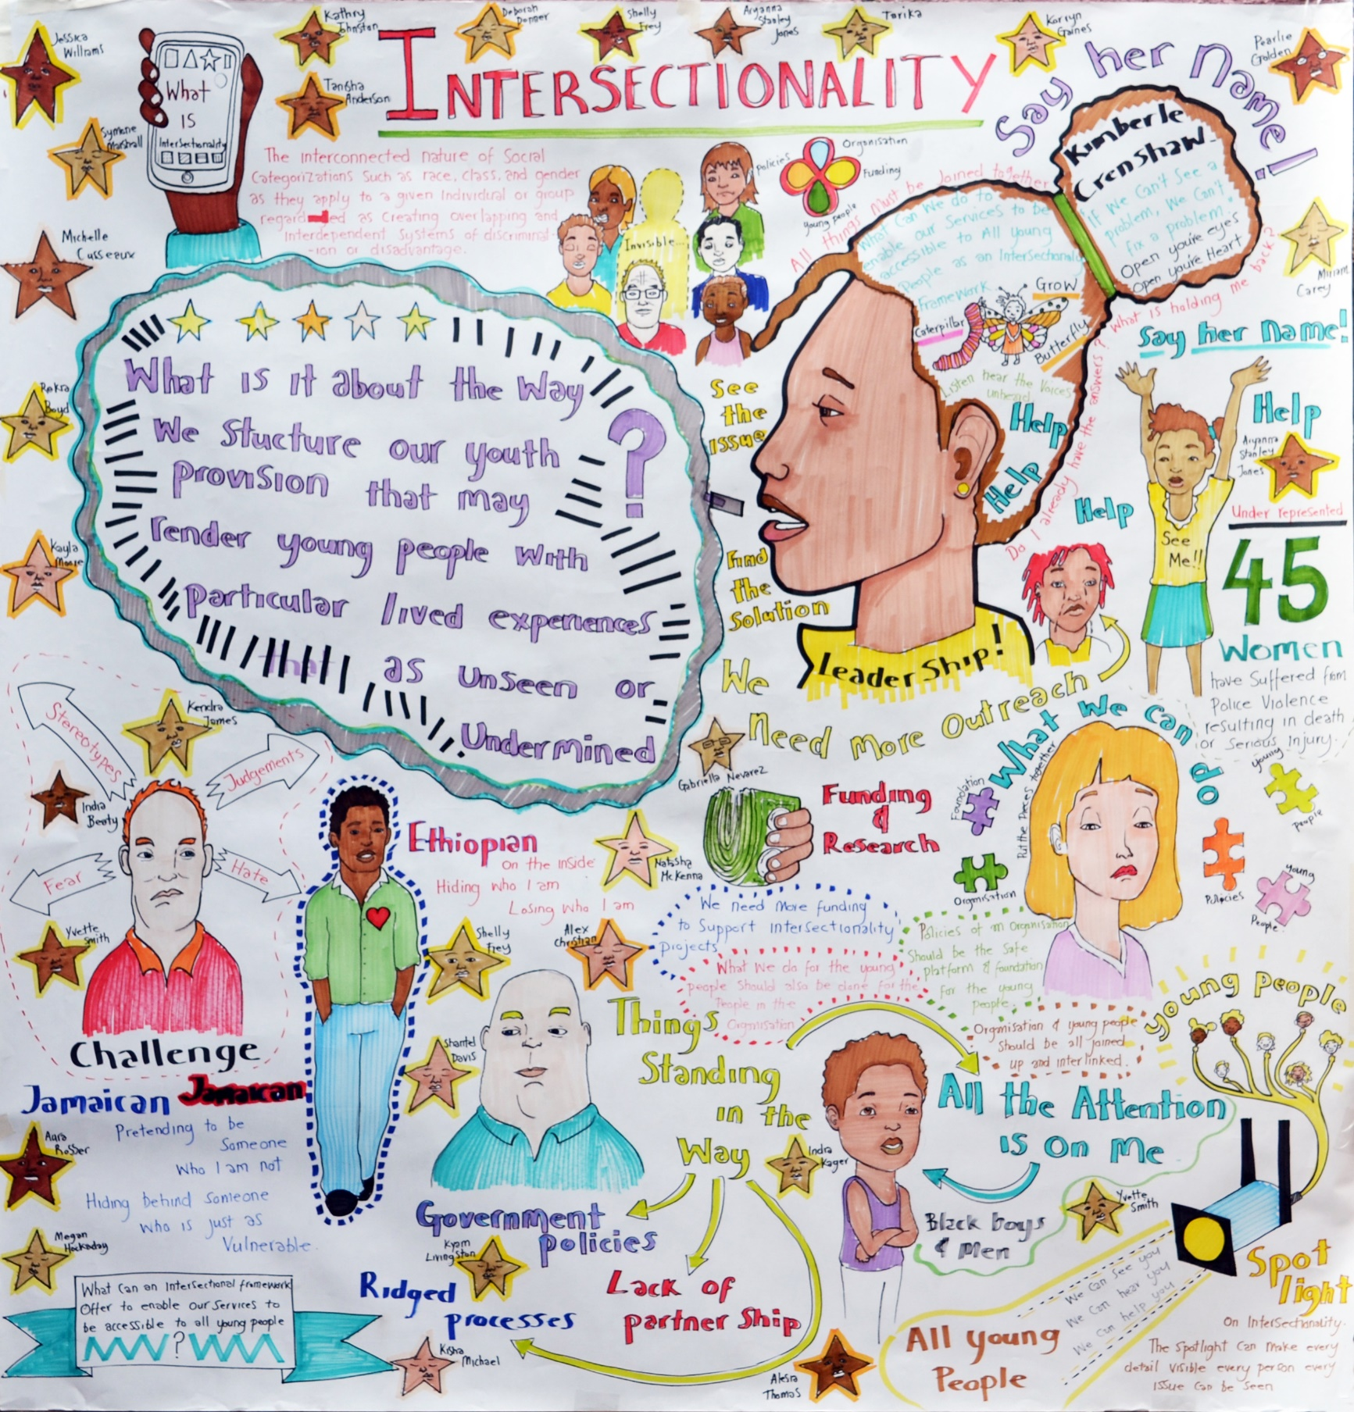

**The Graphic Harvest, by Drew Sinclair**

We invited artist, Drew Sinclair, to our session to capture some of the work through illustration. Many of the points on the Harvest are outlined in the briefing sheet. Some of the images refer more generally to what the intersectional framework is about whereas other images are related directly to discussions held in the session.

**A Special Note - #Say Her Name**

As well as being a professor of critical race theory, Kimberlé Crenshaw is a civil rights activist. The Stars on the Graphic Harvest represent some of the African American girls and women she identified in her work as having died whilst held in police custody. She argues that these girls and women have not been included in public debate on this issue because of their gender and that

**‘if we say the name, we are prompted to learn the story’**.

<https://www.youtube.com/watch?v=_wyUk-XLVg8>

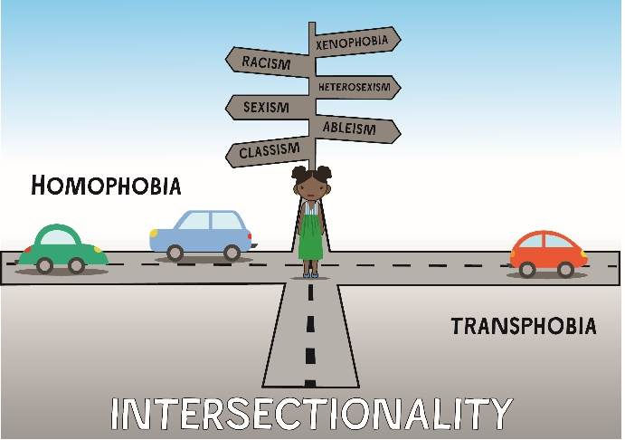

**The Intersection Graphic**[1]

You can use this illustration as a stimulus for discussing with colleagues how you might embed an intersectional approach into the structure of your organisation.

**Activity One**

You can print the graphic out along with cars or simply explain what the map and the cars represent and complete the exercise on separate paper or just through discussion.

The roads represent different structural factors that policies are often shaped around – race, gender, ability, sexual orientation. The cars represent the factors that prevent us from applying an intersectional lens for example, cultural practices within our sectors, internal cultures within organisations, a lack of leadership, a lack of time, a lack of funding etc.

**Use the graphic as a starting point for discussion**

Ask each person participating in the activity to think about the different obstacles within the organisation or within their practice that are currently prohibiting working from an intersectional standpoint. Each car represents a separate factor; if you are using the graphic ask your colleagues to put their cars on the roads.

Using a solution focused approach, ask each participant to explain the challenges they have identified and to suggest potential steps they think should happen to overcome those challenges.

Ask other participants to build on initial ideas, as appropriate. Create necessary action points from the potential solutions shared, not forgetting to factor in time for reviewing and amending action points, as necessary.



1. This graphic was designed by Drew Sinclair and adapted by an original by Kimberlé Crenshaw