**Hearty Vegetable Soup**

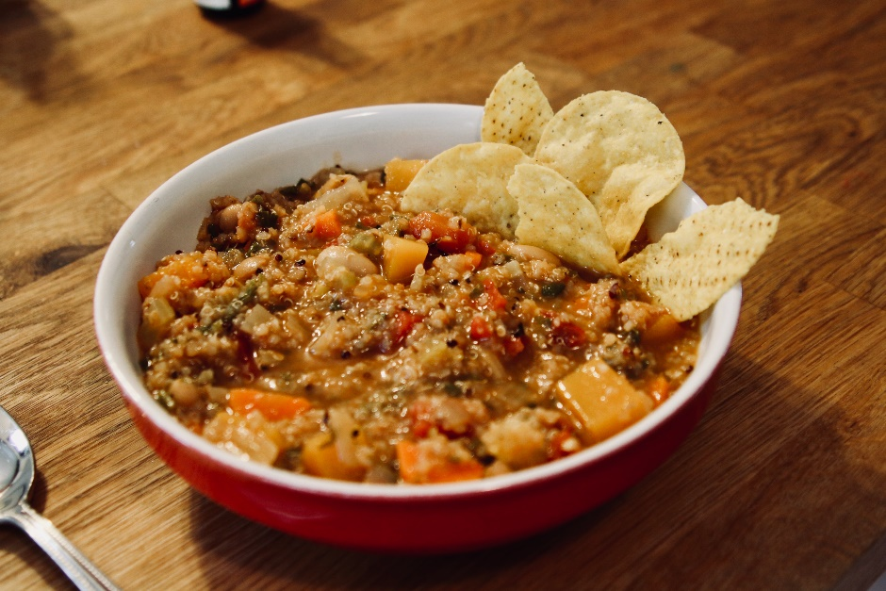

**Recipe by Jennifer Coatanroch**

This is an absolute family favorite! It makes a great big portion, which makes for healthy leftovers for the week. If you’re not into leftovers, freeze in single portions to use later. Leftovers are great as-is, thrown in a frittata, or even spooned over a few handfuls of mixed green salad. Enjoy!

Vegan, Gluten free, Dairy free, Nut free, Soy free

Serves: 8

**Ingredients**

* 1 Tablespoon olive oil
* 1 medium onion, diced
* 2 medium carrots, diced
* 2 celery ribs, diced
* 1 large leek, sliced into ½″ rings, rinsed thoroughly
* 2 cloves garlic, chopped
* 3 Tablespoons tomato paste
* 1½ cups cooked white beans, rinsed (one 15 ounce can or homemade from dry beans)
* 1 cup uncooked rinsed quinoa
* 1 (28 ounce) can diced tomatoes
* 8 cups vegetable or chicken broth, or water
* 1 teaspoon dried thyme
* 2 cups diced butternut squash
* 3 cups loose leaf spinach, chopped
* salt and pepper, to taste

Optional additions: sliced avocado, tortilla chips, crusty bread, corn bread

**Instructions**

1. Heat oil in a large soup pot. Add the onion and leeks, and cook, stirring often, until they start to soften. Add the carrots and celery, and continue cooking, for about 5 minutes, stirring often. Add the garlic and cook for another 30 seconds, being careful not to let it burn.
2. Add the tomato paste and stir well. Then add beans, quinoa, diced tomatoes, broth, thyme, and butternut squash. Add salt and pepper, to taste. Bring to a simmer and let cook uncovered for about 20-30 minutes, or until the squash is tender.
3. Add the spinach and let cook for another 5-10 minutes. Taste and adjust seasonings if needed.

Bon Appetit!

Recipe adapted from: Lindsey Johnson, [www.hellonatural.com](http://www.hellonatural.com)