**Healthy Apple Cider Muffins**

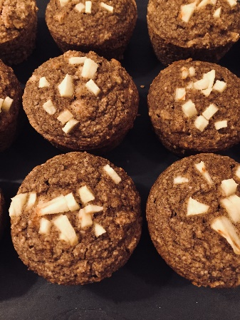 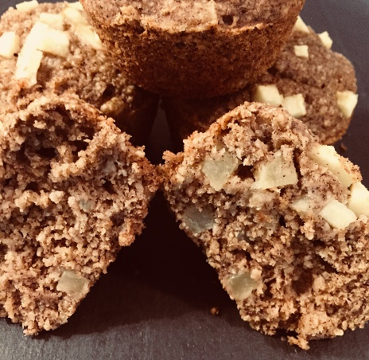

**Recipe by: Jennifer Coatanroch**

Prep time 15 mins

Cook time 25-30 minutes (until a tooth pick comes out clean)

Total time 45 mins

Determined to come up with a healthy, vegan alternative to the classic Apple Cider Donuts, this recipe was born. Guilt free, dairy free, nut free, soy free, refined sugar free…enjoy with a cup of tea, or even with a scoop of dairy free ice cream! Bon Appetit!

Servings: 12 muffins

**Ingredients:**

**Dry Ingredients**

* 1 ½ cup oat flour* (GF if necessary)
* ½ cup buckwheat flour (GF if necessary)
* 1 tsp baking soda
* 1 tsp baking powder
* 2 tsp cinnamon
* ¼ tsp nutmeg
* ½ tsp allspice

**Wet Ingredients**

* ½ cup unsweetened applesauce
* 1/3 cup plain yogurt (I use non-dairy)*
* ½ cup maple syrup
* ¼ cup apple cider
* 2 tbsp. apple cider vinegar
* 1 fresh apple, diced (2 tablespoons reserved)
* 2 tbsp. coconut oil, melted

**Instructions**

1. Preheat oven to 375 degrees F.
2. Spray a muffin pan with coconut oil or another nonstick spray.
3. In a medium bowl, whisk together dry ingredients until evenly combined.
4. In a separate bowl, combine all wet ingredients except the 2 tablespoons diced apple, and mix well.
5. Stir the wet ingredients into the bowl of dry ingredients and mix well. (If the batter fizzes up, it’s just the baking soda reacting with the apple cider vinegar.)
6. Pour the batter evenly between 12 muffin cups. Garnish the tops of the muffins with the reserved diced apple.
7. Bake muffins for 25-30 minutes (until a tooth pick comes out clean). Once done, let cool for a few minutes.

*To make oat flour, place old-fashioned oats in a blender (I use a Nutribullet), and blend until a flour forms (about 15 seconds). Store in the refrigerator.

*If not making this recipe nut-free, I like the Kite Hill nondairy plain, unsweetened almond milk yogurt.

* **Muffin variations:**

-Replace applesauce with pumpkin, and add 1 tsp dried ginger

-Add raisins

-Add cranberries

-Top with pumpkin seeds

|  |  |
| --- | --- |
| **Nutrition Facts** | |
| Servings 12.0 | |
| Amount Per Serving | |
| **calories** 146 | |
| **% Daily Value \*** | |
| **Total Fat**4 g | **6 %** |
| Saturated Fat 2 g | **11 %** |
| Monounsaturated Fat 0 g | |
| Polyunsaturated Fat 0 g | |
| Trans Fat 0 g | |
| **Cholesterol** 0 mg | **0 %** |
| **Sodium** 115 mg | **5 %** |
| **Potassium** 69 mg | **2 %** |
| **Total Carbohydrate** 25 g | **8 %** |
| **Dietary Fiber** 3 g | **10 %** |
| **Sugars** 10 g |  |
| **Protein** 3 g | **7 %** |
| Vitamin A | **0 %** |
| Vitamin C | **2 %** |
| Calcium | **3 %** |
| Iron | **6 %** |
| * The Percent Daily Values are based on a 2,000 calorie diet, so your values may change depending on your calorie needs. The values here may not be 100% accurate because the recipes have not been professionally evaluated nor have they been evaluated by the U.S. FDA. | |