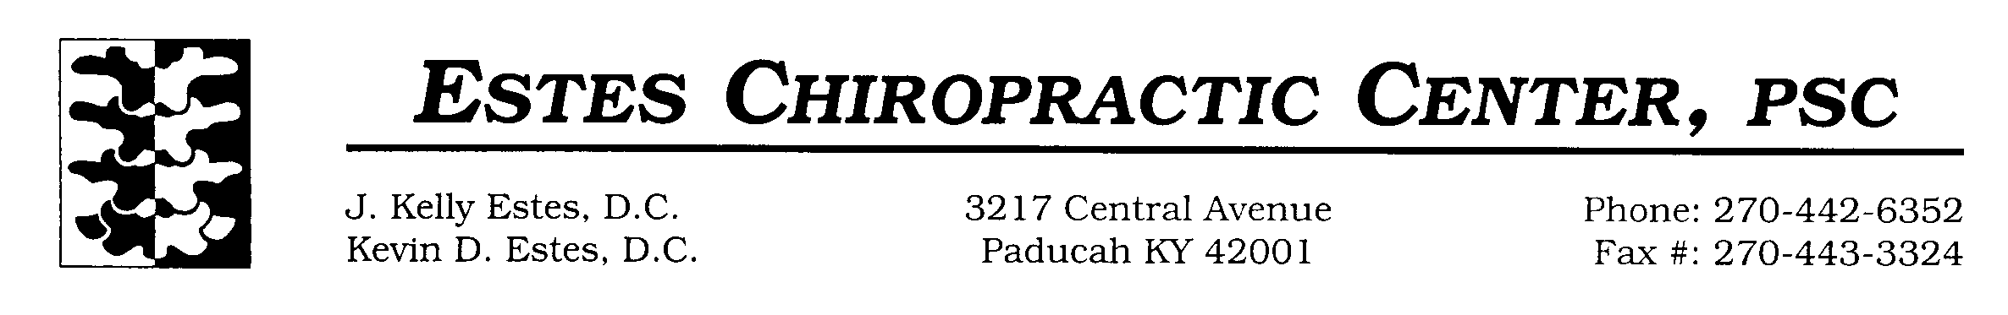**Patient Information**

**Instructions:** This form is part of your permanent health record. Please fill it out **COMPLETELY**. **PLEASE PRINT**.

**First Name**: **Middle Initial:**  **Last Name**:

**Address:**   **City/State/Zip:**

**Date Of Birth:** **Current Age:**  **Gender (Circle one)**: Male/Female

**Marital Status:**   **Spouse’s First Name:**  **Number of Children:**

**Names and Ages of Children:**

**Social Security #:** **Cell** **Phone #:**   **Home Phone#:**

**Work Phone #** **E-mail Address**: @

**Employer:**  **Occupation:**

**How were you referred to our office? Web Physician Other**

**Have you had previous Chiropractic care?** **If so, where?**

**Recent MRI or X-rays (Circle one)**  **If so, where?**

**Family Physician:**  **Are you pregnant?**

**Emergency Contact:**  **Phone**:

**Place the corresponding letter next to the Medical Condition that applies: (X)Self (M)other (F)ather (S)ibling**

*Stroke Heart Attack Clogged Arteries Surgeries High Blood Pressure Broken Bones*

*Diabetes Cancer Rheumatoid Arthritis Multiple Sclerosis Heart Disease*

**Describe above circles:**

**Are you currently taking any medications?** (Please include regularly used over-the-counter medications)

|  |  |
| --- | --- |
| Medication Name | Dosage and Frequency (i.e. 5 mg daily, etc.) |
|  |  |
|  |  |
|  |  |
|  |  |
|  |  |

**Do you have any medication allergies?**

|  |  |  |  |
| --- | --- | --- | --- |
| Medication Name | Reaction | Onset Date | Additional Comments |
|  |  |  |  |
|  |  |  |  |

**Informed Consent**

I understand that chiropractic is a separate and distinct health service. The only goal of the chiropractor is to correct vertebral subluxations. I understand that Estes Chiropractic Center does not offer medical services or advice and they do not discourage me from seeking a medical evaluation. Regardless of what the disease is called, the chiropractor does not offer to diagnose, heal or treat it. The chiropractor does not offer advice regarding the treatment of disease. The information I have provided, on this history form, is true and accurate, to the best of my knowledge. I give Estes Chiropractic Center permission to render care to me today. This visit could include a health history consultation, chiropractic examination, x-rays (if warranted), video fluoroscopy, and any initial care that is determined to be clinically necessary and mutually agreed upon. **Initial:**

**Consent To Treat (Minor)**

I hereby request and authorize J. Kelly Estes, Jr, DC and/or Kevin D. Estes, DC to perform diagnostic tests and render chiropractic adjustments and other treatment to my minor son/daughter: . This authorization also extends to all office staff members and is intended to include radiographic examination at the doctor’s discretion. As of this date, I have the legal right to select and authorize health care services for the minor child named above. **Initial:**

**HIPAA Privacy Policy Patient Consent**

I may request a copy of the Privacy Policy and understand it describes how my personal health information is protected. **Initial:**

**Patient Procedures and Rules**

We are a **cash practice** and do not accept or file **ANY** insurance. Medical records will be on paper and not stored electronically on computer anymore. It is to be understood and agreed that all services rendered to you and your family are your responsibility and you are responsible for payment before receiving services. If you have new information since your last office visit, (change in name, address, or phone number) please notify the front desk staff when you arrive for your appointment. In consideration for those patients who already have scheduled appointments, please call in advance to schedule your appointment. Please call at least 2 hours in advance to cancel or reschedule your appointment. If not you may be subject to a $20 no-show fee. **Initial:**

**Patient Name:**

**Patient Signature: Date:**

**Witness: Date:** *(FOR OFFICE USE ONLY)*

*We want to thank you for choosing our office! We understand that you have many choices when it comes to your chiropractic healthcare. It is our goal to make you feel 100% comfortable and satisfied. If at any time you have questions or concerns, we will be glad to help in any way we can!*

**Pain Chart**

**Name:**

**Please describe your condition:**

**Please mark the area(s) of injury or discomfort using the appropriate symbols.**

**NUMBNESS PINS AND NEEDLES BURNING ACHING STABBING**

**--------- 0000000 ^^^^^^^ XXXXX •••••**

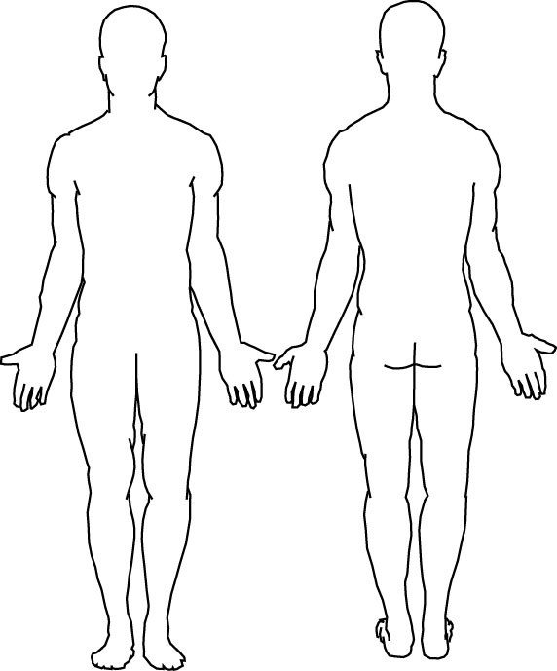

**FRONT BACK**