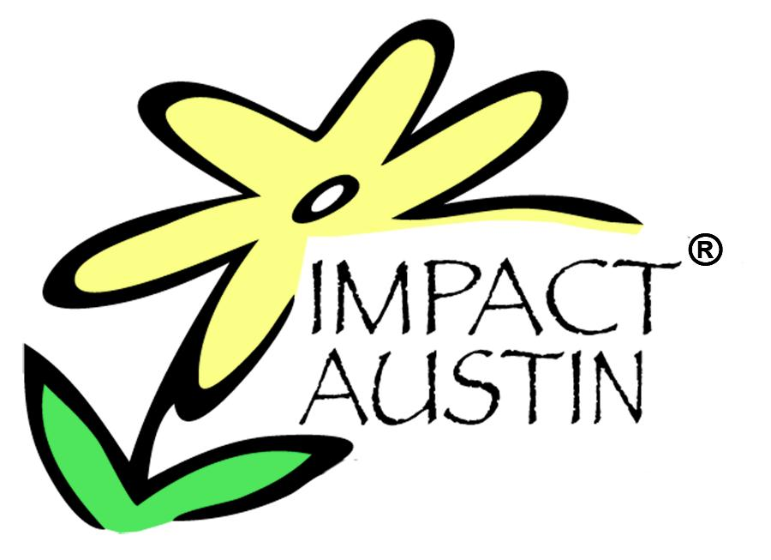

PRESS RELEASE
For Immediate Release Contact: Lauren Paver
Cell: 512.590.5314
lpaver@impact-austin.org

IMPACT AUSTIN CELEBRATES
Five Austin-Area Nonprofits Receive $105,000 Grants

Twenty Five Austin Area Nonprofits Receive Over $2.6 Million in Seven Years

Austin, TX, June 8, 2010– Impact Austin, a local philanthropic group of women, announces the five Community Partners for its 2010 grant cycle. There are 525 women in Impact Austin for 2010, which results in five $105,000 grants. With these grants, Impact Austin will have put over $2.6 million to work in the community to benefit local area projects since 2004.

“When you think that in just seven years, 25 Austin area nonprofits have received a grant of no less than $100,000, makes you stop and realize that the power of collective giving can be life changing for not just one life, but thousands. And despite the challenging economic climate Impact Austin membership is at an all time high, reinforcing the commitment of 525 Central Texas women who believe in the nonprofit community and what they are doing by supporting high-impact programs,” said Rebecca Powers, Impact Austin’s Founder and CEO.

Each year Impact Austin considers proposals in five focus areas: culture, education, environment, family, and health and wellness. The finalists are chosen by focus area committees who evaluate proposals and conduct site visits before making their recommendations to the general membership.

The check presentations for the five Community Partners will be throughout the day on Monday, June 14th at the headquarters of the five Community Partners. (For media purposes, the times and locations of each check presentation will appear on the Impact Austin website, www.impact-austin.org by Friday, June 11th.)

The five 2010 Community Partners and their proposed use of Impact Austin’s grant money are:

CULTURE
Organization: Badgerdog Literary Publishing
Project: It’s Elementary!
Badgerdog Literary Publishing's program, "It's Elementary!" will bring the art of creative writing and the joy of seeing their work in print to 4th graders at all eight East Austin elementary schools that feed into Eastside Memorial High School. Each school will be assigned a paid "Writer in Residence” (a published author) who will work with each class for 25 weeks, teaching the children to use a wide variety of literary forms such as; poetry, playwriting, fiction and creative non-fiction.

-more-
Impact Austin 2010 Community Partners…..page 2

EDUCATION
Organization: Communities in Schools of Central Texas
Project: XY-Zone
The XY-Zone is a nationally recognized leadership development and peer support program for high school age boys at-risk for school dropout. The XY-Zone challenges and empowers young men to aim high, get an education and break the cycle of poverty. Impact Austin's grant will fund expansion of XY-Zone to the Bastrop High School Campus.

ENVIRONMENT
Organization: Austin Parks Foundation
Project: Barton Creek Trail Corps
The Austin Parks Foundation's Barton Creek Trail Corps addresses environmental issues through a restoration and improvement project for the Barton Creek Greenbelt wherein young adults gain professional experience in the green job sector. The program incorporates a multifaceted approach to educate the public, raise awareness, increase financial donations, and thus continue to fund the Barton Creek Trail Corps into the future.

FAMILY
Organization: CASA of Travis County
Project: Transitioning Youth Program
CASA (Court Appointed Special Advocates) of Travis County’s Transitioning Youth Program expansion will provide support to an estimated 100% of the cases assigned by the courts for youth ages 14 to 18 who are at risk of aging out of foster care. The program emphasizes education, preparation and connections to prepare the youth for independent adult living.

HEALTH AND WELLNESS
Organization: Austin Groups for the Elderly
Project: Resources for Caregiving for Seniors
The Austin Groups for the Elderly (AGE) project, Resources for Caregiving for Seniors, will expand the durable medical equipment lending program, currently serving a critical and unmet need in Travis and Williamson counties. Program expansion will increase the equipment available in addition to improving access to the equipment by increasing public awareness of the service; efficiency of storage, retrieval, and distribution of equipment while also optimizing volunteer activity and community cooperation.

For interviews with the 2010 Community Partners or Rebecca Powers, Founder and CEO of Impact Austin, contact – Lauren Paver, 512.590.5314 or lpaver@impact-austin.org.

About Impact Austin:
Impact Austin is a 501(c)(3) public charity made up of women seeking to transform lives in the Austin area through high-impact and lifelong giving. The only membership requirements are to be female and donate $1,000 each year. Impact Austin combines the annual donations from members and gives large grants each year to local worthy causes selected by the members. Grant applications are accepted in each of the following focus areas: culture, environment, education, family, and health and wellness. Collectively, we are changing the face of philanthropy in Austin www.impact-austin.org.

