2 questions; 2 podcasts & 1 article

2 Q’s
What if doctors and other clinical staff had patient/family mentors that were matched early in their career (residency/fellowship) and attempted to stay in contact throughout their careers?
What if residents and fellows partnered with patients/family members (who were teachers and trainers in their careers -- but non in meded) and, together, they co-created/designed a curriculum on what are important learnings from the patient lens?

2 Podcasts
This month – the focus is on the importance for healthcare to learn and understand behavioral science and behavioral economics—2 critical academic disciplines that (IMHO) will help to improve understanding of patients/their families and ourselves.
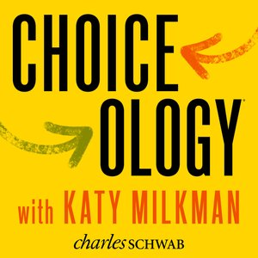https://podcasts.apple.com/us/podcast/choiceology-with-katy-milkman/id1337886873 Can we learn to make smarter choices? Choiceology explores the lessons of behavioral economics, exposing the psychological traps that lead to expensive mistakes. Season 1 of Choiceology was hosted by Dan Heath, bestselling author of Made to Stick and Switch. Check out anchoring bias (often concern for initial diagnosis from patient or from clinician) in Season 1 Episode 6 https://podcasts.apple.com/us/podcast/a-number-in-mind/id1337886873?i=1000409596320

http://freakonomics.com/podcast-tag/healthcare/ This is one of my all-time favorite podcasts and even when not related to healthcare, I often find ways to apply the learnings from the podcast to healthcare. Based on the book of the same name, I hope you can enjoy one of these “tagged in healthcare” episodes to get you started on your freakonomic journey.

1 Article

In keeping with the behavioral science theme… here is a wonderful short piece from the Penn Medicine Nudge Unit in the NEJM on how health systems/hospitals like Ascension-Genesys might create such a unit….

https://catalyst.nejm.org/launching-nudge-units-health-care/ - “Recognizing that many of our routine practices are influenced by the nature in which choices are presented to clinicians, health systems have been considering the formation of a nudge unit or behavioral design team to make higher-value choices easier to make.” “Some of these changes seem straightforward, but change is difficult, and change in the matrixed environment of health care — where technical expertise is diffused — is particularly challenging.”

Bonus- a quote
"People are irrational - and predictably so." ~ Dan Ariely

