

**Free Festive Meals in Lewisham**

[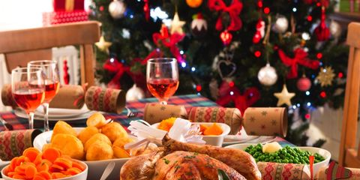](https://www.google.com/url?sa=i&rct=j&q=&esrc=s&source=images&cd=&ved=&url=https://www.goodhousekeeping.com/uk/consumer-advice/a573576/christmas-dinner-is-getting-more-expensive-heres-where-its-cheapest-in-2017/&psig=AOvVaw1wBixpE1gEDhlychxKxE9c&ust=1573825821715851)

**No one needs to be alone on Christmas day in Lewisham! Join one of the free community Christmas meals around the borough.**

If you know of any other free community meals during the festive season, please let us know at [community.connections@ageuklands.org.uk](mailto:community.connections@ageuklands.org.uk) or 0208314 3244. **Thank you to Lewisham Pensioner’s Forum (020 8690 7869) for compiling and sharing this list with us.**



**Christmas Day - December 25th**

**Deptford Methodist Church, 1 Creek Road, SE8 3BT**

A 10.30 service (or just come along at 11.30) for welcome, tea and coffee. Then a 3-course lunch followed by games & entertainment, ending at 3.30.

Call in to Reception or ring Rev David Gillman on **020 8692 0048** for an application form and to discuss transport.

**All Saints Community Centre, Monson Road, SE14 5EH**

Christmas Mass in the Hall at 11am, then a traditional lunch starting at around 1pm, followed by tea with cakes and sandwiches and a visit from Father Christmas. There is no charge for anything. Phone Father John on **07703 567 214** as some transport may be available.

**St John’s, St John’s Vale (corner of Lewisham Way), SE8 4EA**

Lunch 12.30to 3pm. Advance booking preferred: callPeter, **020 8692 2857** or **07786 160 993,** oremailpeter.stjohnsdeptford@gmail.com. Limitedtransport may be available.

**Cummin’ Up Restaurant & Take-away 389 Lewisham High Street, SE13 6NZ**

Richard Simpson and his family will cook traditional British Christmas Day fare (even Brussels sprouts!), plus jerk chicken, rice and peas and mixed salad

1pm to 6pm.

**Christchurch URC Bellingham Green, SE6 3HQ**

Lunch, tea, fun and games from 11.30 to 5pm. Ring or text Tommo on 07712 677 174 or Jan on 07962 344 744to book your place and enquire about transport.

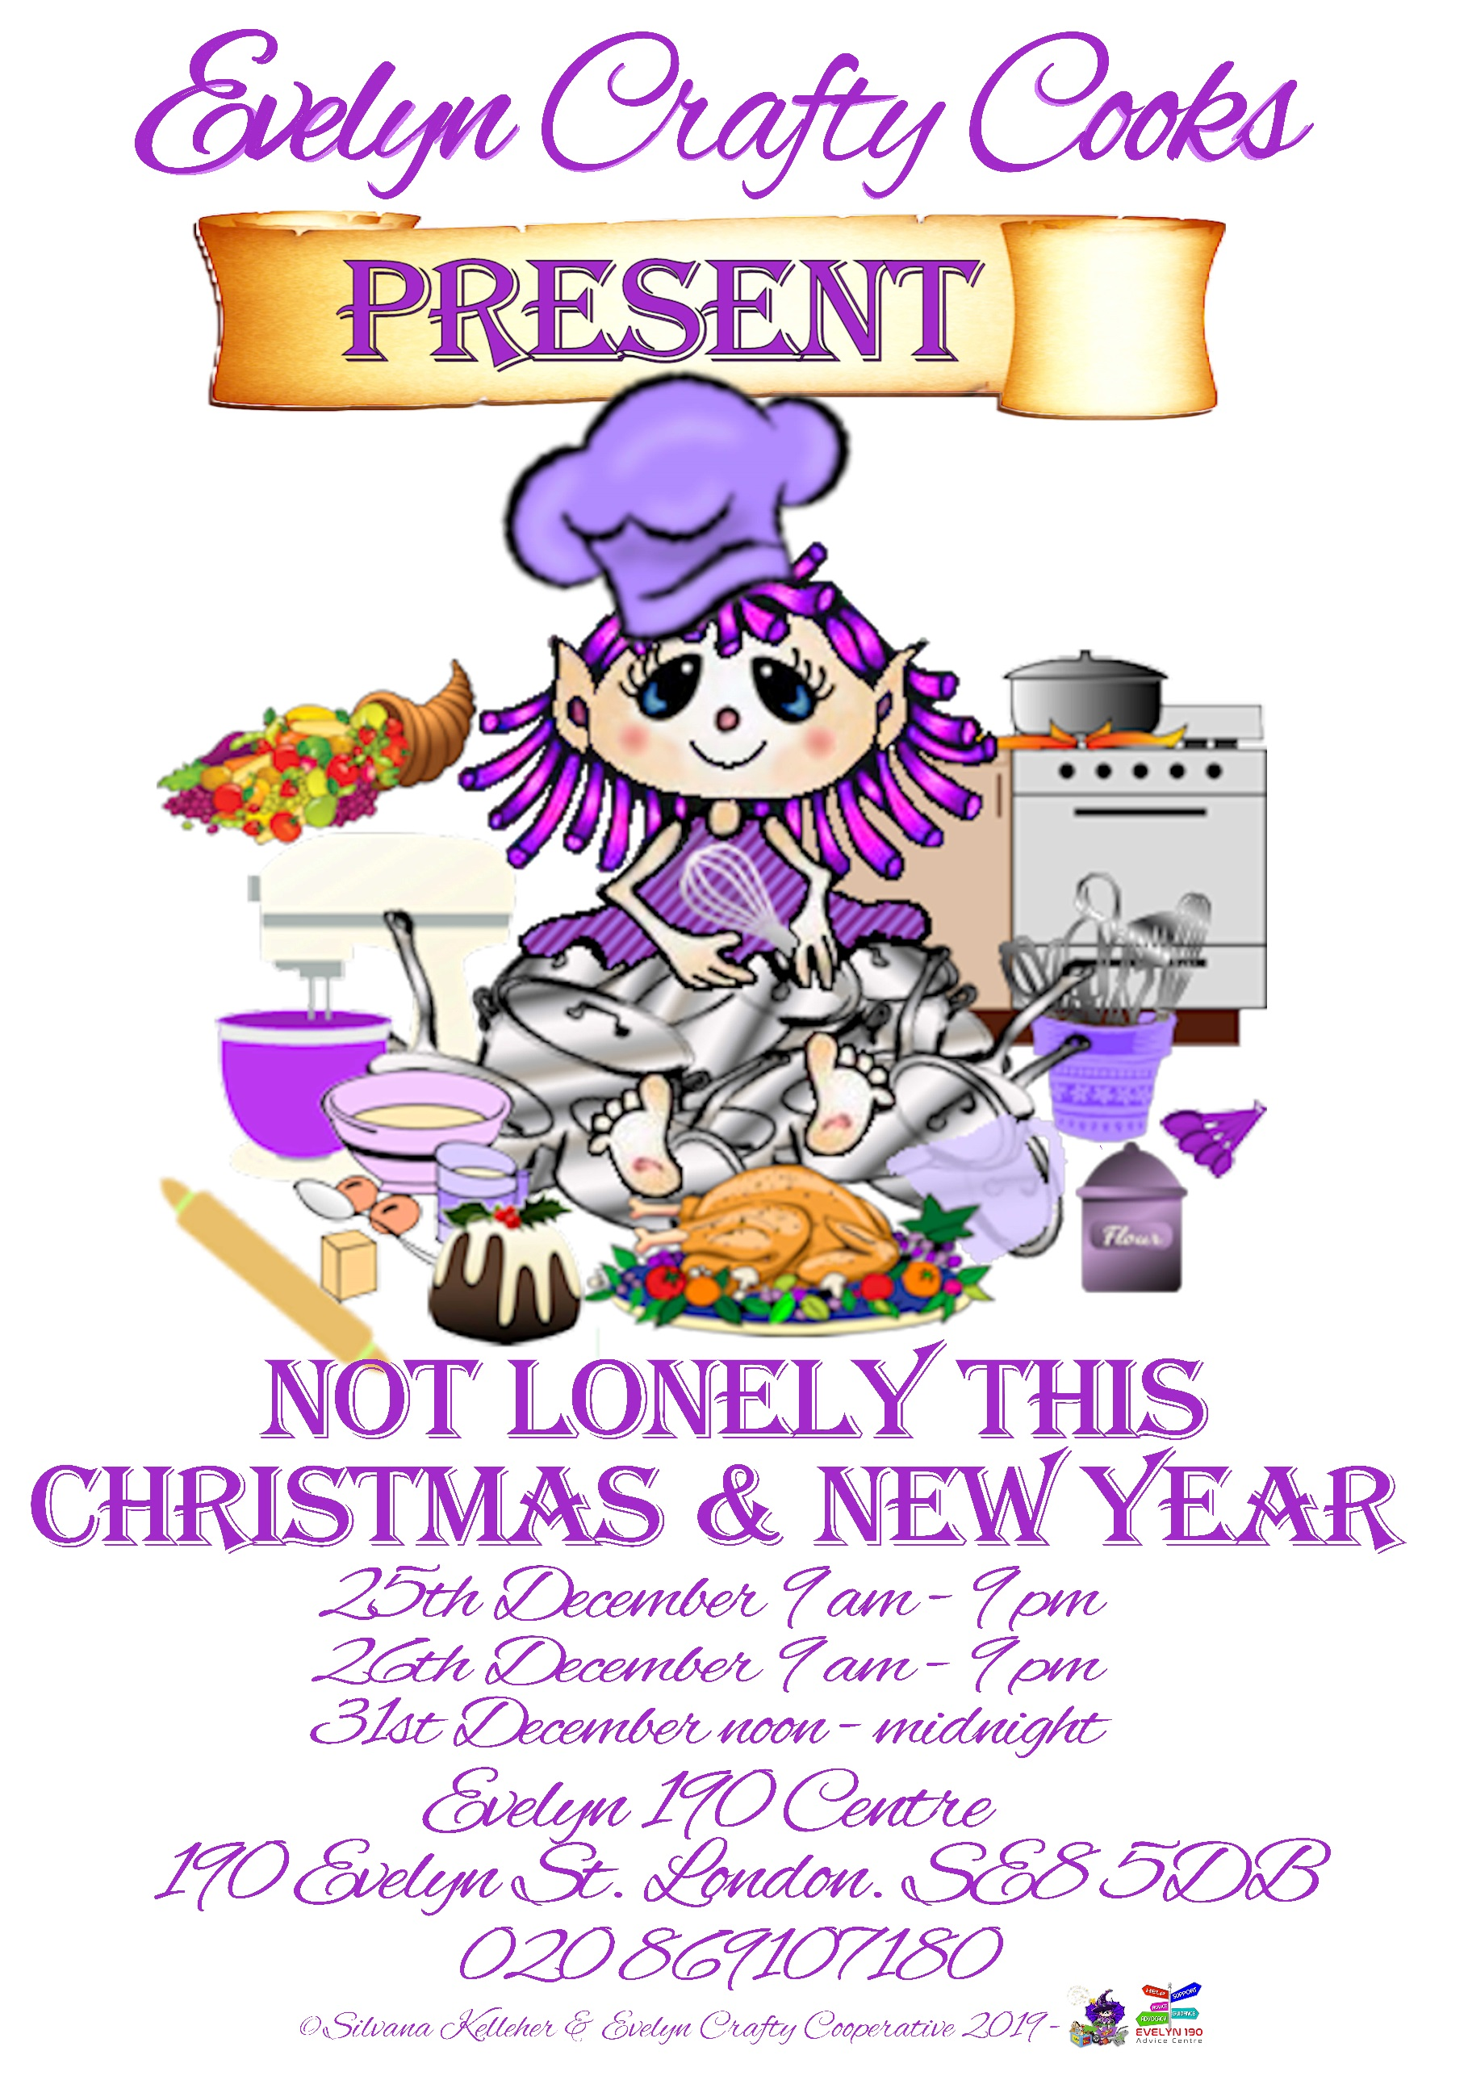

**Evelyn 190 Community Centre, 190 Evelyn Street SE85DB (in the old church)**

Evelyn Crafty Cooks invites you to their launch event “Not lonely this Christmas”, from 9am to 9pm. Come to enjoy nice food, play games and have fun ! No booking required. For info call 02869107180

**Forest Hill Methodist Church, Normanton Street, Forest Hill, SE23 2DS** Traditional turkeyand Christmas pudding, with an option of beingpicked up and dropped home. Free, but not a drop-in. Please phone VSL on 020 8291 1747 as soon as possible to make arrangements, or else call in at the Voluntary Services Lewisham office, in the Leemore Centre, 29-39 Clarendon

Rise, SE13 5ES to fill in the form.

**Boxing Day – December 26th**

**More boxing day and news year meals overleaf**

**The Hill Station, Kitto Road, SE14 5TY** (close to the 343 and 484 bus routes)

Open from 12noon to about 4pm. Anyone feeling the let-down after Christmas is welcome to come along and bring any leftovers they have to share, or just bring themselves! There will be hot drinks, biscuits, cake and company. All free.

**St Barnabas Church Hall, Downham Way, BR1 5EL**

Free tea and cakes and a fun-filledafternoon 3.00 to 5pm. Contact Fr Stuart Leckon 020 8698 0283to say if you’re coming or findout more. On bus routes 181, 136 and 336.

**Evelyn 190 Community Centre, 190 Evelyn Street SE85DB (in the old church)**

Evelyn Crafty Cooks will welcome you from 9am to 9pm. Come to enjoy nice food, play games and have fun ! No booking required. For info call 02869107180

**Christchurch URC Bellingham Green, SE6 3HQ**

Lunch, tea, fun and games from 11.30 to 5pm. Ring or text Tommo on 07712 677 174 or Jan on 07962 344 744to book your place and enquire about transport.

**New Year’s Day — January 1st**

**Christchurch URC Bellingham Green, SE6 3HQ**

As above from 10.30 to 5pm.

Ring or text Tommo **07712 677 174** or Jan **07962 344 744** to book your place or ask about transport**.** Hoppa Bus 336 or a 15 minute walk from Bromley Road.

**Evelyn 190 Community Centre, 190 Evelyn Street SE85DB (in the old church)**

Evelyn Crafty Cooks will welcome you from noon to mighnight ! Come to enjoy nice food, play games and have fun ! No booking required. For info call 02869107180

**I**



**If you New Year’s resolutions include, being more social, making new friends, learning a new skill or giving back to the community, get in touch with Community Connections !**

We use the 5 ways to wellbeing and a person-centred approach to support our clients:

[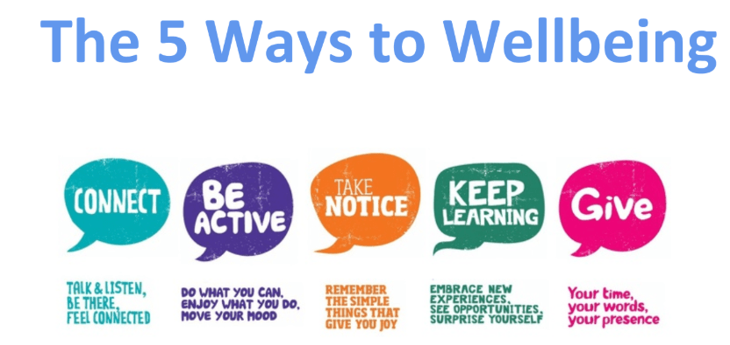](https://www.google.com/url?sa=i&rct=j&q=&esrc=s&source=images&cd=&cad=rja&uact=8&ved=&url=https://tockwith.ebor.academy/uncategorized/compass-buzz-mental-health-wellbeing/&psig=AOvVaw1_MstumRYrHMKGe8idtc8K&ust=1574244201499244)

Our Community Facilitators know everything that goes on in your local area and can point you in the right direction: crafts groups, community gardens, yoga classes, English classes, family play groups… You name it, we find it and make sure you get a warm welcome there !

**To refer yourself or someone you know, call 020 8314 3244 or email** [**communityconnections@ageuklands.org.uk**](mailto:communityconnections@ageuklands.org.uk)

**and tell us: your name, phone number, address and post code why you would like support and what sort of support you need.**

Hope to hear from you soon ☺