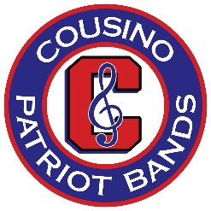
COUSINO HIGH SCHOOL BAND BOOSTERS
LEIF LINDBLOM SUMMER MUSIC SCHOLARSHIP
APPLICATION FORM

Name of Student _______________________________________________________________

Grade _______ Instrument (including voice) to be studied ____________________________________

Name of Private Instructor ________________________________________________________

Signed by the Cousino Director of Bands ____________________________________________

---------------------------------------------------------------------------------------------------------------------

Please attach a 1 page MINIMUM 200-word essay to this application form that explains:

- The reasons why you are applying for a scholarship, and.
- Your overall musical goals for the 2019 - 2020 school year.

Your essay is to be typed and submitted in the following format:

Margins - 1.0” for Left, Right Top, and Bottom Margins
Title Font - Times Roman Regular - 14-point size - Centered
Text Font - Times Roman Regular - 12-point size
Spacing - Double Spaced
Word Count - Provide the word count of your essay _____________

---------------------------------------------------------------------------------------------------------------------

We hereby consent to the release of this Scholarship application and essay for use by the:

- Cousino High School Band Booster Scholarship Committee and the Cousino Director of Bands for the purpose of consideration for one of the Leif Linblom Summer Music Scholarship and
- Warren Consolidated School District for the purpose of public relations.

Student Signature _______________________________________________________________

Parent/Guardian Signature ________________________________________________________

Date of Signatures ______________________________________________________________

Please return the completed form with essay to one of the Cousino High School Band Booster Officers or to the Director of Bands no later than the end of the school day Wednesday,
May 15th, 2019.

All essays will be adjudicated for their content and presentation including formatting, proper sentence structure, grammar, and spelling.

Scholarship recipients will be announced at the Tuesday, May 28th 2019 Annual Awards Banquet.

