|  |  |
| --- | --- |
| **Connecticut Mobile Methane Leaks Survey and Analysis Results**  1 April, 2019 | Abstract  This report reflects the results of 2019 mobile methane surveys done in Hartford, Danbury, and New London, with the Hartford results compared to a similarly executed survey done in 2016. The results support that methane leaks remain prevalent and persistent in Hartford and are also present in other Connecticut towns, with Danbury yielding the most comparable results. New London also has indications of leaks, but of a lower range of methane emission than Hartford and Danbury. |

**Connecticut Mobile Methane Leaks Survey and Analysis Results**

Tim Keyes PhD (1), Gale RidgePhD (2), Martha KleinRN MPH (3), Nathan PhillipsPhD (4), Bob Ackley (5), Yufeng Yang (4,6)

1. Evergreen Business Analytics, LLC
2. Steering Committee, 350 CT
3. Sierra Club Connecticut
4. Boston University, Department of Earth and Environment
5. Gas Safety, Inc.
6. Institut National des Sciences Appliquées, Lyon

Contents

Executive Summary 1

Detailed Account 2

Purpose of the Study 2

Overview of Survey Methodology 3

Overview of Data Analytics Methodology 3

Hartford Results 4

2016 Results 4

2019 Results 5

Comparison of 2016 and 2019, and Conclusions 5

Danbury 2019 Results 6

New London 2019 Results 6

Conclusions and Recommendations 7

Acknowledgements 8

References 9

APPENDIX 10

High-level Steps for File and Data Processing 10

Software for Processing Data Files 10

File Locations, Lists and Output Results for Each Survey 10

# Executive Summary

Multiple mobile methane leak surveys were conducted on the public streets of Hartford, Danbury, and New London, Connecticut (CT), during the month of March, 2019. The Hartford survey was done to determine if results from a 2016 survey (Keyes, et al., 2019) were persistent, and surveys in additional towns were done to determine if similar methane leak observations could be made using an identical leak detection approach. The results show that Hartford continues to be problematic, with approximately 3.4 leaks per road mile observed in 2016 and the same or more estimated in 2019 (4.3 leaks per mile). This leak frequency compares to the leaks per mile previously found in Boston, Massachusetts (MA) (Phillips, et al., 2013). Moreover, the surveys and analysis done for Danbury, and New London, CT also reveal problematic leaks, particularly for Danbury with an estimated 3.6 leaks per mile. The road miles covered in New London were more limited, and therefore their leaks per mile figures should be used with caution. However, New London also revealed leak-prone areas, albeit with a range of CH4 readings lower than those in Hartford and Danbury. The data collection method for the 2016 and 2019 surveys were identical to the method used in Boston. The results, analysis and report for this study was produced over a two-week period, demonstrating the informative value that can be gained from data-driven evaluations of pipeline performance.

# Detailed Account

## Purpose of the Study

The Hartford survey was done to determine if results from a 2016 survey (Keyes, et al., 2019) were persistent, and surveys in additional towns were done to determine if similar methane leak observations could be made using the same leak detection approach. These survey results are aimed to be used to influence forthcoming legislation to improve the manner in which public utilities in Connecticut manage natural gas pipelines and serve ratepaying customers. A related goal is to demonstrate the relatively efficient, effective and pro-active manner in which surveys like the ones described in this report, can be done by the Public Utilities Regulatory Authority (PURA) or the Local Distribution Companies (LDCs).

There are three investor-owned natural gas utilities (LDCs) in Connecticut serving urban and suburban communities. These are Connecticut Natural Gas (CNG; cngcorp.com), Southern Connecticut Gas (SCG; www.soconngas.com), and Eversource/Yankee Gas Company (ES; www.eversource.com). Gas service in Hartford is supplied by CNG, the smallest of the three main utilities in terms of miles of pipeline mains (with 296 miles of leak-prone cast iron and wrought iron mains in 2017 (14% of their total miles), per data from the Pipeline Hazardous Materials Safety Administration (PHMSA, 2015-17). Hartford is the largest city within CNG service area. Gas service in Danbury and New London is supplied by Eversource/Yankee Gas. See Figure 1.

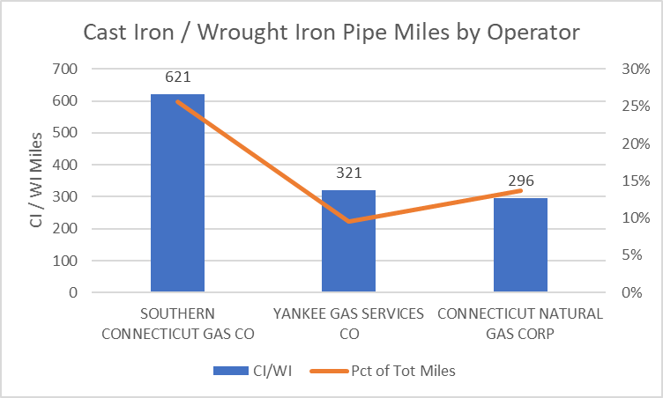

**Figure 1: Mileage of cast iron pipe managed by Connecticut operators**

## Overview of Survey Methodology

Surveys were conducted mid-February through late March, 2016 in Hartford, and again in mid-late March in 2019 in Hartford, Danbury, and New London, CT, a timing that suppressed alternative methane emission signals from possible wetland, landfill or other subsurface sources, because of cold temperatures. The 2016 survey in Hartford was conducted to be a near census of all 225 road miles in the town (Connecticut Dept of Transportation, 2014), whereas the 2019 surveys done in Danbury and New London were samples of road miles in each town. As a result, comparing results from Hartford across time requires recognition that the 2019 survey was a smaller sensor sample (not a census of road miles).

The same mobile Picarro G2301 Cavity Ring-Down Spectrometer (Picarro, Inc., Santa Clara, CA; [www.picarro.com/)](http://www.picarro.com/)) was used in all surveys (2016 and 2019), installed in a vehicle equipped with a geographic positioning system (GPS), and driven on the public roads in each town. Focus on the 2019 Hartford survey was on main roadway arteries and problematic areas based on 2016 conclusions. A filtered inlet tube was placed outside the passenger side of the vehicle. The analyzer was periodically tested with 0 and 5 ppm CH4 test gas (Spec Air Specialty Gases, Auburn, ME; [www.mainespecialtygases.com/](http://www.mainespecialtygases.com/); reported precision ±10%) throughout the 2016 survey.

As roadways in the town being surveyed are driven, the system records parts per million (ppm) methane (CH4) concentration each second, along with latitude-longitude GPS coordinates. The system operator will typically start and stop the recording of data into individual files representing survey micro-areas likely to have similar ambient conditions, and therefore each town survey results in many individual files of CH4 readings by geo-position. For example, the survey in Hartford, 2016 produced 65 data files.

## Overview of Data Analytics Methodology

To distinguish discrete leaks from the spatially continuous raw methane concentration data (ambient conditions) in a micro-area, a modified Tau approach (Olewuezi et al., 2015) was used to perform outlier detection. This method is a statistical method for deciding whether to keep or discard suspected outliers in a population sample, in this case an individual CH4 system file representing a micro-area within the town being surveyed. A threshold methane level that meets the outlier category, indicating a leak, is calculated by the data file’s CH4 sample size, sample average, sample standard deviation, and desired confidence level.

To avoid double-counting leaks that were sampled (driven past) multiple times, or that were in close proximity to each other (and likely only a single actual leak), a procedure was used to eliminate multiple outliers within a spatial window of 30 meters radius from the highest peak methane concentration in the vicinity. Sensitivity analysis on the spatial window was done using windows small as 5 meters up to 30 meters. It was found that there was relative insensitivity of the total leak count in this range, while predicted leak count decreased substantially in window sizes above 30 meters. Since vehicle lane widths are generally approximately 10 meters or less, the 30-meter window is large enough to prevent double-counting but small enough to avoid incorrectly combining separate actual leaks into one predicted leak.

A quality control check was performed in the 2016 survey by auditing 5 randomly selected leaks from the driving survey and subsequent analysis, and verifying / pinpointing subsurface methane concentrations using a ‘bang bar’ to penetrate the surface, in combination with a combustible gas indicator (Gas Sentry, Bascom-Turner, Inc. Norwood, MA; <https://www.bascomturner.com/>).

Once each town’s survey was complete, the corresponding data files described above were created (.DAT and .KML) for use in subsequent analysis, the essential steps of which are outlined in the Appendix. The Appendix also contains the file control lists, software (R code) for processing the data files, and the resulting outlier files (predicted leaks).

Hartford Results

## 2016 Results

Table 1 below displays key results from the Hartford, 2016 mobile methane survey. Further work on this survey was reported in Keyes, et al., 2019.



**Table 1: 2016 Hartford Survey Results**

Figure 2 below shows a map of recorded measurements in blue, and predicted leaks in red.

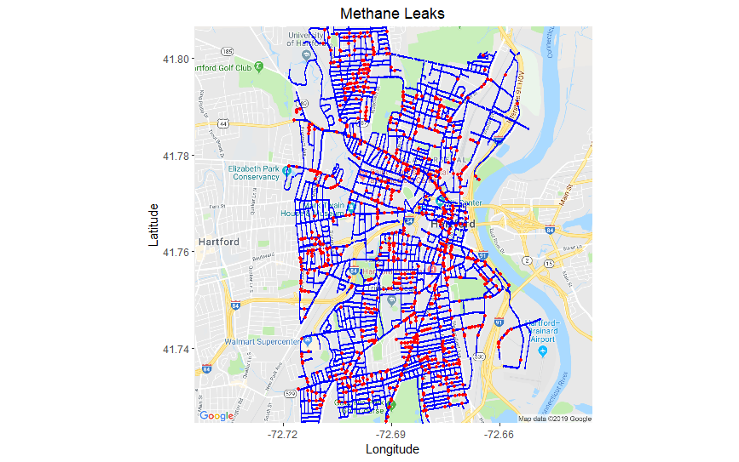

**Figure 2: 2016 Hartford Survey Results Map (blue = measurement, red = leak)**

## 2019 Results

Table 2 below displays key results from the Hartford, 2019 mobile methane survey. Given that this survey was not a census (i.e., not all 225 road miles of Hartford were driven), the Road Miles entry is a figure estimated using a ratio of the number of measurements taken in the 2019 study (62,546) to the number of measurements taken in the 2016 study (i.e., 100 miles ~ 62,546 / 140,602 x 225 miles). Note both the smallest and largest leaks recorded in 2019 are above similar measurements from 2016.



**Table 2: 2019 Hartford Survey Results**

Figure 3 below shows a map of recorded measurements in blue, and predicted leaks in red.

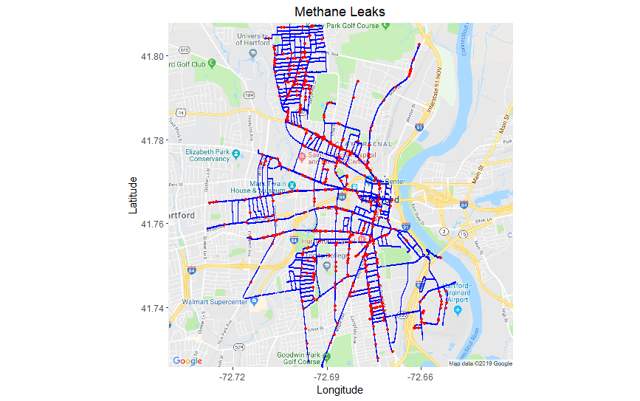

**Figure 3: 2019 Hartford Survey Results Map (blue = measurement, red = leak)**

## Comparison of 2016 and 2019, and Conclusions

Figures 2 and 3 suggest that leaks throughout the town continue to be problematic, and are persistent, for example along Albany Avenue, Maple Avenue or the Kenney Park area to the north of town, and east of the University of Hartford. Tables 1 and 2 indicate that the estimated number of leaks per road mile has increased from 3.2 per mile, to 4.3 per mile (coincidentally similar to the figure resulting from the earlier Boston study), although the latter figure is based on an admittedly crude estimate of road miles driven. Assuming reasonably that the surveying vehicle is travelling at the same speed in each survey, and each side of each road is surveyed, then a constant one-second sensor refresh rate implies that the total number of sensor readings is indicative of total miles driven. Benchmarking this to the 2016 Hartford study gives an approximate conversion of sensor readings to survey road miles.

# Danbury 2019 Results

Table 3 below displays key results from the 2019 mobile methane survey. Again, an estimate is made for the road miles driven, using the methodology explained above. Figure 4 below shows a map of recorded measurements in blue, and predicted leaks in red. This evidence shows there is a cluster of predicted leaks in the vicinity of Rogers Park, and also in the downtown area. The estimated leaks per mile is 3.6, consistent with the 2016 and 2019 results for Hartford.



**Table 3: 2019 Danbury Survey Results**

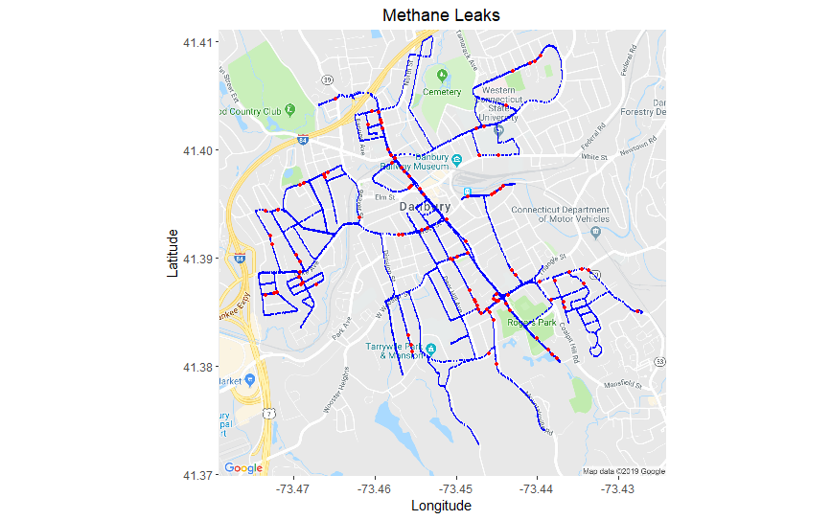**Figure 4: 2019 Danbury Survey Results Map (blue = measurement, red = leak)**

# New London 2019 Results

Table 4 below displays key results from the 2019 mobile methane survey. Given the relative short distance covered (based on the estimation approach), the Leaks / Mile figure should be used with caution. From Figure 5, most of the leaks in New London appear to be in the central part of the town and in the Fort Trumbull area. The range of CH4 ppm is relatively lower than that of Hartford and Danbury.



**Table 4: 2019 New London Survey Results**

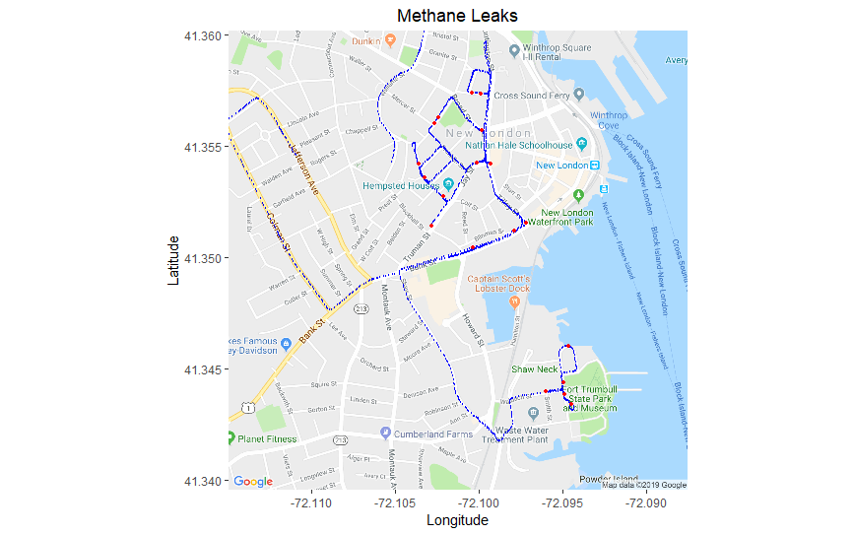

**Figure 5: 2019 New London Survey Results Map (blue = measurement, red = leak)**

# Conclusions and Recommendations

This report reflects the results of 2019 mobile methane surveys done in Hartford, Danbury, and New London, CT, with the Hartford results compared with a similarly executed survey done in 2016.  The results support that methane leaks remain prevalent and persistent in Hartford and are also present in other Connecticut towns:  Danbury has a leak propensity similar to that in Hartford, while New London has problematic leak indications, but less pronounced CH4 readings than those in Hartford and Danbury.

This study outlines and demonstrates a straightforward approach to pro-active leak management – one that could be applied by PURA or the LDCs to improve system performance, or by Connecticut legislators to evaluate energy management policies in the state.

Further advances to the analytic methodologies may include overlaying pipeline grid locations with the predicted leaks identified as a result of a survey, with the aim of further verifying (beyond the validation work done in 2016), that leaks are allocatable to specific pipeline sections, and therefore to specific remediation actions.

# Acknowledgements

The analytics work used in this study was adapted from methodologies developed in 2016 by Nathan Phillips and Yufeng Yang (who are co-authors of this report), and initially deployed in Hartford in 2016 and reported in Keyes et al., 2019. Contributions by Bob Ackley and Tim Keyes were sponsored by the Sierra Club Connecticut.

# References

Connecticut Department of Transportation, Public Road Mileage (2014). Retrieved from [www.ct.gov/dot/lib/dot/documents/dpolicy/publicroad/PublicRoadMileage2014.pdf](http://www.ct.gov/dot/lib/dot/documents/dpolicy/publicroad/PublicRoadMileage2014.pdf).

Keyes T, Ridge G, Klein M, Phillips N, Ackley B, Yang, Y (2019). Hartford, Connecticut Mobile Method Leak Survey (under review at the Acadia Center). Retrieved from <https://ctsierraclub.wixsite.com/sierraclub-ct/hartford-mobile-methane-leaks-study>.

Olewuezi NP, Onoghojobi B, Udeoyibo CV (2015). A comparative study of different outlier detection method in linear regression. Far East Journal of Theoretical Statistics 50:171-179.

Phillips, NG, Ackley R, Crosson ER, Down A, Hutyra LR, Brondfield M, Karr JD, Zhao K, Jackson RB (2013) Mapping urban pipeline leaks: methane leaks across Boston. Environmental Pollution 173:1-4. Retrieved from <http://dx.doi.org/10.1016/j.envpol.2012.11.003>.

Pipeline Hazardous Materials and Safety Administration (PHMSA). Gas Distribution-Gathering-Transmission data (2015-17). Retrieved from <https://www.phmsa.dot.gov/data-and-statistics/pipeline/gas-distribution-gas-gathering-gas-transmission-hazardous-liquids>.

# APPENDIX

## High-level Steps for File and Data Processing

1. Upload files (.DAT, .KML) to a shared Google Drive.
2. View .KML files in Google Earth Pro and determine which individual files are associated with a town’s survey, versus the vehicle being “in transit” to or from the vehicle’s starting and ending point for the day of the survey (readings are taken whenever the vehicle is in use). The latter files are excluded from analysis.
3. Create a survey “File List” for use in subsequent outlier detection and de-duplication (files associated with a micro-area within a town).
4. For each file in the File List,
   1. Record the number of observations (individual CH4 measurements taken).
   2. Perform the modified Thompson’s Tau outlier detection methodology; an outlier as determined by this methodology is an initial indication of a predicted leak.
   3. Perform de-duplication methodology to omit repeated observations of the same predicted leak within a threshold radius (30 meters as previously described), keeping the largest outliers as final indications of predicted leaks *for the file*.
5. Once all individual files in the File List are processed,
   1. Aggregate each file’s final predicted leaks into a combined, town-level data set.
   2. Repeat the de-duplication methodology in step 4) a. above, for the aggregated list of predicted leaks. This produces the final predicted leaks associated with a town’s survey.
6. Plot GPS points associated with each survey measurement, superimposed with GPS points associated with each predicted leak.

## Software for Processing Data Files



## File Locations, Lists and Output Results for Each Survey

|  |  |  |  |
| --- | --- | --- | --- |
| **Location** | **Location of Input Files** | **List of .Dat Files Processed** | **Output Files (Predicted Leaks)** |
| Hartford, 2016 | [Google Drive](https://drive.google.com/open?id=17KOqmlky6Tx_aIOlYi0v2TBRBuZFepkz) |  |  |
| Hartford, 2019 | [Google Drive](https://drive.google.com/open?id=18oCTzG0Jp8jTDP9y8btJvAFbJvDLvAMh) |  |  |
| Danbury, 2019 | [Google Drive](https://drive.google.com/open?id=1gAZmwtY3C2bbZCahHcfz1n6obDfkkoFu) |  |  |
| New London, 2019 | [Google Drive](https://drive.google.com/open?id=1gAZmwtY3C2bbZCahHcfz1n6obDfkkoFu) |  |  |