
ASSEMBLY RESOLUTION 8-011
A RESOLUTION to ENACT THE FALL 2018 CSG bUDGET
WHEREAS, Central Student Government funds are comprised of semesterly student fees and rollover funds from the prior semester; AND
WHEREAS, these funds are distributed between the CSG accounts in accordance with funding guidelines stipulated in the Compiled Code; AND
WHEREAS, funds are to be distributed to CSG accounts at the earliest convenience for use by CSG; THEREFORE BE IT
RESOLVED, that the budget attached below be enacted as the CSG operating budget for the Fall 2018 Semester.
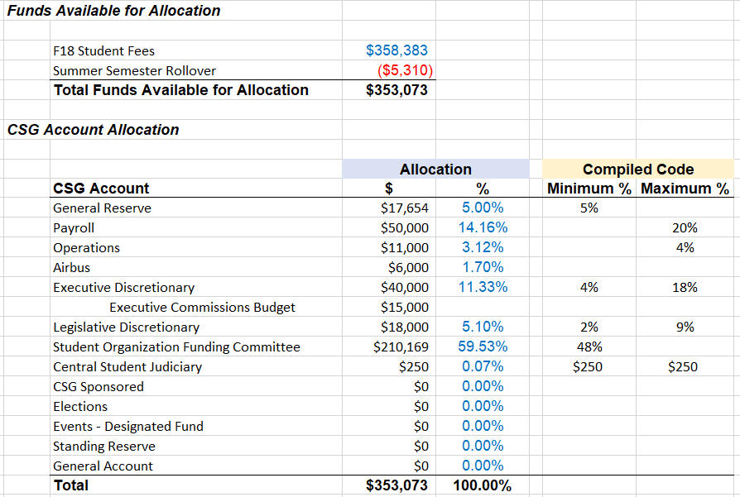
Authors
Niccolo Beltramo, College of Literature, Science, and the Arts
Central Student Government Treasurer

Attest

_______________________________
Austin Glass, Rackham
Speaker of the Assembly

Presented to the Assembly for First Reads on ______________________________________
Presented to the Assembly for Second Reads on ____________________________________
Yes: _____ No: _____ Abs: _____ Date/Time: _____________________________
Signature Necessary: Yes / No
President’s Approval

_______________________________
Daniel Greene, Ford
President

Signed (Date/Time): ___________________ OR Vetoed (Date/Time): ___________________

