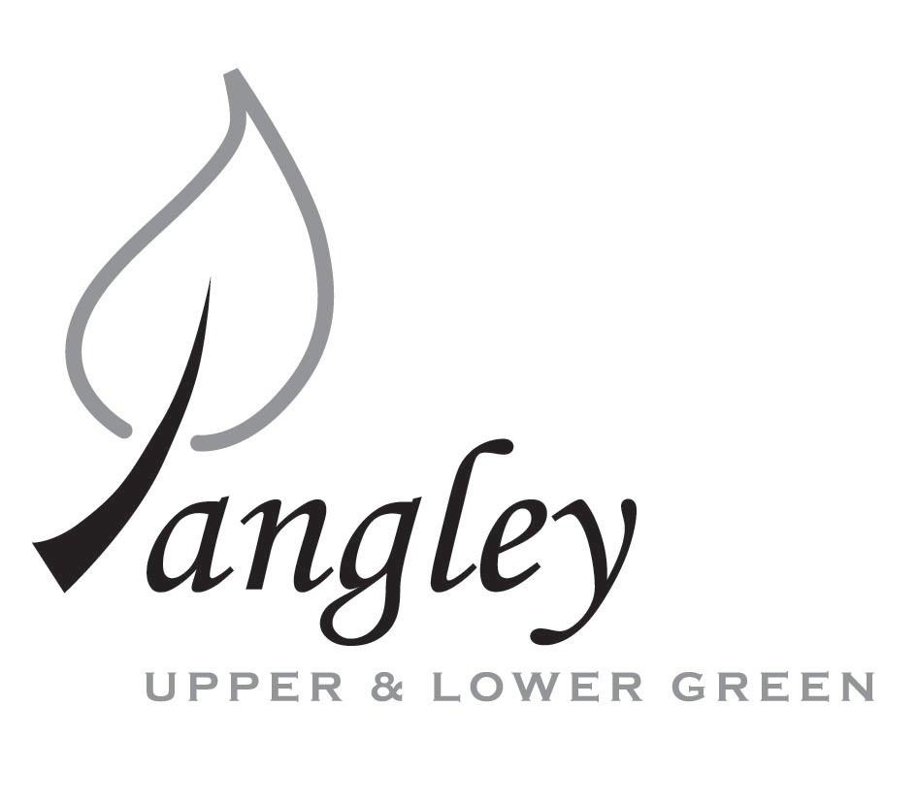
13 Princes Close, Balsham, Cambridgeshire CB21 4EE
E-mail: langleyclerk@googlemail.com
Telephone: 07539 249852

COUNCILLORS ARE SUMMONED TO ATTEND A MEETING OF LANGLEY PARISH COUNCIL
HELD AT LANGLEY COMMUNITY CENTRE, LANGLEY UPPER GREEN ON
MONDAY 11th November 2019 at 8.00pm
THE PRESS AND THE PUBLIC ARE CORDIALLY INVITED TO ATTEND

AGENDA
This Parish Council supports the rights of anyone to record this meeting but advises that anyone so recording cannot disrupt the meeting, by means of the recording and expresses the hope that the person (or persons) carrying out the recording has obtained the necessary legal advice, for themselves, to ensure they understand the rights of any members of the public who may be present who do not wish to be filmed or recorded.

1. APOLOGIES FOR ABSENCE
1.1 To receive apologies for absence.

2. DECLARATION OF INTERESTS
2.1 To declare any disclosable pecuniary, other pecuniary or non-pecuniary interests relating to items on the agenda.

3. PUBLIC PARTICIPATION SESSION WITH RESPECT TO ITEMS ON THE AGENDA AND OTHER MATTERS THAT ARE OF MUTUAL INTEREST
3.1 The maximum time allowed for this item is 15 minutes. Members of the public who wish to comment on an Agenda item should do so at this point – maximum time allowed 5 minutes per Agenda item. Any questions raised shall not require a response at the meeting nor start a debate on the question. The Chair of the meeting may direct that a written or oral response be given.

4. MINUTES OF THE LAST MEETING
4.1 Councilors are asked to agree the Minutes of the Parish Council meeting held on Monday 14th October, 2019 as a true and accurate account of the proceedings of the meetings.

5. GENERAL ADMINISTRATION
5.1 Clerk’s report to the Council
5.2 Parish Clerk attending meeting with Jane Kidd on 8th November to review monthly financial information
5.3 Approval for Christmas break regarding December meeting

6. FINANCIAL
6.1 Financial Report – Bank reconciliation as at 23rd October, the current account balance was £14,241.81. PC unpresented cheques, £426.68 resulting in a current account balance of £13,815.13 Broken down as follows: Playground funds £2,765.56; Highways Devolution Project £1,000, PC funds £10,049.57. PC deposit account £13,134.87 – reserves unrestricted of £9,134.87 and reserves restricted (playground fund) of £4,000.
6.2 Review of Cheque Run
6.3 2020/2021 Precept Planning

7. PLANNING APPLICATIONS/PROPERTY
7.1 UTT/19/2620/FUL – Unit 4 Brices Yard, Butts Green, Valance Road, Clavering. Comments to be made by 21st November 2019.

8. LANGLEY VILLAGE PROJECT
8.1 Update from Village Project representatives.
8.2 Costs associated with additional work on the lease estimated at £400 plus VAT and approx. £40 for each title. Awaiting invoice from solicitor.
8.3 Defibrillator for Community Centre – email received about grants available

9. VILLAGE GREEN
9.1 Letter developed by Cllr Rivett ‘Safeguarding of Public Land in the Parish’ sent to all Councillors for final review prior to adoption as Parish Council processes.

10. LOCAL ENVIRONMENT
10.1 RBL request to plant Oak Tree. Cllr Rivett to mark location with a stake and RBL to be notified at November meeting
10.2 Electronic Parish Communication, flyer to be approved prior to print and distribution with Village Voice
10.3 Co-option policy progress
10.4 ECC Microgrants, ideas
10.5 Withdrawl of Essex Infonet services – Latest status
10.6 Uttlesford Association of Local Councils – any further information found?
10.7 Latest from Gigaclear?
10.8 Highways Devolution update.
10.9 Village Tidy: Gareth Law has done final cut of Common Land. Dead tree opposite Bury Farm

11. PLAYGROUND
11.1 Grant application – CIF panel meeting rescheduled again to 15th November
11.2 Inspection status update and removal of concrete from playground

12. DISTRICT AND COUNTY COUNCIL
12.1 Cllr. Oliver to provide District Council report.

13. CHEQUES FOR SIGNING
13.1 Council to agree to the following cheques to be signed:
Langley Parish Council - Cheque run for 2019
Erica Williams | Clerks Salary | 101368 | £306.48
Michael Clarke | Grass Cutting | 101369 | £120.00
 |  | Total: | £426.48

14. MATTERS TO BE RAISED BY MEMBERS FOR THE NEXT AGENDA
14.1 Please note that no decisions can lawfully be made under this item. LGA 1972, Section 12 10(2)(b) states that business must be specified; therefore, the Council cannot lawfully raise matters for decision.

15. DATE OF NEXT MEETINGS
15.1 The next meeting will be on Monday 13th January 2020.

SIGNED (CLERK): | DATE:

