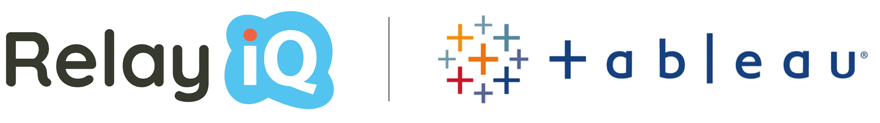

RelayiQ Notifications vs. Tableau Alerts

We are regularly asked what the difference is between RelayiQ alerts and Tableau’s native alerts. This list outlines the differences and highlights the top reasons RelayiQ and Tableau are better together.
Personalization – Chances are you don’t want everyone in your organization to get the exact same alerts. People have different roles and need to be alerted for different reasons and with different guidance. Tableau’s native alerts do not currently support this feature, and therefore were a non-starter for insights delivery right out of the gate. In contrast, RelayiQ notifications can be personalized to each recipient from a standard dashboard used by everyone.
Context – Not only can each person in your organization get a personalized alert, but each alert is context sensitive and comes along with an explanation for the notification. If I am the sales manager for the Northeast, my alerts are tied to sales performance in the Northeast and my alerts come with context (positive/negative), so I know why I am receiving them.
Prescription – So we have the “who” (personalization) and the “why” (context), but we also provide the “what.” Unlike Tableau’s native alerts, RelayiQ’s notifications include a prescription of the desired action to be taken based on the context of the message. This can include links to any location (calendar, CMS, inventory management system etc.) to drive that action.
Measurement – Are your Tableau alerts being read and acted upon? It turns out that there is no way you can answer that question with Tableau’s native alerting. RelayiQ solves this by measuring if a person clicked on a prescription link.
Escalation – If you are a sales manager for a team of 100, you may not want to be alerted each day one of your reps falls behind quota - but you may want to be alerted if they fall behind quota by 50% or more in the second half of the year. With RelayiQ, rules can be created to notify a manager on a different frequency from the recipient for an escalation path.
Availability – This one is huge. Tableau alerts are limited to marks on an axis. With RelayiQ, notifications can be set on any mark in any dashboard. No axis is required. You can essentially set an alert for anything in Tableau using RelayiQ, which is ironically not possible with Tableau’s native alerting.
Scalability – With RelayiQ, personalized notifications can be set for up to thousands of people from the same dashboard - no need to create custom views per person, which for most people is a non-starter.
Filtered – RelayiQ notifications can include filtered images of the dashboard based on each person’s personal conditions. Imagine you have a dozen regional reps working off a sales dashboard by region, and you only want them to see the portion of that dashboard that is relevant to them. With RelayiQ individual filters can be assigned to each person exposing only the aspects of a dashboard you want them to see. There is nothing like this in Tableau’s native alerts, which makes it really hard to use them at scale for insight delivery.
Self-Service Configuration – Insight alerts and notifications can quickly feel like spam if the end user does not have control over filtering their subscriptions and frequency. Only with RelayiQ can end users set simple filters, channels, and the frequency of their notifications. You can also override this feature if you are a manager who wants to guarantee your team is getting the alerts.
Channel – Tableau native alerts are set to use email, but that is not always the right communication channel depending on the use case and your company culture. RelayiQ enables three channels, offering e-mail, Slack, and SMS. Have a channel that we do not support? Let us know and we can add it!
KPIs – Every group has its own KPIs (key performance indicators). Applications in RelayiQ are created in the solution for end users to subscribe to based on their role, enabling true self-service of data-driven notifications.
Schedule/Frequency – Notifications delivery and condition checking are available as frequently as every 15 minutes, and up to one year!
Message – Rich text formatting is available to create messages to include fonts, bullets, images, etc., to enable the end user experience to be amazing and on brand.
Development – Tableau’s native alerts have remained pretty much static since they were first released. We deploy new releases with customer-driven features every few weeks.
Advanced Features – We are actively developing advanced features like anomaly detection and a trello-style action board that tracks compliance to prescriptive notifications.
Robotic Process Automation - RPA is enabled with our solution to automatically check for conditions and send out prescriptions saving significant time.

