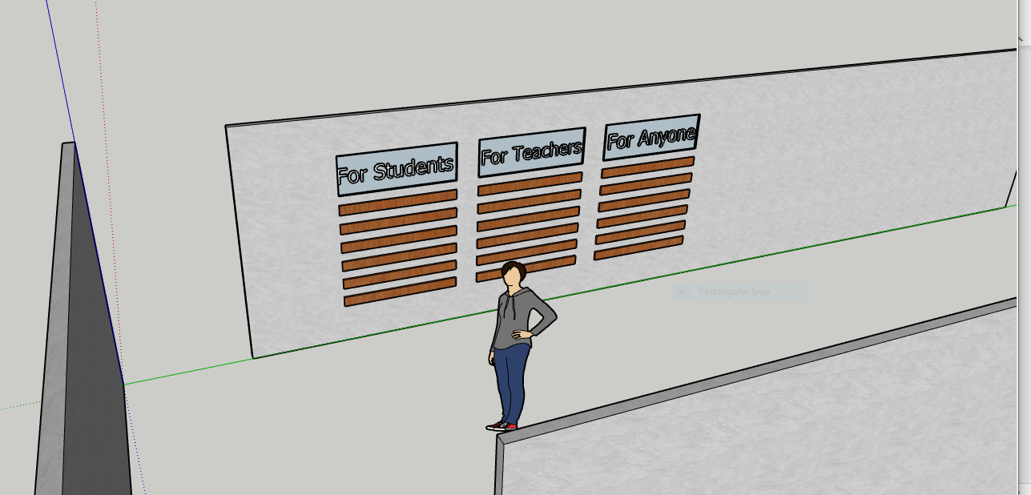Final Deliverable [Iteration 2]

**Figure 1** – Isometric View on prospective wall

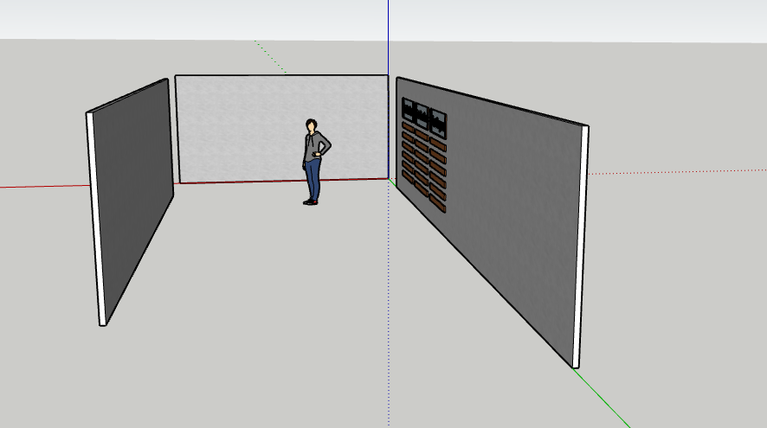

**Figure 2** – Front View featuring hallway

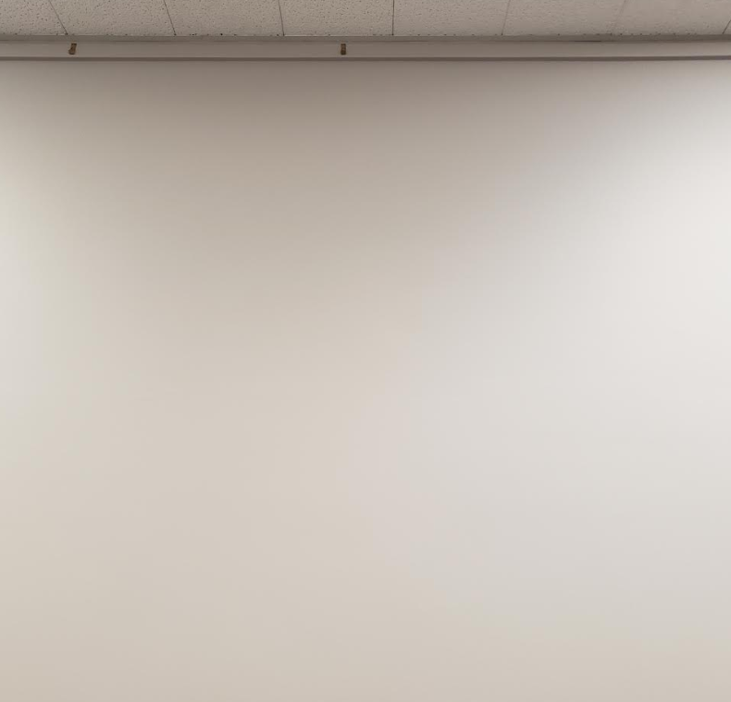

**Figure 3** – Front view of actual wall

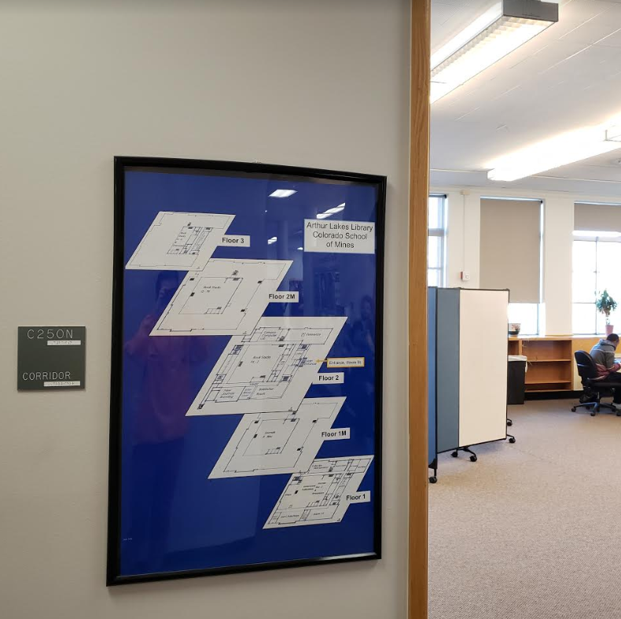

**Figure 4**– Dimetric view facing away from wall

**Figure 4**– Isometric view facing toward the wall

**Materials:**

* Five 8’5’ oak wood planks
* Laser engraver machine (found in Senior Design Lab of Brown Building Basement)
* Appropriate screws or nails for attaching boards to wall
* Tape measure
* Pencil or tool marker
* Water or laser standard level balance

