**Practicum Preliminary Plan – Best Practices List**

**Purpose**

Faculty: Give lifestyle tips and encourage faculty to talk about mental health

Students: Provide ideas for students in balancing studying/time for self-care

Everyone: Help more of the Mines community feel safe to speak about mental health and provide both faculty and students universal self-care suggestions

**Acquiring Information**

* Interviews of faculty and other employees who are willing to volunteer to be interviewed or quotes about their willingness to talk about mental health. Other faculty members could also be interviewed regarding beneficial self-care practices for faculty
* Use the social norm data form campus survey (based on the existing positive social norms within the Mines community)
* Interview students and counseling center staff about self-care tips for students

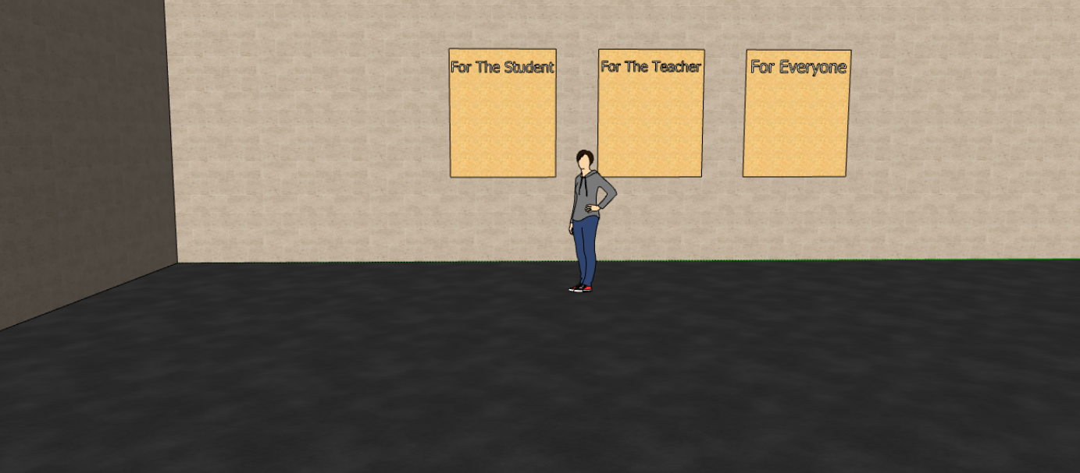**Final Deliverable**

**\*Displayed in the Student Center**

Laser-engraved lettering

Wooden Boards

Person for scale

*Phrasing of best practices list titles are subject to change