*Welcome to the Diamond Dotz Craft*

*Diamond Dotz is an amazing new craft where stunning designs are created with tiny “Diamond” like facets.*

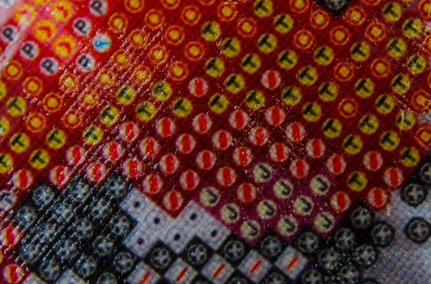 The Diamond Dotz Chart

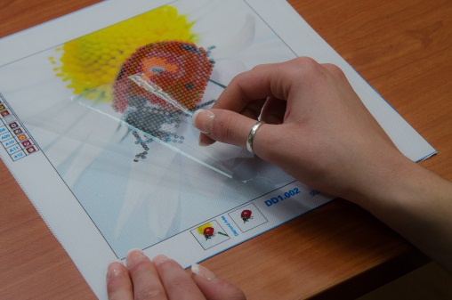 Peel back the protective film from the first area to be worked.

*TIP: Do not remove the protective film from the whole design. Rather, gradually peel back the protective film as you progress. Wash hands before working.*

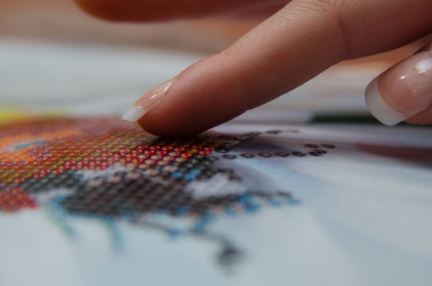 *The charted area is pre-printed with a special adhesive.*

*TIP: Take care to recover the adhesive area with the protective film when you are not working on your project. This saves the adhesive surface from becoming dry and or gathering dust.*

I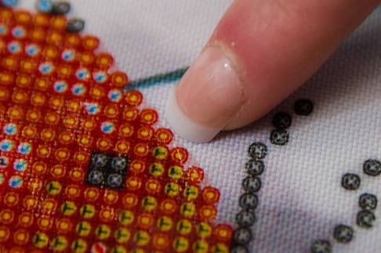 *Identify the first symbol on the chart to be worked.*

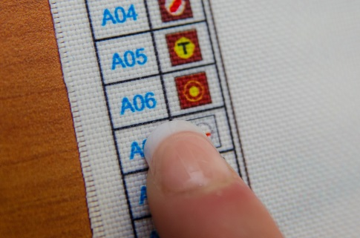 Locate the symbol & Diamond Dotz number on the key at the side of the design

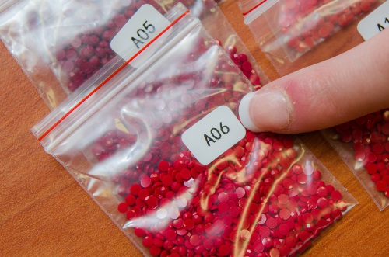 Identify the Diamond Dotz packet shade number.

*Diamond Dotz are pre-sorted by colour and each packet of Diamond Dotz is labelled with its own number.*

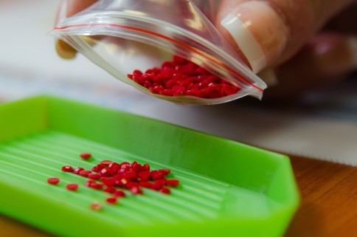 Pour the Diamond Dotz into the Diamond Dotz Tray

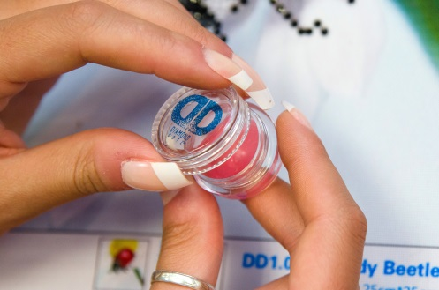 Twist open the Diamond Dotz Wax Caddy

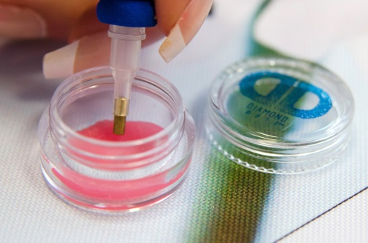 Press the head of the Diamond Dotz Stylus firmly into the wax several times before picking up your first Diamond Dotz.

*TIP: It is important to coat/load the head of your Stylus very well with wax before picking up the first Diamond Dotz. You may also move the head of the Stylus from side to side in the wax at first to ensure a good coating. Once a good coating is achieved you will not need to dip into the wax caddy so often.*

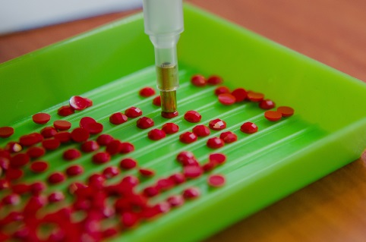 Pick up the Diamond Dotz from the Diamond Dotz Tray making sure to place the head of the Stylus over the round/faceted side*.*

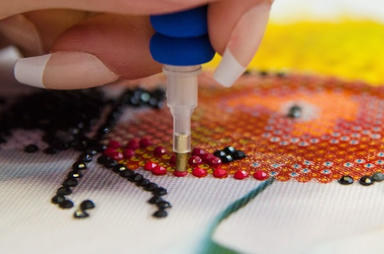 *Place the Diamond Dotz onto the corresponding symbol on the chart. The adhesive surface on the chart makes it easy to place and stick the flat side of the Diamond Dotz down.*

*Continue the process working one shade at a time.*

*TIP: It is recommended to start at the bottom edge of the design and work up. Diamonds can be re positioned after sticking however it is recommended to avoid repositioning wherever possible.*

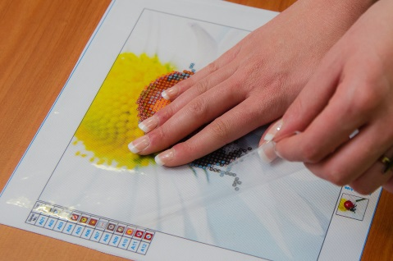 *When you are not working on your project, place the protective film back over the chart to protect it from dust.*

*TIP: Close the Diamond Dotz Wax Caddy well to stop the wax from becoming dry.*

*TIP: Wrap the head of your Diamond Dotz Stylus in plastic when not in use to prevent it from drying out.*

*Care Instructions:*

If the fabric becomes soiled during the working process it can be cleaned by gently wiping (avoid scrubbing) with a soft damp cloth. (Use cold water).

When your design is complete, lay the protective film over the top of the diamond area and (using a cylindrical container (glass bottle or rolling pin)) gently roll over to secure the diamonds on the sticky surface.

To store, roll the fabric piece (design facing in) gently.

Keep away from ink pens and paints.

Do not wash, iron or dry clean.

Assembled in China for 

[www.diamonddotz.com](http://www.diamonddotz.com)

Kit Contents:

Colour Printed Fabric Piece – 100% Polyester

Diamond Dotz pre-sorted by shade to complete the design

Diamond Dots Stylus, Craft Tray and Wax Caddy

Instruction Sheet