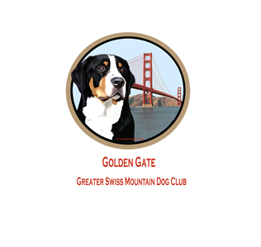You are invited to the GGGSMDC End of Summer Party!!

September 27-29,2019

1309 East Bonness Rd

Sonoma, CA 95476

Come join in on a weekend of fun and laughs with our dogs in beautiful Sonoma!

Camping is available Friday afternoon though Sunday. There is a weight pull on Friday evening and Sunday morning. There will be a Membership meeting followed by a tri-tip dinner. Saturday evening there will be a vineyard walk.

Friday 9/27: Weight pull -start time 4pm

Saturday 9/28: 12pm membership meeting, tri-tip dinner to follow, (please bring an X-pen or soft crate to put dogs up during meeting/lunch), vineyard walk in the evening

Sunday 9/29: Weight pull- start time 8am

Cost for dinner is $20.00 (kids free)

Cost for weight pull is $20.00, there will be harnesses’ available.

RSVP for camping: Paula Robles, [clocks7405@sbcglobal.net](mailto:clocks7405@sbcglobal.net)

RSVP by 9/18 for meeting and dinner: Heidi Steenstra, [hcsteenstra@gmail.com](mailto:hcsteenstra@gmail.com)

