## Upcoming Meeting!

Monthly meetings every 2nd Saturday of the month.

This month's meeting will be held on **Saturday, November 9th, 2019 at 9:30 am**

**Meeting Location:**

**We now meet at St. Luke Presbyterian Church**

**8915 Timberside Drive Houston, Texas 77025**

### **(Visible from Bethany Methodist parking lot.)**

## 

### Our speaker for November,

### Alisha Harper

### 

## Alisha Harper, a native born Houston Texan, a mother to four amazing young men Jimmy, Baron, Bastin and Blake, also a grandma to beautiful girl Bevyn Aubree, a compassionate person with drive to support others with hearing loss, and huge country girl at heart.

## Alisha was born deaf but identifies herself as hard of hearing, has a lifetime experience with hearing aids. Alisha is actively involved in the deaf and hard of hearing community and has a goal to obtain a certificate to be a CDI.

## An interesting fact about Alisha, while she loves animals, pigs are her favorite! ( oink oink). Alisha is excited to see what her future will bring as a D/HH Technology Specialist.

## Our Chapter Board Members

## Jan Connolly **President** email: janpatrice@att.net

## Allan Ofield **Past President** email: nbtawq3@yahoo.com

## Enriqueta Martinez **Treasurer** email: martinezenriqueta@yahoo.com

## Mike Quinlan **Secretary** email: mquinlan@sbcglobal.net

## Teri Wathen **Advisor** email: teriwathen@sbcglobal.com

## Lois Johnson **Advisor** email: ettalois@gmail.com

## 

## 

## 

## Upcoming Events!

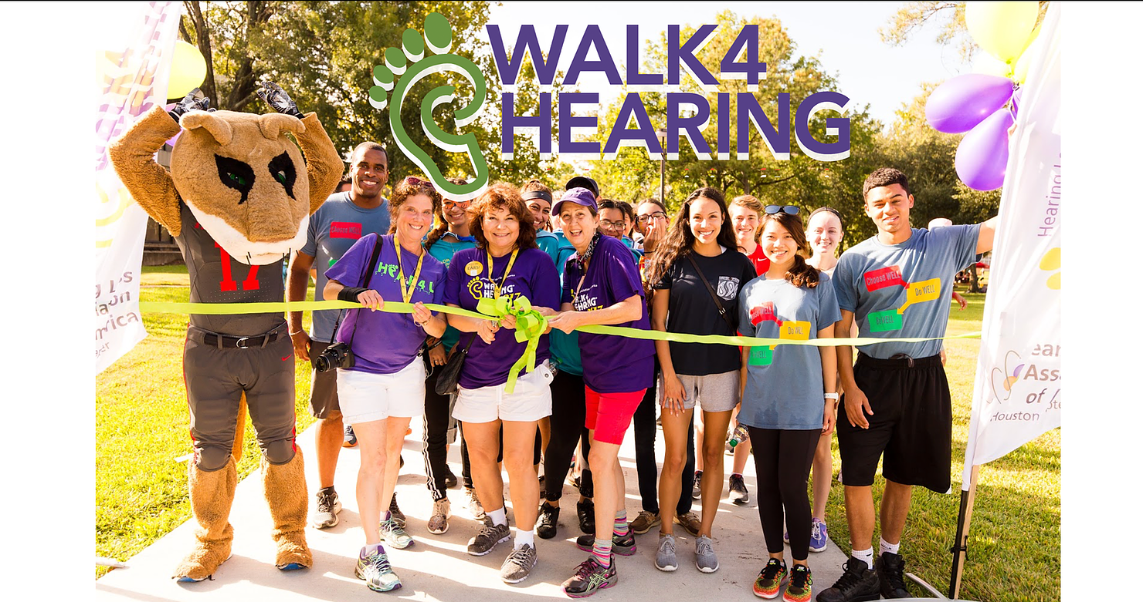

**Thank you all for joining us at the Walk 4 Hearing 2019!**

See pictures on website <http://www.hlaahouston.org>

Article to read

[From HearingTracker.com](https://www.hearingtracker.com/news/will-2020-be-the-year-medicare-starts-covering-hearing-aids)

# **Will 2020 Be the Year Medicare Starts Covering Hearing Aids?**

## **Medicare Hearing Aid Act of 2019 Takes a Step Forward in the House**

**WRITTEN BY**

## [**David Copithorne**](https://www.hearingtracker.com/news?author=david-copithorne)

Content Director

20 October 2019

Anyone who has spent thousands of dollars on [hearing aids](https://www.hearingtracker.com/hearing-aids/) can tell you that private health insurance [rarely covers](https://www.hearingtracker.com/hearing-aid-insurance-coverage) much—*or any*—of the cost. And how much of the cost do you think Medicare insurance will cover when you turn 65 years old?

**You guessed it**: *zip, zero, nada.*

Two members of the U.S. House of Representatives have set out to change that distressing fact of life for millions of seniors living with untreated [hearing loss.](https://www.hearingtracker.com/hearing-loss) This past week, the House Energy and Commerce Committee passed the [Medicare Hearing Act of 2019 (H.R. 4618](https://mcbath.house.gov/2019/10/mcbath-dingell-legislation-to-improve-seniors-access-to-hearing-aids-under-medicare-passes-house-committee)[)](https://mcbath.house.gov/press-releases?id=CA5B2ABC-BA9C-4204-A3AC-AC0EC32F54D8). Sponsored by Rep. Lucy McBath (D-Georgia) and Rep. Debbie Dingell (D-Michigan), it amends the Social Security Act to provide **insurance coverage for hearing aids** and hearing health services under Part B of the Medicare program.

[**Rep. Lucy McBath✔**@RepLucyMcBath](https://twitter.com/RepLucyMcBath) My bill with [@RepDebDingell](https://twitter.com/RepDebDingell) to make hearing aids affordable under Medicare was APPROVED late last night by the [@EnergyCommerce](https://twitter.com/EnergyCommerce) Committee!

We will make health coverage work [#ForThePeople](https://twitter.com/hashtag/ForThePeople?src=hash) & for America's seniors.

It’s only the first step in a long legislative process, and there are some notable [coverage limitations](https://www.hearingtracker.com/news/will-2020-be-the-year-medicare-starts-covering-hearing-aids#a-coverage-limitations), but it’s a promising start. And with 10,000 Baby Boomers turning 65 every day, it comes at a time when lawmakers are increasingly aware of the growing problem of hearing loss in the U.S. population.

## **Preventing devastating medical consequences of hearing loss**

## 

“Far too many people go without hearing aids because they are **too expensive**,” Rep. McBath said in a news release. Rep. Dingell added that the coverage is necessary because hearing loss “can lead to a sense of isolation and other negative health impacts.”

The two representatives drew on groundbreaking [research](https://www.ncbi.nlm.nih.gov/pmc/articles/PMC3277836) developed by Frank R. Lin, M.D., Ph.D, and others at Johns Hopkins University to make their case that Medicare coverage for hearing aids can **help prevent devastating medical consequences** of hearing loss:

Hearing loss affects nearly **48 million Americans** and, left untreated, “has serious emotional, social and medical consequences for older adults.”Older adults with hearing loss are 32% more likely to require hospitalization, face a 24% increased risk for **cognitive impairment**, and increasingly suffer from isolation and depression.A 10-year longitudinal Johns Hopkins study found that patients with hearing loss had a higher probability of developing **dementia**, with the probability rising as the severity of hearing loss increased.

[**Frank R. Lin, MD PhD** @DrFrankRLin](https://twitter.com/DrFrankRLin) "I was *thrilled* to see the Medicare Hearing Act reported successfully out of the House E&C Committee yesterday. This is the first hearing bill that leverages the impact that the bipartisan OTC Hearing Aid Act of 2017 will have on reshaping hearing care in the US."

Seniors fitted with hearing aids, on the other hand, show **lower rates of social isolation and other ill effects of hearing loss.** A [2019 study](https://www.sciencedaily.com/releases/2019/09/190905080110.htm) at the University of Michigan found that older adults fitted with hearing aids have a lower risk of being diagnosed with dementia, depression or anxiety, and a lower risk of suffering fall-related injuries, than those who leave their hearing loss uncorrected.

## **Momentum builds for a legislative solution**

## 

Representatives McBath and Dingell aren’t the only legislators addressing the hearing loss problem. In the U.S. Senate, Elizabeth Warren (D-Massachusetts) and Rand Paul (R-Kentucky), are another political duo promoting hearing assistance. Their [Medicare Audiologist Access and Services Act of 2019](https://www.warren.senate.gov/imo/media/doc/Medicare%20Audiologist%20Access%20and%20Services%20Act%20Fact%20Sheet.pdf) ensures seniors and people with disabilities on Medicare have **access to a full range** of hearing and balance health care services provided by licensed audiologists.

Among other things, it **eliminates the requirement** that patients get a referral from an MD before accessing audiology services. Rep. Tom Rice (R-S.C.) introduced identical companion legislation in the House of Representatives.

“Seniors who suffer from hearing conditions **shouldn’t have to jump through hoops** to see their preferred audiologist,” said Rice. “The Medicare Audiologist Access and Services Act cuts through the red tape to help Medicare patients access quality, affordable care. I will continue to reach across the aisle to find straightforward solutions to health care problems.”

In the meantime, the FDA is currently writing rules to implement the [Over-the-Counter Hearing Aid Act](https://www.hearingtracker.com/over-the-counter-hearing-aids), which will enable manufacturers of hearing aids to sell lower-cost hearing aids directly to consumers. Warren sponsored that bill along with Republican Sen. Chuck Grassley of Iowa.

[**Elizabeth Warren✔**@ewarren](https://twitter.com/ewarren) "Washington is deeply broken, but sometimes we can still work together to get things done. The bill I passed will allow hearing aids to be sold over-the-counter like eyeglasses. It will make a huge difference for millions of people."

## **A promising start on a long road to passage of legislation**

## 

The Medicare Hearing Aid Act has a long road ahead of it before it becomes law. It still requires a vote by the entire House of Representatives. Then the **U.S. Senate** will have to consider and pass the same legislation. And finally, the president will have to sign the new law.

However, the Act is already off to a strong start, having **passed an important initial milestone** with the successful committee vote. And it’s worth keeping in mind that the House Energy and Commerce Committee, established in 1795, just happens to be the oldest continuous standing committee in the House of Representatives. And it also has the broadest jurisdiction of any authorizing committee in Congress. When it speaks up on a bill, the rest of Congress listens.

## **Coverage limitations**

## 

The Medicare Hearing Act of 2019 includes the following limitations for coverage:

- Medicare will only pay for one pair of hearing aids every five years

- Coverage will only be provided to those with severe-to-profound hearing loss

- Over-the-counter hearing aids are not covered

- A written order from a doctor or qualified audiologist will be required

Article to read

[From HearingTracker.com](https://www.hearingtracker.com/news/will-2020-be-the-year-medicare-starts-covering-hearing-aids)

**WRITTEN BY**

## [**David Copithorne**](https://www.hearingtracker.com/news?author=david-copithorne)

Content Director

20 October 2019



## 

## 

**We are *HEAR* for you!**

### The Hearing Loss Association of America Houston Chapter is your local support group and organization for the deaf and hard of hearing of Houston, Texas. We wouldn't be here helping those in need without YOU! We are continuously growing in support, technology, and resources to help all who we can.

### 



### 

C0set Media Management

With the internet & media rapidly growing, I am here to help the HLAA Houston Chapter reach those in need of support and to raise awareness of hearing loss to audiences through social media, thus giving the organization more outreach than ever before.



Want to add a caption to this image? Click the Settings icon.

## C0set

## Photography, Videography, Editing, Website Development, Social Media Management

## 

## 

## 

## 





Want to add a caption to this image? Click the Settings icon.

## **Follow us on social media! @HLAAHOU**

## 







## 



## 

This concludes our November E-newsletter of 2019!

A special thank you to the readers and sponsors supporting the HLAA Houston chapter. The best is yet to come!