Good ESOP Candidates and ESOP Myths
By Kyle Seymour and Lee Eisenstaedt

Good ESOP Candidates
ESOPs are not for everyone and every company. The best candidates have a track record of stable, predictable profits and cash flow. Other characteristics of good candidates include:
- C or S taxed corporations
- Owners needing an exit or desire some liquidity
- Founders and owners who want to preserve their legacy
- An ownership group that doesn’t want to sell to private equity
- Non minority-status businesses (because the ESOP is counted as a non-minority shareholder which limits the ESOP to owning 49% of the company’s stock)
- Companies with W-2 employees, not 1099-contractors as with many real estate and insurance agencies
- Succession management team is or will be in place
- Companies that are large enough to justify installation and maintenance expenses – typically, at least 30 employees with annual sales of at least $5 million
ESOP Myths
There are some misconceptions about the rules and regulations under which ESOPs operate. Common myths include:
- By selling your company to an ESOP, all of the employees will have access to your financial records, details of your compensation package, etc. and will even have the right to tell you how to run things. FACT – the ESOP is a passive investor. While some companies choose to have open books, it’s neither required nor a standard practice. The required disclosure of financial information is limited to share values in participants’ accounts, which is determined by a third party valuation firm each year.
- With an ESOP, the employees can vote you out of the company you founded or built. FACT – again, the ESOP is a passive investor whose shares are voted by the ESOP trustee who is selected by the Board of Directors.
- If you form an ESOP, you cannot take care of management and key employees. FACT – ESOPs are allowed to offer other forms of deferred compensation including 401(k), phantom stock, incentive stock options (ISOs) and stock appreciation rights (SARs).
- You can make more money selling to a third party. FACT -- Many times the net proceeds to an ESOP will actually be higher when you factor in the transaction costs and the seller's tax treatment.
- Employees won’t understand or appreciate the ESOP. FACT -- Because the majority of the plan’s assets are company stock, it may actually be easier to understand an ESOP than other retirement plans. Employees can see their account balance change over time and many ESOPs have communication and education plans for their participants.

About the Authors
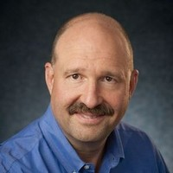
Kyle Seymour Kyle Seymour is President and CEO and a member of the board of directors of S&C Electric Company, a 100% ESOP-owned S corporation, headquartered in Chicago, Illinois. Prior to joining S&C, Kyle was Chairman, President and CEO of Xtek, Inc. A veteran of the machine tool industry, he served as Senior Vice President at UNOVA, Inc., Group Vice President–Machine Tools at Milacron, and as Chairman of the board of directors of Hardinge, Inc. Kyle currently serves on the board of governors of the National Electrical Manufacturers Association (NEMA), where he is a member of the Executive Committee of the Board of governors and Chair of its Strategic Initiatives and Councils Committee. Past industry board of directors’ service includes: American Gear Manufacturers Association (AGMA); and the Association for Manufacturing Technology (AMT), where he also served on its government relations committee.

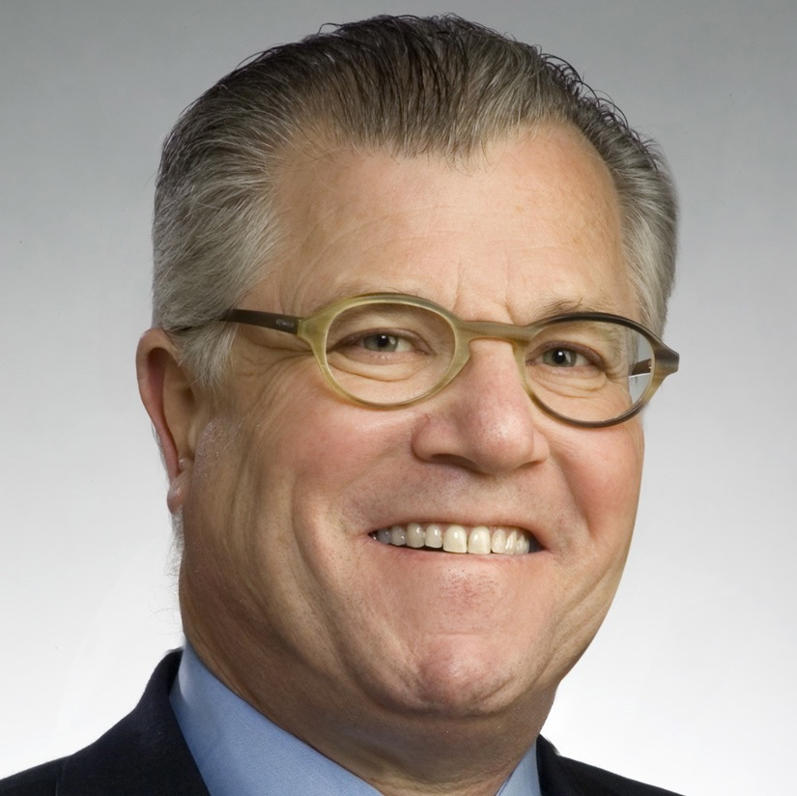
Lee Eisenstaedt the Founder of the Leading With Courage®️ Academy in Chicago who provides succession planning and leadership development consulting primarily to ESOP organizations (http://www.lwcacademy.com ). He’s a member of both the National Center for Employee Ownership (NCEO) and Private Directors Association (PDA). Lee has written four books on leadership and is a certified/authorized trainer/partner of Everything DiSC®, Five Behaviors of a Cohesive Team®, Genos suite of emotional intelligence assessments, and Engagement Multiplier®. Prior to founding LWCA, Lee spent nearly 25 years as a senior finance and operations executive in the US and Europe with SC Johnson & Son and was a two-time COO with a Top 5 and a Top 50 CPA firm.

