As we’ve explored purpose these past few weeks, we’ve talked about how your GPS guides you to the places you can have the greatest impact. To recap, your GPS includes your:
Exploring Your GPS: Examples to Guide the Way
Gifts—what you’re naturally good at  Passions—the things that matter most to you  Significant experiences—circumstances that have shaped who you are | 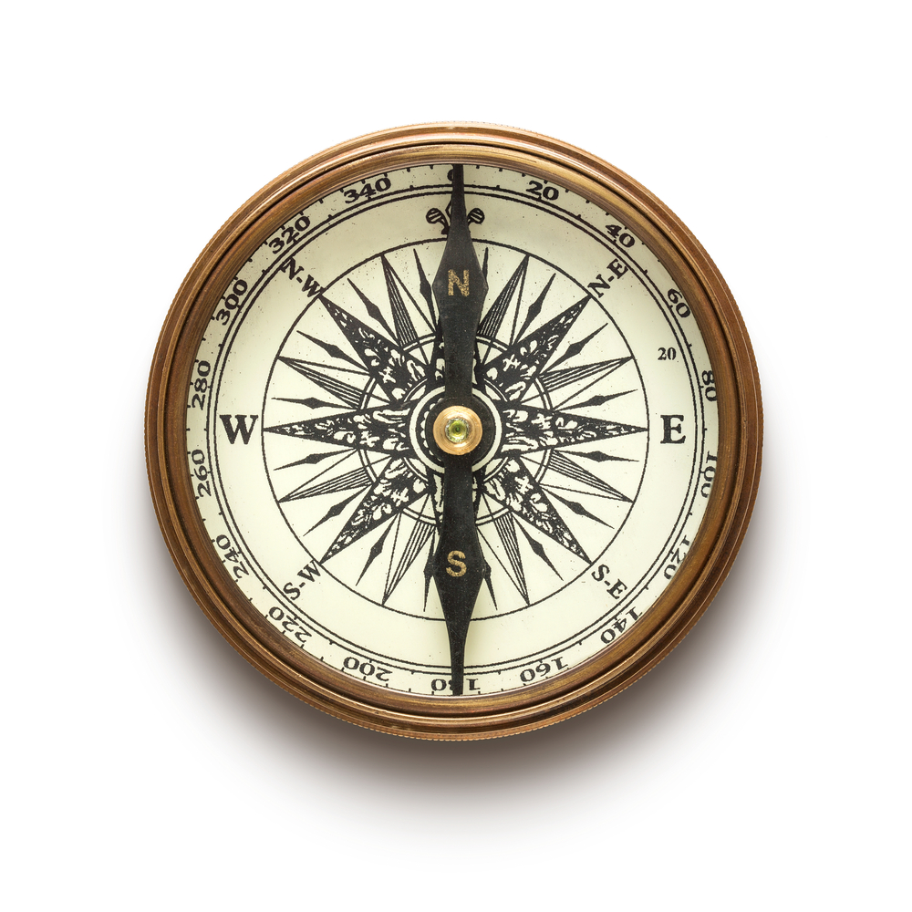
Your purpose is broader than your job/career or family. It’s a common thread that runs through the various areas of your life. One approach to gain insights into possibilities is to look at different combinations of your particular G, P and S. Examples…

Susan
- Key Gifts: creative, observant, warm
- Passions: connecting with others, art, working with her hands
- Experiences: styling her friends’ hair in high school and seeing their confidence soar

Purpose: To make people feel beautiful by styling their hair to express who they are.

How she lives it: With her family at home, in her job as a hairstylist, as a volunteer at her local homeless shelter.

Ansley
- Key Gifts: compassion, sensitivity, accepting, wise
- Passions: animals of any kind, working with children, books
- Experiences: having learning disabilities that caused her to struggle in school

Purpose: To show young people with learning disabilities that they can still excel in life.

How she lives it: By using pet therapy in tutoring sessions at local schools; encouraging anyone she encounters with a family member who has learning difficulties to get resources that allow them to learn in the ways that are best for them.

Thomas
- Key Gifts: creative, intelligent, persistent, inspiring
- Passions: entrepreneurship, adventure (sports, travel)
- Experiences: starting up and selling four profitable companies

Purpose: To help young entrepreneurs ignite their ideas.

How he lives it: Speaks at grad schools, business conferences and incubators; coaches entrepreneurs one-on-one (both pro bono and for profit); teaches business skills at Junior Achievement chapters.

Susan
- Key Gifts: optimistic, encouraging, intuitive, communicative
- Passions: listening to live music, refinishing furniture, traveling
- Experiences: has been through difficult challenges in life but emerged
stronger and with a positive outlook

Purpose: To bring out the best in others.

How she lives it: Being intentional about having positive contact with everyone she encounters – at home, work, the grocery store, the gas station, in her neighborhood…

May these examples help stoke the fire on your journey toward your purpose!

