Meeting Agenda
Red Rock Pastel Society of Nevada welcomes Members! Everyone please sign in! New member and board introductions. Order of the day.
- Vision and Goals of Society
Members share their outlook and goals for new society. Please share your experience of being a member. And what do you expect?
- Membership
We are working on providing our members benefits unique to Red Rock.
Members will receive 10% Off Coupon for Dakota Art Pastels in the mail.
Girault Special Offer. Samples from sponsor partners to try after the Demo.
- Meetings
Meetings for 2019 will be planned 2-3 weeks in advance. Goal is to meet every or every over month. With paint ins and plein airs scheduled in between.
- Workshops and Exhibitions
  - March 15th 2019 – entry deadline for Red Rock 1st Online Exhibition
  - Richard McKinley Workshop November 8-10 2019
  - Local Show in October-November 2019
  - Whom are you looking forward to see in 2020-2021
- Social Media

- David Gilmore Demo
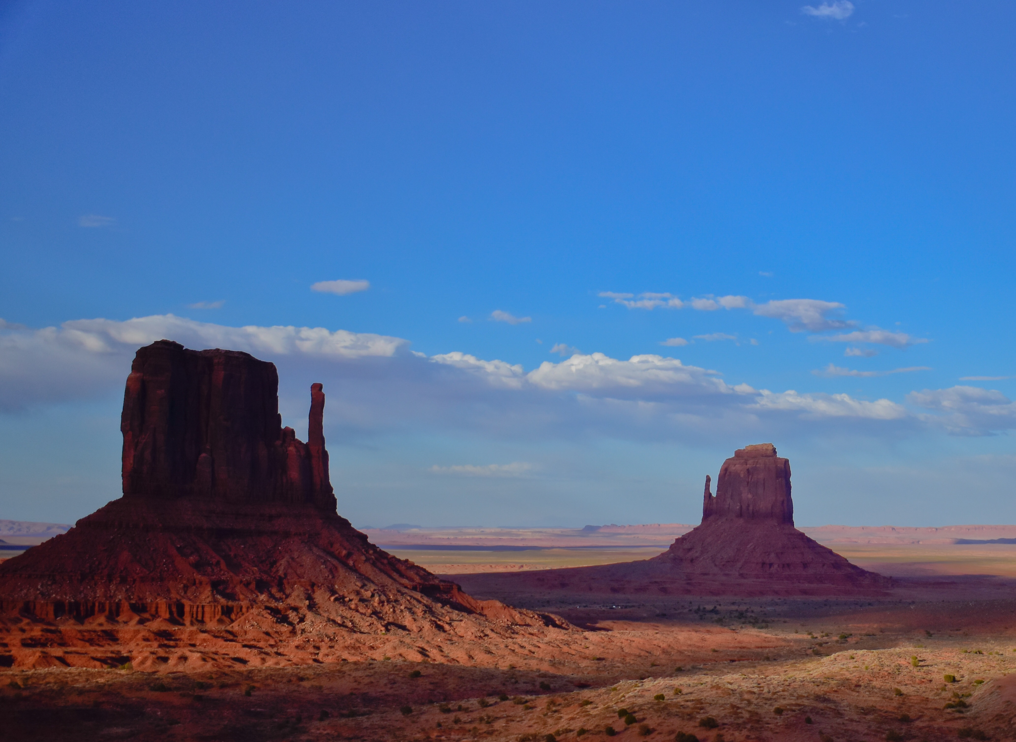
- Samples for you to try and to keep.
- Paint in – optional
Thank you for being a member of RED ROCK!

