**A LOW COST SPIROMETR**

A

MINOR PROJECT

REPORT

Submitted by

SHIVAM TRIVEDI(160305111006)

SANJAY HADIYA (160305111002)

BACHELOR OF ENGINEERING IN

INSTRUMENTATION & CONTROL ENGINEERING

UNDER THE GUIDENCE OF

Ms DIMPAL KHAMBHATI



MARCH 2019

FACULTY OF ENGINEERING AND TECHNOLOGY

(PIT)

VADODARA

GUJARAT

**CERTIFICATE**

This is to certify that

The project report entitled **“A LOW COST SPIROMETER”** submitted by Mr.**SHIVAM** **TRIVEDI** (Enrollment number **160305111006**) in the department of biomedical engineering at **Parul Institute of Technology.** The work carried out by her under Ms.**Dimpal Khambhati** guidance and supervision. The work submitted, in my opinion, has reached to level required for being accepted for the examination. The mattersembodied in this project report, to the best of my knowledge, have not been submitted to any other university or institute.



**Date of submission:**

**Place:**

**CERTIFICATE**

This is to certify that

The project report entitled **“A LOW COST SPIROMETER”** submitted by Mr.**SANJAY HADIYA** (Enrollment number **160305111002**) in the department of biomedical engineering at **Parul Institute of Technology.** The work carried out by her under Ms. **Dimpal Khambhati** guidance and supervision. The work submitted, in my opinion, has reached to level required for being accepted for the examination. The matters embodied in this project report, to the best of my knowledge, have not been submitted to any other university or institute.



**Date of submission:**

**Place:**

**ABSTRACT**

A spirometer is an apparatus for measuring the volume of air inspired and expired by the lungs. A spirometer measures ventilation, the movement of air into and out of the lungs. The Spiro gram will identify two different types of abnormal ventilation patterns, obstructive and restrictive. There are various types of spirometers which use a number of different methods for measurement (pressure transducers, ultrasonic, water gauge).Through a set of medical tests it is used to identify and quantify defects and abnormalities of various lung conditions in human respiratory system .These tests also help in monitoring the response of lungs to medical treatment.

**ACKNOWLEDGEMENT**

It gives me immense pleasure to express my deepest sense of gratitude and sincere thanks to my highly respected and esteemed guide Ms **Dimpal Khambhati** PIT, PU Vadodara. For their valuable guidance, encouragement and help for completing this work. Their useful suggestions for this whole work and co-operative behaviour are sincerely acknowledged.

I would like to express my sincere thanks to principle of PIT for giving me this opportunity to undertake this project.

I would also wish to express my gratitude’s to Dr. **Poonam Mondal** HOD (Biomedical Engineering)for her kind hearted support.

I also wish to express my indebtedness to my parents as well as family members whose blessings and support always helped me to face the challenges ahead.

At the end I would like to express my sincere thanks to all my friends and others who helped me directly or indirectly during this project work.

**PLACE: Limda SHIVAM TRIVEDI (160305111006)**

**DATE: SANJAY HADIYA (160305111002)**

**TABLE OF CONTENT**

|  |
| --- |
| Certificate |
| Abstract |
| Acknowledgement |
| Chapter 1: Introduction   * 1. Introduction   2. Application   3. Advantage   4. Limitations   5. Objectives of the project   6. Significance of the project |
| Chapter 2: Literature Review  2.1 Literature Review |
| Chapter 3: Proposed systems  3.1 list of components  3.2 methodology  3.3 block diagram |
| Chapter 4: Conclusion  4.1 Future Scopes  4.2 Conclusion  4.3 References |

**CHAPTER-1**

* 1. **Introduction**

The rural areas in India don’t have as many medical facilities as those available in the urban areas. Hence, people face a lot of problems in getting treatment or even at times receiving suitable emergency aid. The surveys conducted on this topic with pulmonologists revealed many issues which are faced by them while treating patients who are suffering from pulmonary diseases. These problems persist not only in cities but also in rural areas. The cost of the spirometers used in testing is very high; also, accessibility is a major issue when it comes to remote areas. Thus, the proposed device is aimed mainly at the aforementioned issues.

**1.2 Applications**

* Diagnose certain types of lung disease (such as asthma, bronchitis, and emphysema)
* Find the cause of shortness of breath
* Measure whether exposure to chemicals at work affects lung function
* Check lung function before someone has surgery

**1.3 Advantages**

* Spirometers gently exercise the lungs and aid in keeping the lungs as healthy as possible.
* This is a low cost device as compared to the one that are present in the hospitals for testing the patients.
* Rural areas people can afford the test of their pulmonary organ.
* Low power consumption.

**1.4 Limitations**

* The mouthpiece is changed per patient and if not changed then infection can occur.
* Sometimes the accuracy is not achieved if proper flow of air is not exhaled.

**1.5 Objective of the project**

The main objective of this project is to develop the spirometer that is low in cost and is efficient to rural peoples.

* To enhance the performance of the pulmonary diagnostic tests.
* To develop the algorithms for measurement of the accurate value by the parameter.

**1.6 Significance of the project**

* The spirometer is used to detect the amount of air we breath in and out of our lungs.
* Volume of air inhaled and exhaled air can be measured.
* It detects various disease like AASTHMA,CHRONIC DYSPNEA.

**CHAPTER-2**

**Literature Review**

|  |  |  |  |  |  |
| --- | --- | --- | --- | --- | --- |
| Sr.no | Author | Title of paper | Conclusion | Journal and publisher name | Publication  Year |
| 1 | Shripad S. Bhatlawande, Jayant Mukhopadhyay and Manjunatha Mahadevappa | Ultrasonic Spectacles and Waist-belt for Visually  Impaired and Blind Person | This wearable electronic navigation system is used for indoor, and outdoor locomotion with less training. | IEEE | 2012 |
| 2 | John A.Brabyn | New developments in the mobility and orientation aids for the blind | The user gets the guidance of directions he needs to move to reach his destination. | IEEE | April, 1982 |

**CHAPTER-3**

**3.1 List Of Components**

1. **Arduino uno R3**

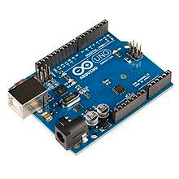

The Arduino UNO is an open-source microcontroller board based on the Microchip ATmega328p  microcontroller and developed by Arduino.cc. The board is equipped with sets of digital and analog input/output (I/O) pins that may be interfaced to various expansion boards (shields) and other circuits. The board has 14 Digital pins, 6 Analog pins, and programmable with the Arduino IDE (Integrated Development Environment) via a type B USB cable. It can be powered by a USB cable or by an external 9 volt battery, though it accepts voltages between 7 and 20 volts.

1. **Ultrasonic sensors (HC-SR04)**

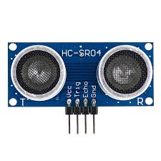

The HC-SR04 ultrasonic sensor uses SONAR to determine the distance of an object just like the bats do. It offers excellent non-contact range detection with high accuracy and stable readings in an easy-to-use package from 2 cm to 400 cm or 1” to 13 feet.

1. **Voice recording and playback module**

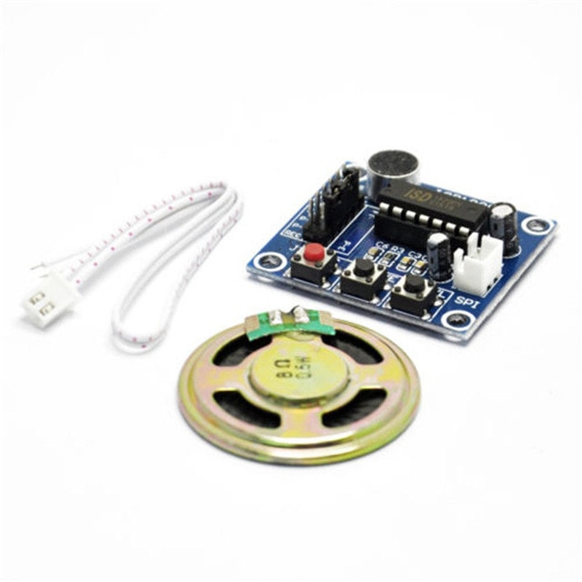

This module is base on ISD1820, which a multiple-message record/playback device. It can offers true single-chip voice recording, no-volatile storage, and playback capability for 8 to 20 seconds. The sample is 3.2k and the total 20s for the Recorder.

This module use is very easy which you could direct control by push button on board or by Microcontroller such as Arduino, STM32, ChipKit etc. Frome these, you can easy control record , playback and repeat and so on.

**3.2 Methodology**

* This project presents and electronic navigation system for visually impaired and blind people. This system understands obstacles around the subject up to 500cm in left, right and front direction using a network of ultrasonic sensors. It calculates distance of the detected object form the subject and prepares navigation path accordingly avoiding obstacles. It uses feedback to aware the subject about the detected obstacle and its distance. This proposed system uses Arduino Uno R3 micro controller based embedded system to process real time data collected using ultrasonic sensor network. Based on the direction and distance of detected obstacle, relevant pre-recorded speech message stored in APR9600 flash memory is invoked. Such speech messages are conveyed to the subject using earphones.

**3.3 Block Diagram**

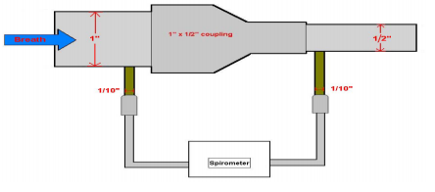

**CHAPTER-4**

**4.1 Future scopes**

* In future our proposed model can be made more efficient. With more advanced technologies coming up , it can be incorporated to make it more accurate.
* Also, it can be made more hygienic. As it is handy and portable in use it can be made available to many patients in rural areas.
* Other important measure that can be taken is to make people learn about how to handle this model especially in rural areas, so as to ensure that the model is properly used and better results can be displayed.
  1. **Conclusion**
* In this project, we had configured and implemented a low cost spirometer with a differential pressure transducer being the heart of the device and tested its feasibility and reliability with a simple experimental setup.
* On the other hand we obtained the real time graph of mass flow versus volume using a simulation software.

**4.3 References**

[1] Shripad S. Bhatlawande, Jayant Mukhopadhyay, Manjunatha Mahadevappa ,“Ultrasonic Spectacles and Waist-belt for Visually Impaired and Blind Person”, IEEE, 2012.

[2] Sushant Mahalle, Himanshu Lokhande, “Ultrasonic Spectacles and Waist-belt for Visually Impaired and Blind Person”, ISOR Journal of Engineering, 2014.

[3] John A.Brabyn, “New developments in the mobility and orientation aids for the blind”, IEEE, April,1982

[4] Zaid O. Abu-Faraj, Elie Jabbour, Paul Ibrahim, Anthony Ghaoui, “Design and Development of a Prototype Rehabilitative Shoes and Spectacles for the Blind”, IEEE, 2012.