EVOLUTION OF CANCER CELLS THROUGH VARIOUS SPECIES
A
MINOR PROJECT
REPORT

Submitted by
JOVAN SENKYA (160305111005)
DIRGHAU PATEL (160305111004)

BACHELOR OF ENGINEERING IN
BIOMEDICAL ENGINEERING

UNDER THE GUIDANCE OF
Dr. DHIRAJ MEHTA


MARCH 2019
FACULTY OF ENGINEERING AND TECHNOLOGY
(PIT)
VADODARA
GUJARAT

CERTIFICATE

This is to certify that

The project report entitled “EVOLUTION OF CANCER CELLS THROUGH VARIOUS SPECIES” submitted by Mr. JOVAN SENKYA (Enrollment number 160305111005) in the department of Biomedical Engineering at Parul Institute of Technology. The work carried out is under the guidance and supervision of Dr. DHIRAJ MEHTA. The work submitted, in my opinion, has reached to level required for being accepted for the examination. The matters embodied in this project report, to the best of my knowledge, have not been submitted to any other university or institute.



Date of submission:
Place:
CERTIFICATE

This is to certify that

The project report entitled “EVOLUTION OF CANCER CELLS THROUGH VARIOUS SPECIES” submitted by Mr. DIRGHAU PATEL (Enrollment number 160305111004) in the department of Biomedical Engineering at Parul Institute of Technology. The work carried out is under the guidance and supervision of Dr. DHIRAJ MEHTA. The work submitted, in my opinion, has reached to level required for being accepted for the examination. The matters embodied in this project report, to the best of my knowledge, have not been submitted to any other university or institute.

Date of submission:
Place:

ABSTRACT

The object of this project is to trace the evolution of cancer cells through various species that include homo sapiens, Pan Troglodytes, Canis Lupus familiaris, Bos Taurus, Mus musculus, Rattus norvegicus, Gallus gallus, Xenopus tropicalis and Danio Rerio. It involves comparison of genetic makeups of a particular type of cancer affecting various members of the animal kingdom and are retrieved from biological databases after which their various FASTA or code word formats are aligned together to detect their similarities. Alignment which is done by a special tool in the biological database called the Basic Alignment Search Tool allows for entry of a reference code sequence as well as the sequences to be compared that are called query sequences.
The effectiveness of the project is that it lends a helping hand in the eradication of illegal hunting or poaching, by comparing products made from organisms with their respective DNA sequences. It is also helpful in predicting the evolution that is about to take place for a certain group of species based on historical data obtained. Moreover, the development of a new pathway to cure or terminate cancerous cells in different organisms.

ACKNOWLEDGEMENT

It gives me immense pleasure to express my deepest sense of gratitude and sincere thanks to my highly respected and esteemed guide Dr. DHIRAJ MEHTA, PIT, PU Vadodara for their valuable guidance, encouragement and help for completing this work. Their useful suggestions for this whole work and co-operative behaviour are sincerely acknowledged.
I would like to express my sincere thanks to principle of PIT for giving me this opportunity to undertake this project.
I would also wish to express my gratitude’s to Dr. POONAM MONDAL, HOD (Biomedical Engineering) for her kind hearted support.
I also wish to express my indebtedness to my parents as well as family members whose blessings and support always helped me to face the challenges ahead.
At the end I would like to express my sincere thanks to all my friends and others who helped me directly or indirectly during this project work.

PLACE: Limda JOVAN SENKYA (160305111005)
DATE: DIRGHAU PATEL (160305111004)

TABLE OF CONTENT
Certificate
Abstract
Acknowledgement
Chapter 1: Introduction
  - Introduction
  - Application
  - Advantages
  - Limitations
  - Objectives of the project
  - Significance of the project

Chapter 2: Literature Review

Chapter 3: Proposed systems
3.1 List of species
3.2 Methodology
3.3 Result
Chapter 4: Conclusion
4.1 Future Scopes
4.2 Conclusion
4.3 References

CHAPTER-1

  - Introduction

Development of cancer has been a mystery for a long time especially in humans. This project is expanding the scope of affected organisms to frogs, wolves, rats, mice, birds as well as cattle so as to view how their cancer cells and genes compare with the humans.
Use of biological databases such as the National Centre for Biological Information can be used to determine the different word sequences associated with all their species and perform an alignment to make the comparison.
NCBI is maintained by the National Library of Medicine (NLM) and National Institute of science (NIH) which provides us with the protein sequence of the query and reference organisms. It will be provided in FASTA format (single letter annotations to amino acids), which will then be fed into BLAST for matching of the reference and query sequences.
1.2 Applications
- Track down evolutionary history of infectious bacteria and viruses.
- Measure phylogenetic diversity.
- Guide our search for new species.
- Find out how species spread geographically in their evolution.
- Conservation of biological species (illegal whale hunting).
- Epidemiology (predictive evolution).
- Gene function prediction and drug development.

1.3 Advantages
- Simple, authenticated and reliable.
- Can be applied to extinct species.
- Easy to understand.
- Branches arranged in accordance with the nearest matching taxon.
- Unlimited species can be compared.

1.4 Limitations
- BLAST is time consuming, depending on the number of query sequences.
- Editing is required before adding the reference and query sequence to BLAST.
- Phylogenetic trees do not decipher the amount of generic change occurred in each evolutionary step.

1.5 Objective of the project
The main objective of this project is to align genetic build of Prostate cancer cells (Tumour suppressor candidate 3) among taxa that are prone to it. Level of similarity between how the cancer cells grow in the different species is to be assessed relating to a reference species and is to be presented in a linear model.

1.6 Significance of the project
- Useful for discovering new pathways for cancer treatment.
- To put an end to poaching by matching organism DNA to its product verifying illegal trade between two parties.
- Predicting the evolution of a certain species of organisms based on the taxon evolution history of that organism.ss

CHAPTER-2
Literature Review
Sr.no | Author | Title of paper | Conclusion | Journal and publisher name | Publication  Year
1 | Thomas. G. Graeber, Katharine Ellwood-Yen | Myc-driven murine prostate cancer shares molecular features with human prostate tumors. | They inferred the Myc status of the human tumors and compared gene expression changes with the Myc-like human tumors. | Elsevier | 2003
2 | Albert J. Viella, Jessica Severin. | EnsemblCompara GeneTrees: Complete, duplication- aware phylogenetic trees in vertebrates | Used TreeBeST method from TreeFam for multiple alignment and tree generation including large number of families in Ensembl. | Cold Spring Harbor Laboratory Press | 2009
3 | ] Van Ranst, Marc, Jeffrey B. Kaplan, and Robert D. Burk.. | Phylogenetic classification of human papillomaviruses: correlation with clinical manifestations. | Clinical manifestations were correlated with phylogenetic classification of human papillomaviruses | Journal of General Virology | 1992
4 | Salvador-Reyes, Lilibeth A | Targeted natural products discovery from marine cyanobacteria using combined phylogenetic and mass spectrometric evaluation. | Mass spectrometric evaluation of marine cyanobacteria using targeted natural products. | Journal of natural products | 2015
5 | ] KRIEGER, JOHN N. | "Bacterial DNA sequences in prostate tissue from patients with prostate cancer and chronic prostatitis." | Porstate patients were used to get bacterial DNA sequences from their respective prostate tissue. | The Journal of urology | 2000

CHAPTER 3

3.1 List of species
- Homo Sapiens
Class: Vertebrata
Common name: Humans

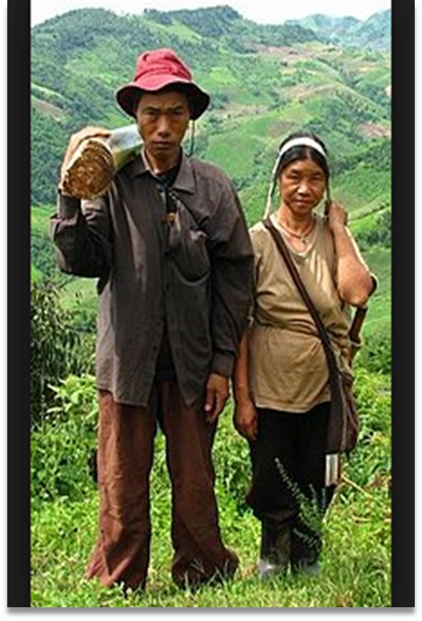

- Pan Troglodytes
Class: Vertebrata
Common name: Chimpanzee
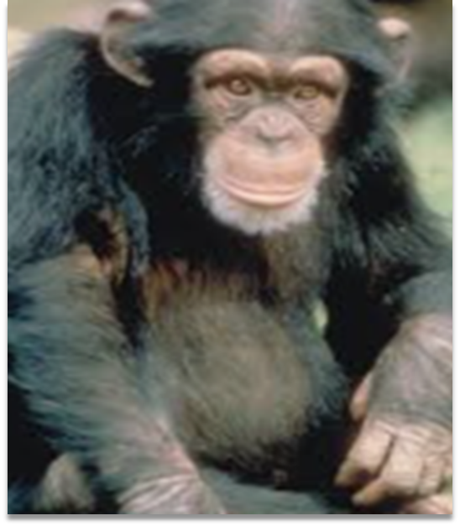
- Canis Lupus Familiaris
Class: Vertebrata
Common name: Grey wolf

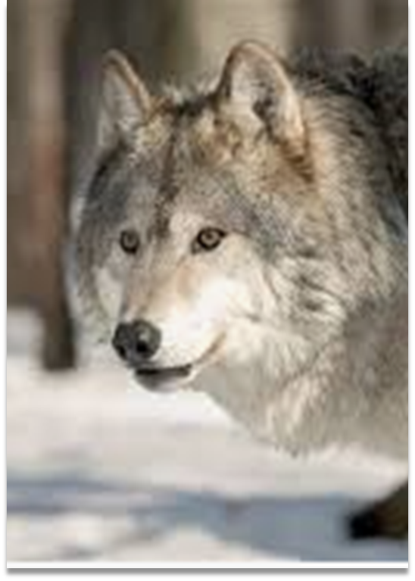

- Bos Taurus
Class: Vertebrata
Common name: Bovine

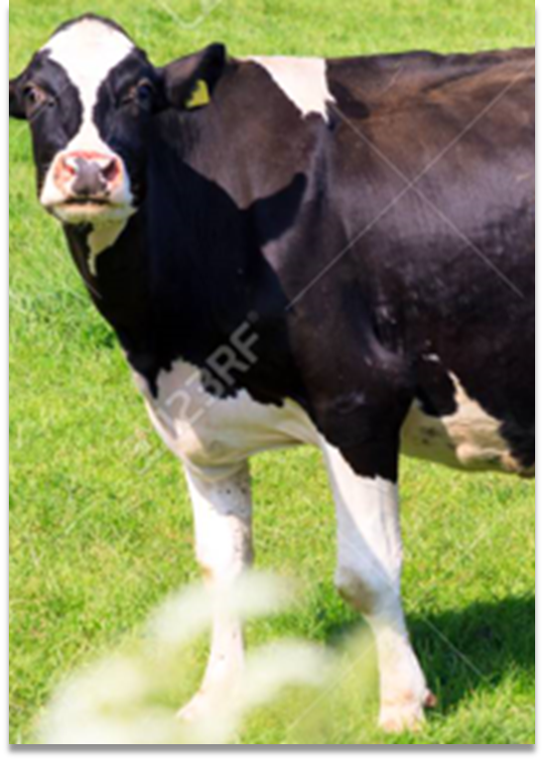

- Mus Musculus
Class: Vertebrata
Common name: House mouse

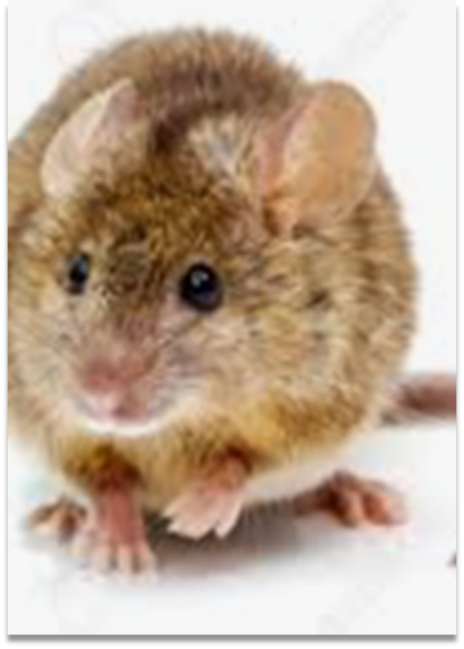

- Rattus Norvegicus
Class: Vertebrata
Common name: Brown rat

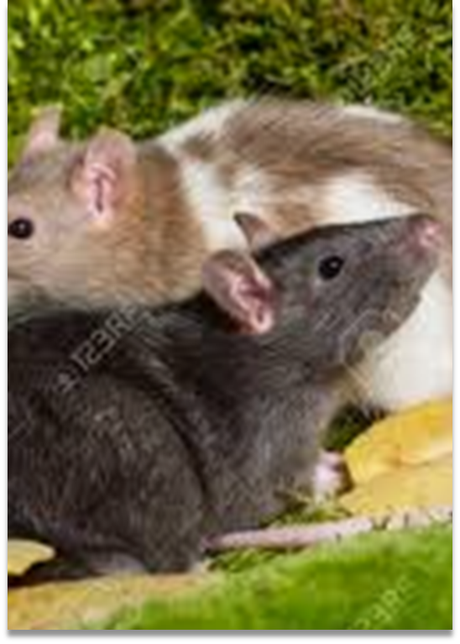

- Gallus Gallus
Class: Aves
Common name: Red Jungle Fowl

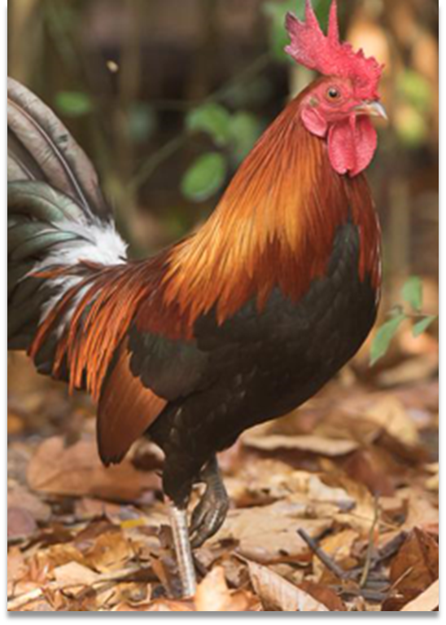

- Xenopus Tropicalis
Class: Amphibilia
Common name: Western Clawed Frog

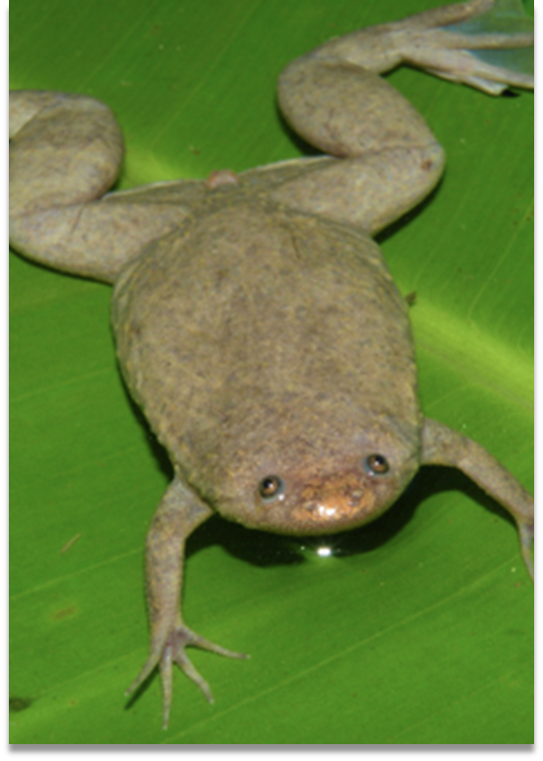

- Danio Rerio
Class: Vertebrata
Common name: Zebra Fish
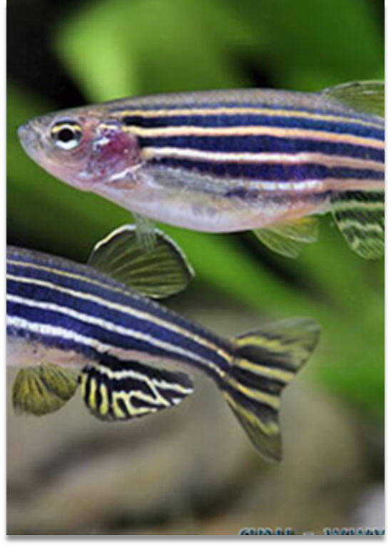

3.2 Methodology
The following are the steps to obtain the desired result of this project step by step;
- Open the National Centre for Biotechnology Information Data base and select the homologene database. Enter cancer/prostate into the search box and select the result with tumor suppressor candidate.

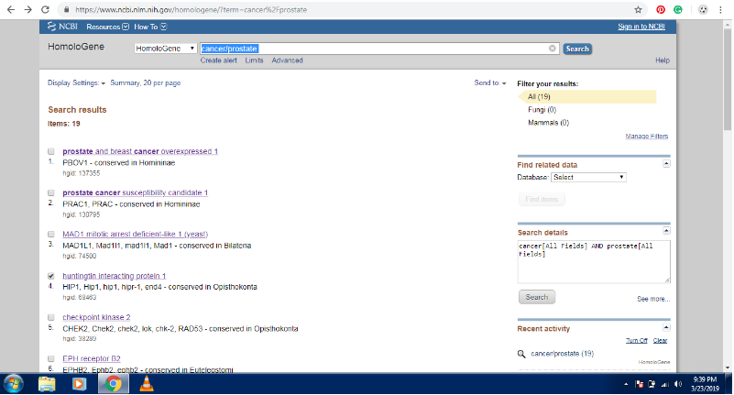
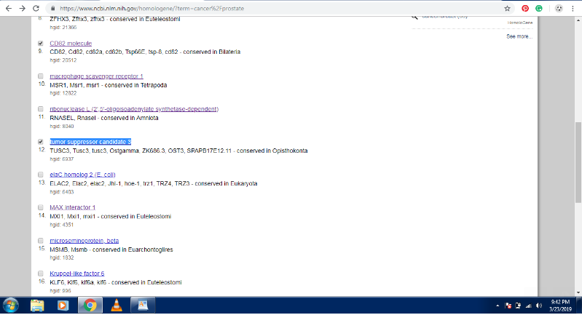
- The result will display the different proteins used in sequence comparisons as well as their conserved domain architectures together with the homologenes.

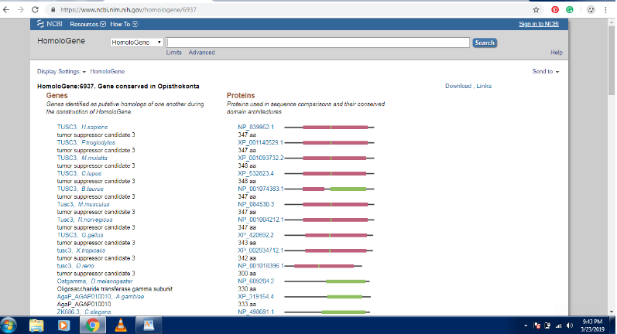
- The homologene FASTA sequences are then obtained and saved. Homo sapien sequence is used as the query sequence while the rest of the sequences are taken as the subject sequences.
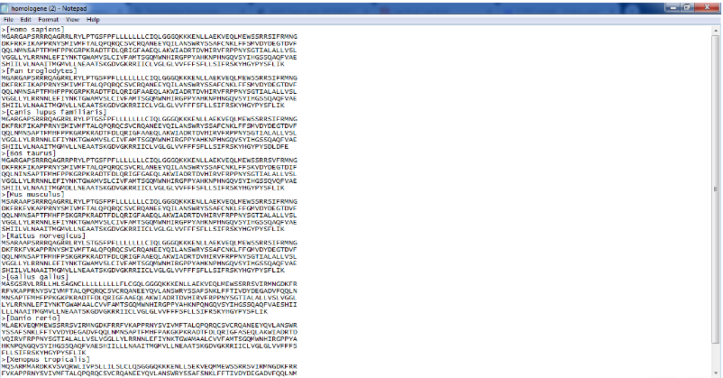

- The next step is to perform the protein BLAST to compare the sequences. Paste the subject sequence into its text box as well as the query sequences in their own text box.

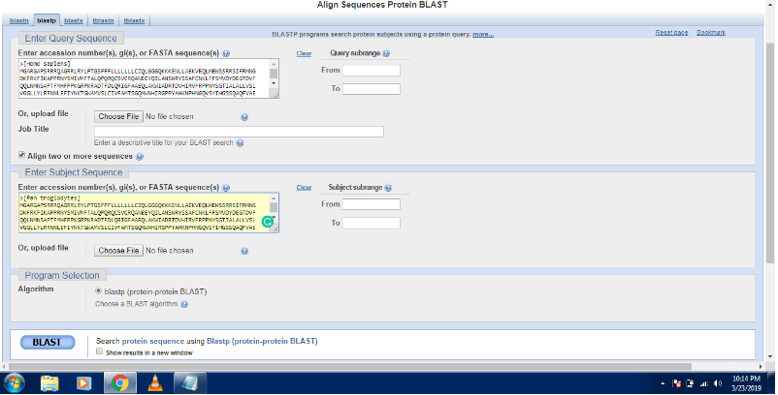
- After the BLAST is carried out, alignment scores of the 8 different subject sequences are obtained.
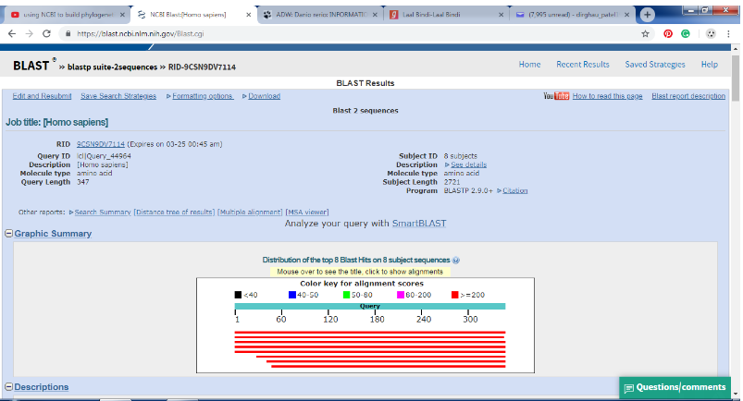

- Sequences are then displayed in order of the best alignment in form of a BLAST tree similar to a classification flow chart.
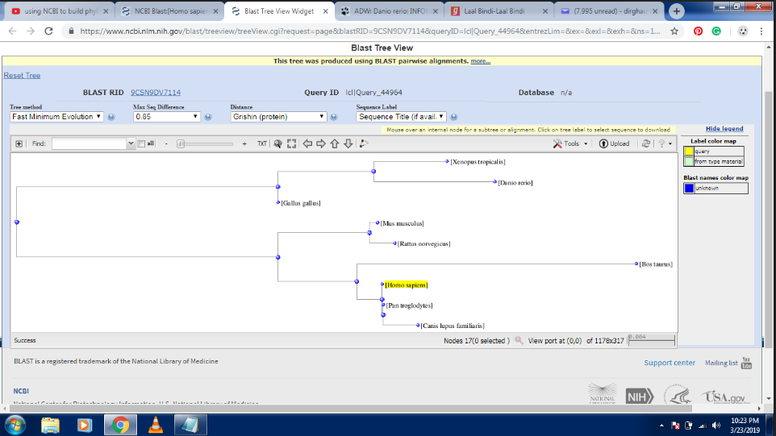

3.3 Result
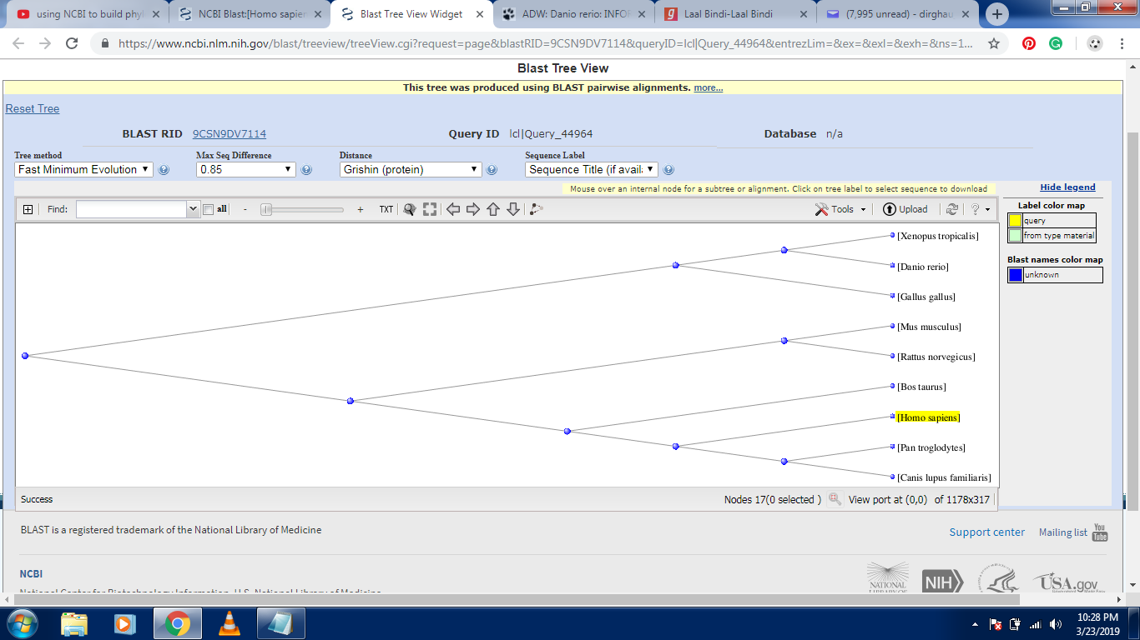
Xenopus Tropicalis ► Danio Rerio ► Gallus Gallus ► Mus Musculus ► Rattus Norvegicus ► Bos Taurus ► Homo sapiens ◄ Pan Troglodytes ◄ Canis Lupus Familiaris
Tumor Suppressor Candidate 3 cells were inherited by Homo Sapiens through Bos Taurus and Pan Troglodytes as common ancestors.

CHAPTER-4

4.1 Future scopes
- Development of epigenetic drugs that lead cancer cells back towards normal growth instead of destroying them.
- Taxon can be genetically wired to eradicate cancerous traits from their genes.

4.2 Conclusion
Tumor suppressor candidate 3 cells present in Homo Sapiens were traced down to the ancestral taxa of humans by comparing them to various other taxon as query sequence in BLAST.
The organisms whose protein sequence were taken as query sequence are Western Clawed Frog, Zebra Fish, Chimpanzee, Grey wolf, Bovines, House Mouse, Brown Rat and Red Jungle Fowl whose sequences were matched with Humans which was taken as reference sequence to develop a phylogenetic tree.

4.3 References
[1] Ellwood –Yen,Kathrine ,et al.“Myc-driven murine prostate cancer shares molecular features with human prostate tumors.” Cancer cell 4.3 (2003): 223-238
[2] Viella, Albert J. ,et al.”EnsemblCompara GeneTrees: Complete, duplication-aware phylogenetic trees in vertebrates.” Genome research 19.2 (2009): 327-335
[3]Salvador-Reyes, Lilibeth A., et al. "Targeted natural products discovery from marine cyanobacteria using combined phylogenetic and mass spectrometric evaluation." Journal of natural products 78.3 (2015): 486-492.
[4] Van Ranst, Marc, Jeffrey B. Kaplan, and Robert D. Burk. "Phylogenetic classification of human papillomaviruses: correlation with clinical manifestations." Journal of General Virology 73.10 (1992): 2653-2660.
[5] An, Hee Jung, et al. "Prospective evaluation of longitudinal changes in human papillomavirus genotype and phylogenetic clade associated with cervical disease progression." Gynecologic oncology 120.2 (2011): 284-290.
[6] Yi, Joo-Mi, et al. "Molecular cloning and phylogenetic analysis of new human endogenous retrovirus HERV-W family in cancer cells." Current microbiology 44.3 (2002): 216-220.
[7] KRIEGER, JOHN N., et al. "Bacterial DNA sequences in prostate tissue from patients with prostate cancer and chronic prostatitis." The Journal of urology 164.4 (2000): 1221-1228.

