GNY Technology Update
GNY Demonstrate Retail Predictions Within A Blockchain

This weekend GNY’s Tom Lorenc and Leo Liang took the next step in moving GNY’s proprietary machine learning platform to a decentralized model on the blockchain. In the following demo we take a classic AI/neural net problem and demonstrate how it can be scaled up to track and predict retail transactions on the blockchain. This demo illustrates how we are going to provide all developers a tool to securely unlock hidden value in their data.

*DISCLAIMER* - this demo requires manual entry of data files, transaction IDs, and run commands. Our subsequent update will replace these manual commands with automated contracts.

This demo is based on a classic computer science problem - how do you use a neural net to predict consumers’ next behaviors? Below, 0’s and 1’s represent retail transactions. For example, let’s say that these represent apples (0’s) and peaches (1’s). The input shows historical data and the output is the prediction of the next purchase.

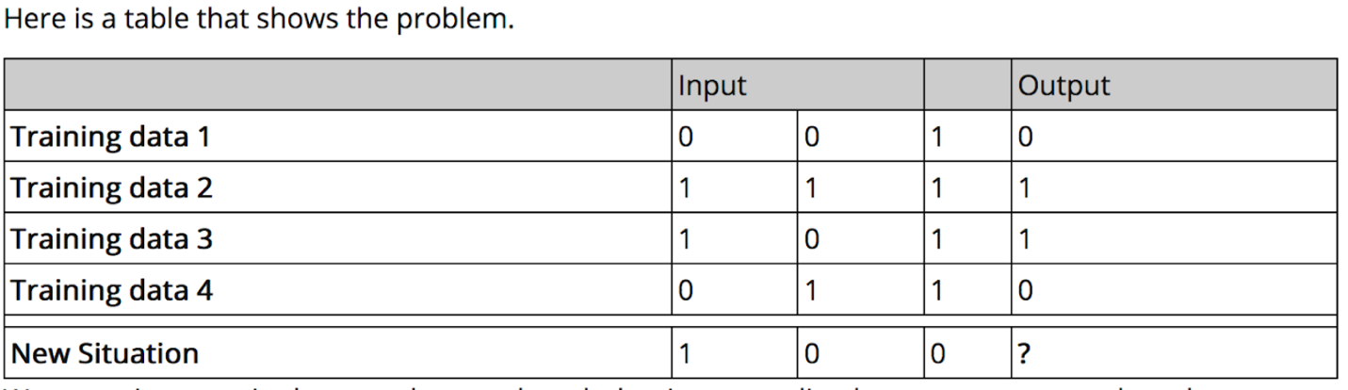
The classic example deals with 4 transactions. GNY Center will be able to handle millions of transactions, but for the sake of the demo we are increasing the prediction volume to 50 transactions at a time. This demo will walk you through installing our blockchain on your Mac or PC, and running a series of predictions with our predictive machine learning platform.
This demo also previews how we will be rolling out subsequent demonstrations and our final product GNY Centre. We plan to continue to provide updates and curated groups of algorithms that are specialized for use cases such as retail predictions, publishing predictions, and data analysis.
So the question is “What will you build?”

DEMO START
FIRST INSTALL A BLOCKCHAIN ON YOUR COMPUTER
Go to our GNY experiment GitHub and reference the instructions to set up your blockchain
FOR MAC
Step 1: Go to Utilities and start Terminal, we will reference this window as Terminal 1
Step 2: Copy and paste this command into Terminal 1
$git clone https://github.com/GNYIO/gny-dist
Step 3: Now install the dependencies, by cutting and pasting each of the following lines one at a time into Terminal 1
curl -o- https://raw.githubusercontent.com/creationix/nvm/v0.33.2/install.sh | bash

export NVM_DIR="$HOME/.nvm"

[ -s "$NVM_DIR/nvm.sh" ] && \. "$NVM_DIR/nvm.sh"

[ -s "$NVM_DIR/bash_completion" ] && \. "$NVM_DIR/bash_completion" # This loads nvm bash_completion

nvm install 8.13

Step 4: Change Directory to your home directory

cd ~

Step 5: Create the following file by running this command

vi .bash_profile

Step 6: Then cut and paste each of the following 3 lines into .bash_profile

export NVM_DIR="$HOME/.nvm"

[ -s "$NVM_DIR/nvm.sh" ] && \. "$NVM_DIR/nvm.sh"
[ -s "$NVM_DIR/bash_completion" ] && \. "$NVM_DIR/bash_completion" # This loads nvm bash_completion

Step 7: Now change the directory back to
cd gny-dist
*****
IF YOU HAVE BREW, SKIP COPYING AND PASTING THIS LINE INTO TERMINAL 1:
/usr/bin/ruby -e "$(curl -fsSL https://raw.githubusercontent.com/Homebrew/install/master/install)"

****

Step 8: After Brew is installed continue by cutting and pasting the following 2 lines into Terminal 1, one at a time

brew install libtool autoconf automake

npm install
Step 9: Now we start the blockchain by cutting and pasting the following line into Terminal 1
node app
The blockchain will look like this in Terminal 1:
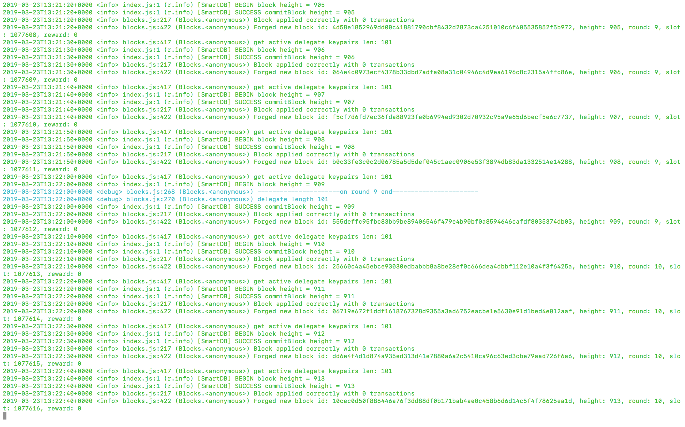

Now that you have set up your blockchain, it’s time to load your first set of historical data. This example represents yesterday’s fruit sales from your store.
Step 10: Click on Menu Item Terminal->Shell->New Window to start another Terminal, which we will call Terminal 2
Step 11: Load a sample set of historical data in Terminal 2. This data represents 50 transactions from yesterday, where 0 = “bought apple” and 1 = “bought peach”.
Run the following commands below from Terminal 2 command prompt by first changing the directory
cd gny-dist/src/gnn
and then cutting and pasting the following line into Terminal 2
node upload.js myDataX1
Step 12: The output of the preceding command will be a transaction ID. In Terminal 2 copy the transaction ID and paste into the machine learning model (gny-dist/src/gnn/genie.js) function fetchData() or id.
{ transactionId: ‘35d1b373b7fb8912db6d00365ed4e09cf9dc67a935d0d2152e0c0f5dd4c90ee3’}
Step 13: From the command prompt run:
vi genie.js

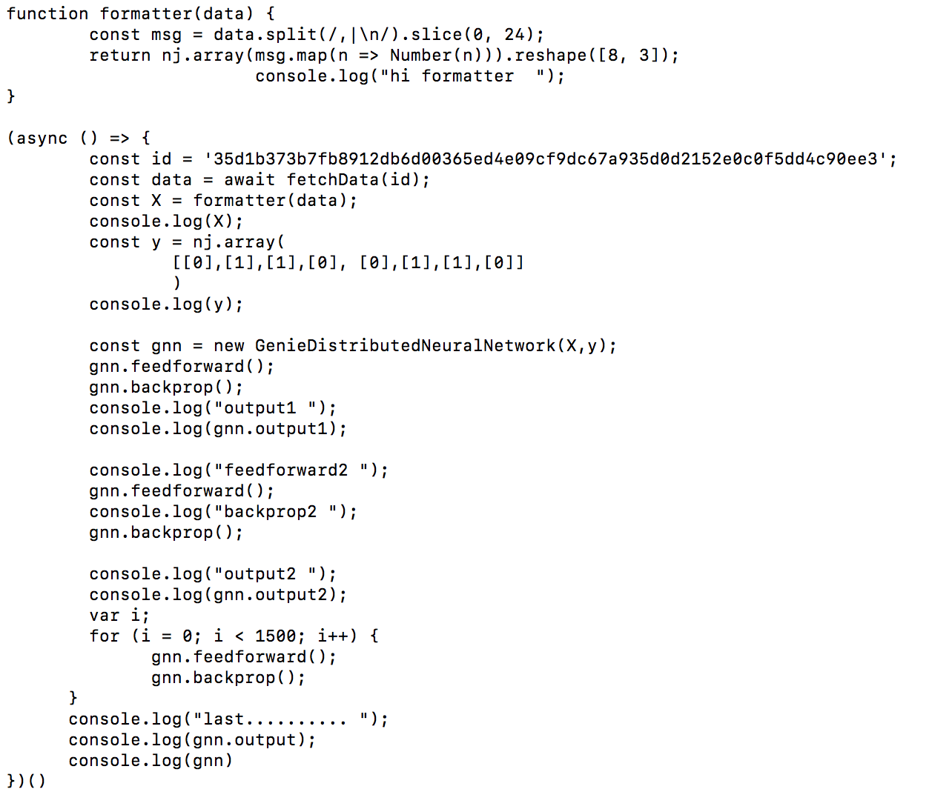

Step 14: Run GNY Neural Net. GNY Neural Net will display the predicted results and simultaneously write the results which are the predictions. This will also be automatically written into the file myDataX2 which will be imported into your next Block.
Copy and paste the following line into Terminal 2.
$node genie.js
predicted purchases..........
array([[ 0.01816],
[ 0.98512],
[ 0.98496],
...
[ 0.98512],
[ 0.98496],
[ 0.01481]])

BLOCK #2
Step 15: Now load 50 rows of 0,0,1 transactions from the file xData2 to the blockchain as transaction message. xData2 represents “today’s” actual sales where 0 = “bought apple” and 1 = “bought peach”
$node upload.js myDataX2
Step 16: Again, in Terminal 2, copy the transaction ID and paste it into GNY neural net so that our neural net can read the latest sales data from the blockchain
So copy the latest transaction ID and paste into the machine learning model function fetchData().
{ transactionId: ‘4aea17a11497ed0a2d8b39b9df43ad00deff0f0f81e95b17bccc37f34a6dd70f’}
vi genie.js

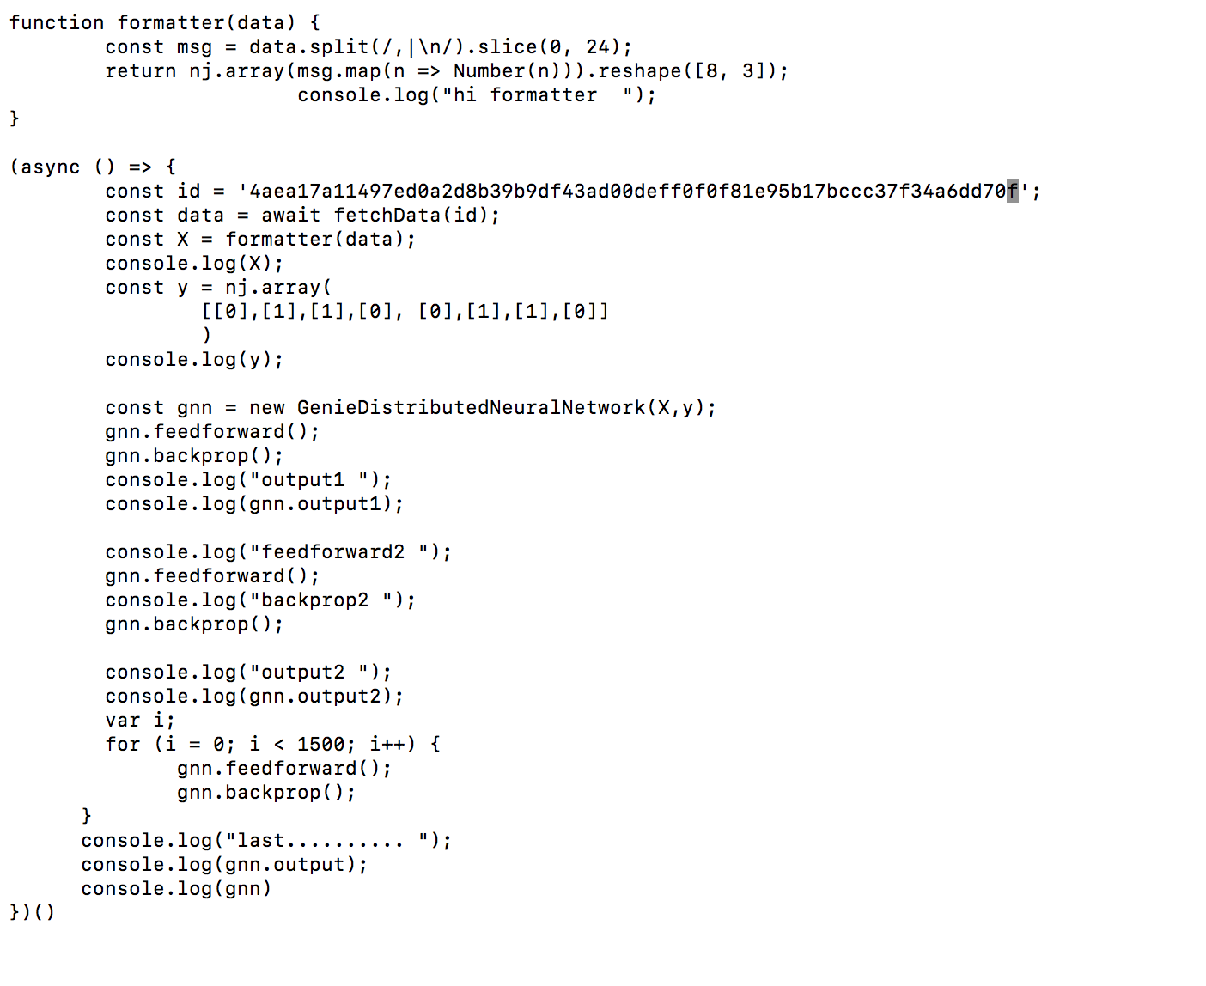
Step 17: Now Run GNY Neural Net which will display the predicted next 50 purchases and then write them into a file ready to be written the file myDataX3 which is automaticly generated
$node genie.js

END DEMO

This demo is meant to show you how you will be able to use GNY Center to customize predictions for your retail, publishing, or data-centric enterprise. Powerful predictive technology should be secure, customizable, and affordable. Welcome to our vision of GNY Centre.

