SC 3.2 (a)

Renewable and Non – Renewable energy

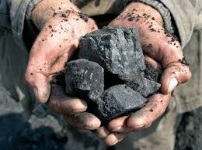 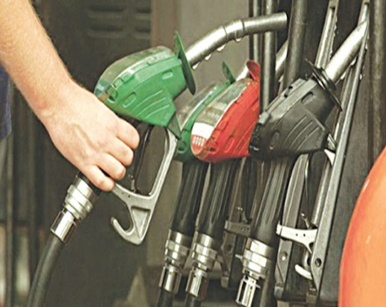 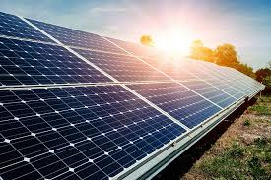

**Task:**

Out of these three sources of energy, which one will you prefer as a fuel ? Give three reasons.

**Explanation:**

|  |
| --- |
|  |