Tableau – ROI

Table of Contents
About Tableau 3
Benefits over traditional reporting? 3
How can Tableau help make you data-driven company of the future? 4
Independent Study Documents 127% ROI for Tableau Customers 5
Seven ways you can drive ROI with Tableau 6
References 10

About Tableau

Tableau helps people transform data into actionable insights that make an impact. Easily connect to data stored anywhere, in any format. Quickly perform ad hoc analyses that reveal hidden opportunities. Drag and Drop to create interactive dashboards with advanced visual analytics. Then share across your organization and empower teammates to explore their perspective on data. From global enterprises to early-stage startups and small businesses, people everywhere use Tableau’s analytics platform to see and understand their data.

Benefits over traditional reporting?

The BI Ecosystem has dramatically changed over the past few years. At the bottom of this technology stack, we had data aggregated from different source systems through a complex ETL structure culminating into one data warehouse. We then had a semantic layer where most of the reporting needs where meet using traditional Reporting tools, on the top of this layer we have the advanced analytics stack which was used to create dashboards and KPI’s. This transformation resulted in Self-service BI where end users can create their own reports and dashboards without relying on IT to create for them. Thus giving the power to the business user who can gain insights on their own business data without relying on any set of developers. Some key features that will make you embrace Tableau are-

- Self Service Capability
It is a Business Intelligence methodology where end users designing and deploying their own reports and dashboards within an approved and supported architecture. The goal is to make BI available to users anywhere within an organization although IT maintains overall control over who has access to which tools and data, but IT no longer acts as a bottleneck to every query, dashboard/report requested.
- Embedded Analytics
It is the art of integrating or using your Analytical content creating from your Self-service BI tools within your business applications. Therefore, this way as customer who does not have the suite of BI data analytics in their applications can add value by collaborating with an embedded analytics provider there-by leveraging data analytical capabilities.
- Deploy and Consume Anywhere

In today’s world of mobile usage business users, want their metrics, dashboards up and running 24/7 this is where cloud solutions score over on premise solutions. Mobile users can access reports, requirements, and make business decisions from mobile devices, tablets and laptops – elevating productivity from a traditional to triumphant scale.

- Machine Learning and AI

Machine learning coupled with embedded analytics is a powerful combination that will drive down the manpower an enterprise takes in and at the same time provide extremely complex data analysis that a self-service tool fails to do by using complex algorithms. The latest tableau version boasts of new features that are AI and ML driven coupled with search-based analytics.

How can Tableau help make you data-driven company of the future?

Some of the Key steps to building a data-driven company of the future are:-

Make Data your Core Competency
The promise of digital transformation is the ability to harness the power of technology to grow your business, reach new markets, and attract new customers. It means that you also need to understand all of the data, or digital exhaust, created by new customer experiences. Digital transformation is not just about collecting more data. You transform to modernize, and modernity means harnessing all of the knowledge you can from your data. To achieve long-term success, a modern company prioritizes the infrastructure and resourcing needed to leverage and extract data to its full potential.

Establish a foundation of governed, trusted data
A strong foundation starts with an attitude of openness, backed by the proper controls. Modern companies are building out a data management function with self-service analytics as the end goal—providing the proper level of control for every type of user. Successful companies opt for an integrated approach between defensive and offensive data strategies, supporting both “customer-focused business functions” and “legal, financial, compliance, and IT concerns”. An integrated governance strategy is the foundation of a solid data company. The result is an environment where IT can ensure security and people have the confidence to explore trusted data and drive business impact.

Foster Adoption with Data Literacy
To derive value from data, employees need to have the skills to understand and analyze it— and to communicate results across the company. Data is only effective if everyone has the desire and the knowledge to leverage it. Data literacy shouldn’t be limited to engineering and analyst roles. Successful adoption means that every department is empowered with data so they can ultimately track performance, discover new opportunities, and contribute new ideas.
Make Data accessible to all
It’s projected that the modern data world will encounter 163 zettabytes of data. All of this data holds your next potential business opportunity. Some organizations will wane in the presence of this growth; but most will find ways to empower their workforce to turn data into insights. When every knowledge worker grows more proficient (and equipped) with data, they can bring unique perspectives based on individual strengths. The result is a data-driven company that is on the forefront of change instead of lagging behind.

Independent Study Documents 127% ROI for Tableau Customers

An independent study of Tableau customers’ ROI by Forrester Consulting showed a 127% ROI using Tableau’s business intelligence products. Based on its in-depth research, Forrester concluded, “Tableau decreases BI support costs and drives end-user empowerment.”

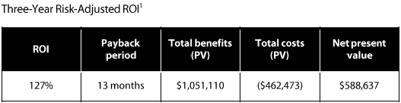

Forrester found the following benefits:
- Increased user adoption of business intelligence
- Increased standardized reports by 400%
- Reduced report creation times by 87.5%
- Reduced report distribution, storage and duplication costs and simplified publishing of reports
- Incurred no training costs to adopt Tableau
- Freed up BI analysts to perform higher-value tasks
- Realized process improvements from use of visualization in root-cause analysis

Seven ways you can drive ROI with Tableau

Tableau’s main goal is to make organizations put more focus on strategy and objectives and make data driven decisions. That means lower costs, more revenue, and a better bottom line for the business.

- Efficient Reporting
Traditional forms of reporting uses tools like SSRS or Crystal Reports are time consuming to develop, maintain and sustain. By adding visualization tools like Tableau in their reporting stack, the time spent in developing and maintaining reports reduces by 60%. The standardization, visual appeal and the data insights that come along with tableau is un-matched and is eye pleasing to customers.

- Cost Avoidance
In large manufacturing organizations spread over different continents let’s say a manufacturing company that has 50 divisions and 300 facilities across the globe tracking, real time insight and updates to the top management is crucial. Tableau has be used across such industries wherein more than 1000 dashboards are being used across to track 1 Million SKU’s across 300 facilities. In such huge and massive organizations one can use shared data sources or common templates upon which individual dashboards can be churned up within minutes thus saving time and cost.

- Identifying Fraud and Risks

Using Tableau one can visualize and easily identify the outliers and potential anomalies to identify the fraud patterns in underlying data. This is huge in Insurance, Banking and Finance industry where every outlier is a cause for concern. Tableau quickly recognizes this and helps you unearth the underlying data.

- Profitability and Growth Analysis Recognition
No matter your industry, a CFO needs to be able to quickly combine complex profit and loss data in order to recognize overall quarterly and yearly performance, as well as be able to analyze profitability and growth—all critical to strategic planning and decision-making.
Which segments are most profitable? Where is high growth occurring? What are your challenges and opportunities? By placing all product segments in dynamic quadrants, CFOs can define winners, losers, and areas of opportunity with Tableau.

- Expense Reduction
Many international financial institutes have used tableau to quickly identify and stop wasteful spending with non-preferred suppliers in cost centers like office supplies, travel, and expense. key metrics including team member influence and spend per person, so they could fairly compare spending by different departments within the organization for each cost center. A dashboard like this one reveals the worst offenders, and clicking into the details reveals insights about suppliers and root causes.

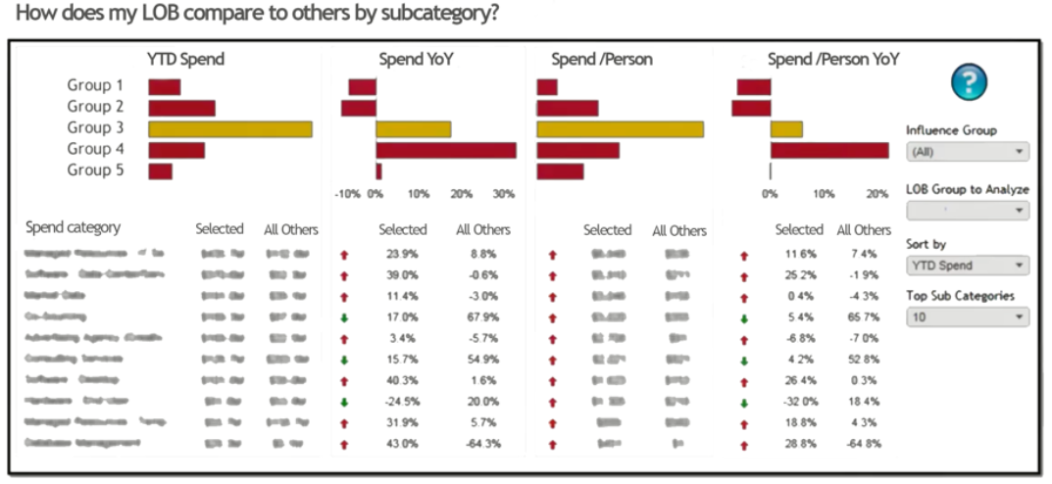

- Revenue Forecasting
While it is close to impossible to predict the future, understanding how the market will evolve and consumer trends will shape up is extremely important for brands and companies across all sectors. This is where Tableau scores over other visualization tools. Tableau uses it’s built in forecasting algorithm to predict sales or any possible events. For example, this dashboard—where the green boxes represent big opportunities and the red boxes represent risk, answers forecasting things like group sales bookings, making the insights from data available in seconds, not days or weeks.
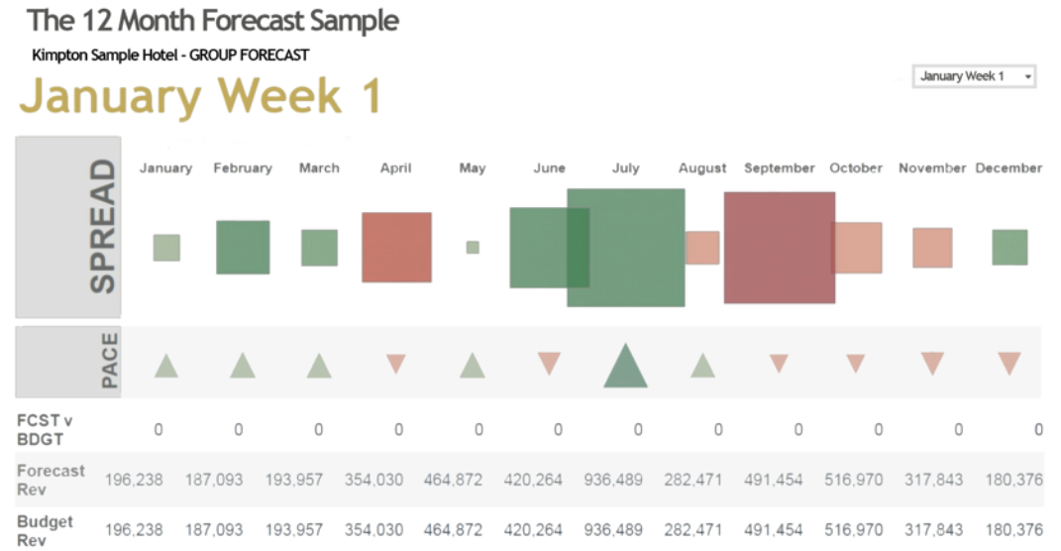

- Cash Flow Management
Where’s the money going? What vendors are being paid? What are the historical cash flows through the company’s bank accounts? Tableau’s own Treasury team uses Tableau for global cash management.

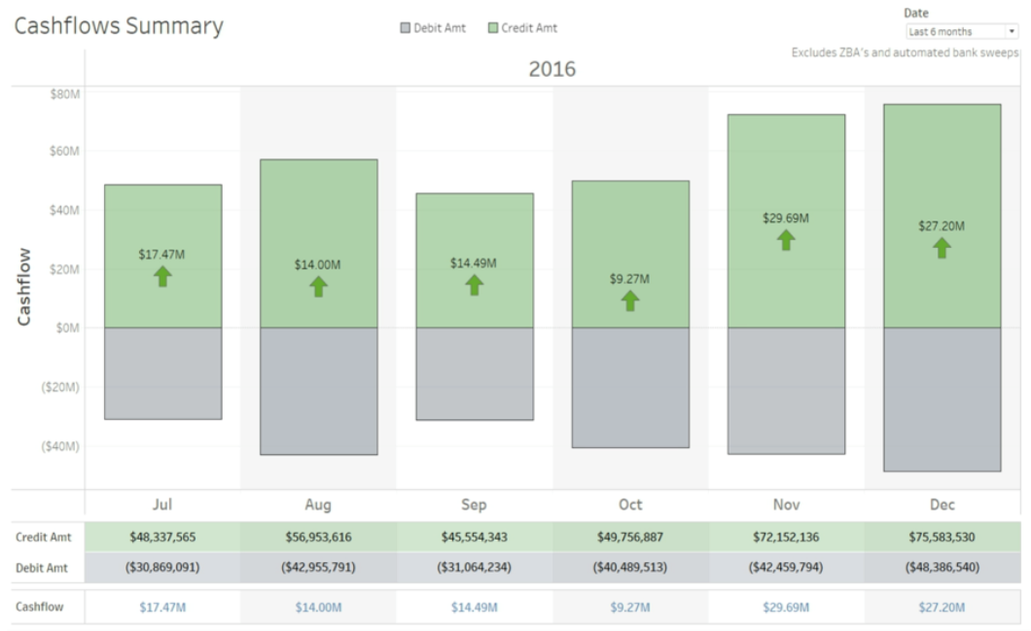
This cash flow summary dashboard helps management understand what cash flows look like in aggregate, in US Dollar terms, but also still allows anyone to drill down into the data for any view that someone within the organization needs. For example, analysts can ask, “what are our balances by currency, subsidiary, country, banking partner or geography?” They can also filter out certain transactions that might gross up the numbers like investment sweeps and zero balance account (ZBA) structures.
Tableau created a process to import daily bank statements that enriches the data with the assignment of a Cash Flow Type and Cash Flow Sub-Type to each transaction, which allows users to focus their analysis on the transaction flows that are most relevant for the questions at hand. Tableau lets the finance team connect to multiple data sources that contain cash balance and cash flow data including our bank statement database, investments database, ERP and other source systems without the need for expensive and time consuming data integration efforts that limit the underlying transaction level data that the Treasury team needs to work with. The next step for the Treasury team is to use Tableau’s forecasting capabilities to project what future cash flows and balances may look like based on historical actuals. The team can then compare the systematic driven forecast to our traditional bottoms up forecast to see if they are in alignment.
Tableau has allowed the Treasury team to move from fixed workflows and static reports to flexible user defined workflows with interactive and dynamic data analysis that provide a much deeper view into the cash flows across the company.

References

- https://www.tableau.com/forrester-roi-report-info-mgmt-1B
- https://www.tableau.com/sites/default/files/whitepapers/7_ways_finance_roi_whitepaper.pdf
- https://www.tableau.com/learn/whitepapers/data-driven-company-of-future
- https://www.tableau.com/forrester-roi-report-info-mgmt-1B

