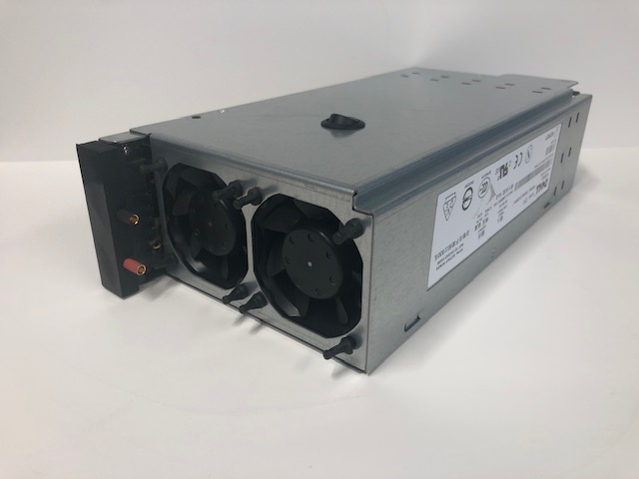

**75 amp 12 volt Power Supply**

This power supply consists of a computer server power supply that has been converted for use as a bench top power supply. It provides a highly regulated, high-current 12 volt output that’s perfect for use with battery chargers that require a lot of amps when charging at high current levels, or for use when charging several batteries at once. As with most computer-based power supplies, the circuit itself is overload protected, temperature protected, and short-circuit protected, making it almost impossible to damage in normal use, and is cooled by high-speed fans that protect the internal components even when operating at high current levels. If the outputs are shorted or overloaded, or if the unit overheats, it will shut down before damage can occur, and can be re-set by simply turning it off for a few seconds before turning it back on again.

The 4.0mm Banana jacks on the left side of the front of the unit are used to connect to your battery charger, or to provide a 12.0 DC output for other devices. On our improved model, the banana jacks are positioned in front of the fans to provide cooling when charging at higher current ratings, and the outputs of the power supply are covered with a black plastic shield to prevent accidental shorts from exposed connections and pins. If you require more than one connection to your power supply, you can use a Power Distribution box, or banana plugs that stack together. You can search our website for both.

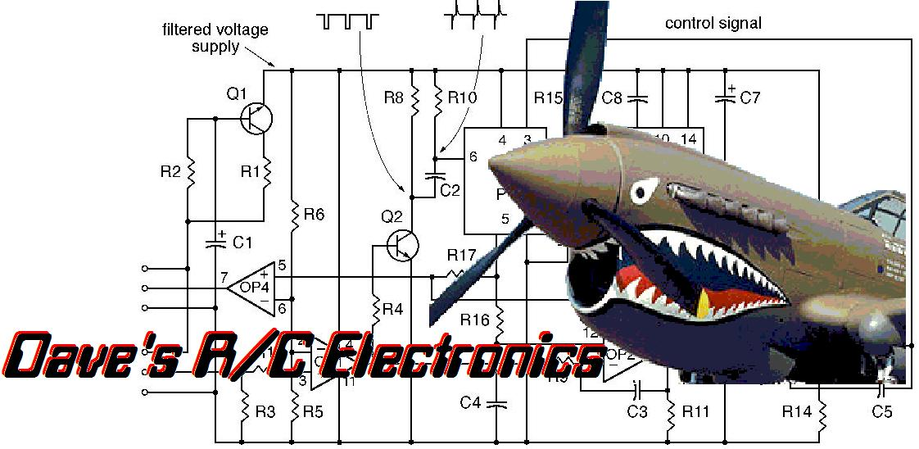***If you have any questions or problems, don’t hesitate to contact me. ENJOY!***



www.davesrce.com

sales@davesrce.com

(423) 544-1657

**SCAN HERE**