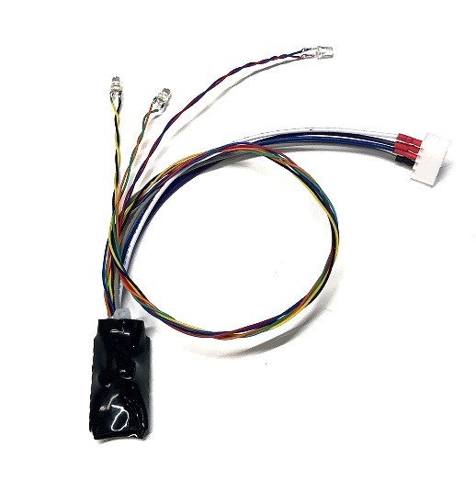

**NavLights for Small Indoor Helis**

This NavLight set is designed specifically for small, indoor helis, to improve orientation and visibility, and to add some scale realism. Because many smaller indoor-type helis utilize receivers that do not have a spare channel that can be used to power or control the lights, it is designed to be powered by direct connection to the model’s flight battery via the Balance Tap connector. It is available in two versions, for models using either 2S (7.4volt) or 3S (11.1 volt) flight batteries. The LEDs will come on as soon as the circuit is connected to the balance tap.

This version includes three 3mm LEDs, two white 3mm LEDs that can be mounted on the skids or anywhere on the front of the heli, and a single red 3mm LED that can be mounted on the tail boom or anywhere on the fuse. The LEDs can be mounted in any way that’s convenient for the modeler, either hot glue, mounting tape, or small wire ties. The wires on each LED are 12” long, and are made using 30 gauge wire-wrap wire to keep the overall weight down to around 5 grams, so that the model’s performance is not affected negatively.

**Note: The wires used on these NavLights is very small (to reduce weight) and should be handled with care. I recommend that you leave the plastic zip tie located near the circuit board in place to reduce strain on the individual wires.**

This basic design can also include other colors and other sizes of LEDs, as well as features like strobes, switchable landing lights, and/or simulated rotating beacons. Feel free to contact us if you have any questions, or would like a quote on a different configuration.

***If you have any questions or problems, don’t hesitate to contact me. ENJOY!***

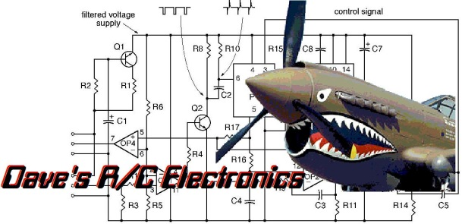



www.davesrce.com

sales@davesrce.com

(423) 544-1657

**SCAN HERE**