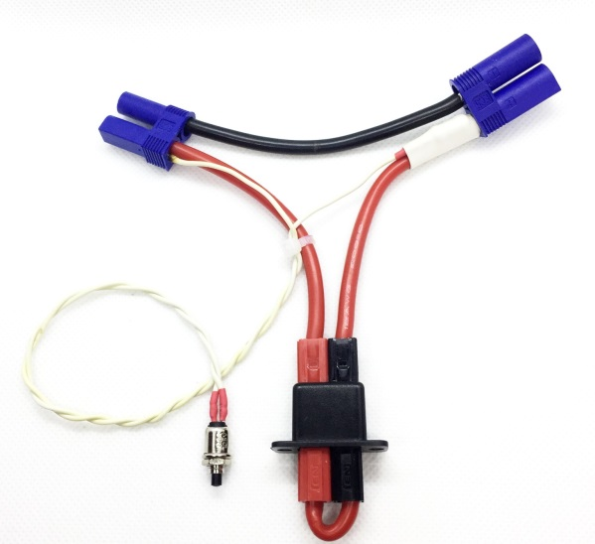

**No-Spark Arming Plug & Harness**

The **No Spark Arming Plug & Harness** is designed to eliminate the dreaded "spark" that often occurs when connecting a large 6S or bigger Li-Po to the ESC in many Giant-Scale models.  Not only is this spark annoying, it is harmful to both the connectors and the electronic parts inside the ESC, and can cause a total failure of the ESC.  In addition to eliminating the spark, the Arming Plug & Harness provide a much safer, more convenient way of connecting power to a larger model, allowing you to install the battery in the model and make all the electrical connections without the danger of bumping the throttle stick and causing an unexpected motor start.

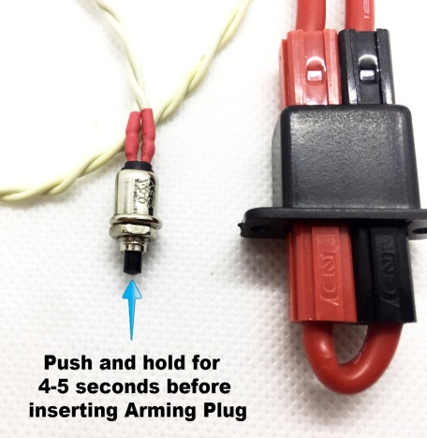Install the harness in the fuselage in a location that is convenient and easy to access. The push-button switch is installed close to the harness so that you can insert the arming plug quickly after the capacitors in the ESC have been charged. To use, install the battery in the model, and connect it the cables from the harness to the connectors on both the ESC and the battery. (The connection to the ESC can remain connected once the harness has been installed.) When you are ready to fly, press and hold the push-button for 4-5 seconds **before** inserting the arming plug. Release the push-button, and immediately insert the arming plug. Sparking and/or arcing of the connectors should be eliminated.

Available in three versions, with the three most popular connectors

used on larger ESCs and batteries, XT-60s, EC3s, or EC5s.

***If you have any questions or problems, don’t hesitate to contact me. ENJOY!***

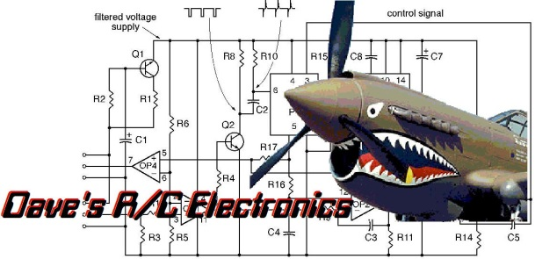



www.davesrce.com

sales@davesrce.com

(423) 544-1657

**SCAN HERE**