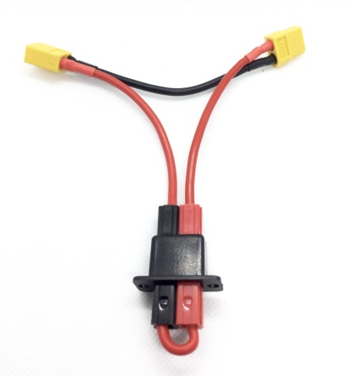

**Arming Plug & Harness**

The **Arming Plug & Harness** is designed to provide an extra layer of protection against unexpected motor strikes on models equipped with electric power systems. The Arming Plug allows you to install the flight battery in the model, making a partial connection between the ESC and the battery without completing the circuit and exposing you to the possibility of injury should the throttle stick be accidentally bumped. Once the battery hatch or cover is safely in place, and the model has been otherwise prepared for flight, the arming plug is inserted, completing the circuit between the ESC and the battery and giving you full power to the receiver and motor.

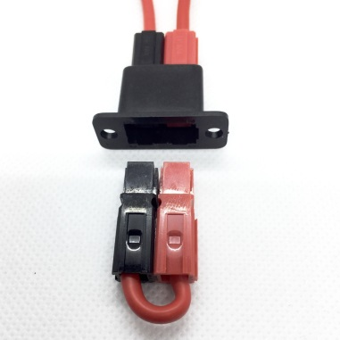 Install the harness in the fuselage in a location that is convenient and easy to access. Connect the ESC to the female connector on the arming plug, and then connect the battery to the male connector. (The ESC can remain connected once the harness has been installed the first time.) When you are ready to fly, or if you need to arm the ESC to perform maintenance on the receiver/servos, insert the arming plug. Available in several versions, with the most popular connectors used on ESCs and batteries, including Deans, XT-60s, EC3s, EC5s, and XT-90s.

If you would like even more safety from unexpected prop strikes, consider our **SafeStart** system. **SafeStart** protects you from injury even while you work on or trim your model, giving you full control of all your servos and control surfaces, while keeping the throttle stick “Low” until you are ready to fly. More information about **SafeStart** is available on our website at:

<https://www.davesrce.com/product-page/safestart?nr=0>

***If you have any questions or problems, don’t hesitate to contact me. ENJOY!***

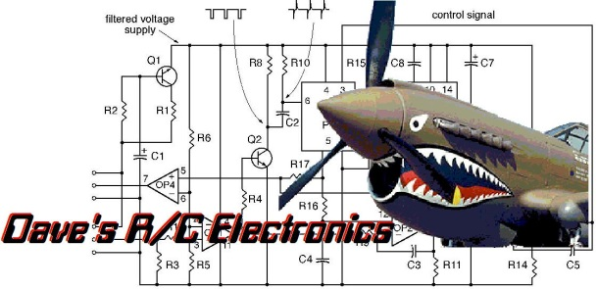



www.davesrce.com

sales@davesrce.com

(423) 544-1657

**SCAN HERE**