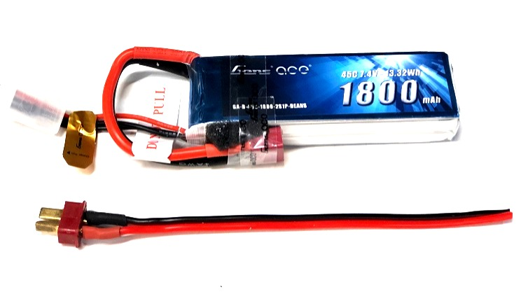

**External Power Packs for NavLights**

The External Power Pack for NavLights is designed to provide power for any of our line of 5mm, 8mm, or Custom Navlights without using the power from the model’s receiver battery or from the main flight battery. The external battery packs are available in two sizes, 800mAh or 1800mAh (capacity), both utilize a 2-cell (2S) 7.4 volt Li-Po battery pack, and both include the necessary power cable to use them with any of our navigation light sets. If ordered at the time you purchase one of our 5mm, 8mm, or Custom NavLight sets, we’ll install the cable on the circuit board (and test it!), all at no extra charge. Order the NavLight Set you want, add the External Power Pack in the size you want, and we’ll install the cable and ship it as a ready-to-use, complete navigation light system.

The 800mAh External Power Pack is best suited for any of our 5mm NavLight Sets, as the 5mm LEDs draw much less current than the larger LEDs, and the 800mAh battery will provide hours of power between charges. The 1800mAh External Power Pack is best suited for our NavLight Sets that feature larger LEDs, like our line of 8mm Giant-Scale NavLight Sets, or any Custom NavLight Sets that feature 10mm LEDs or the larger 1 watt Emitters. If you are in doubt about the size you need for your NavLights, feel free to give us a call and we’ll help you decide.

**Note: Since all of our NavLight Sets are regulated to operate the LEDs at 5.0 volts, you should check the voltage of your battery pack frequently to prevent over-discharging. A 2S Li-Po should not be discharged lower than ~3.0 volts per cell, or ~6.0 volts for the pack. The battery should register about 8.4 volts fresh off the charger, I recommend re-charging when the pack voltage reads 6.5 volts or less.**

***If you have any questions or problems, don’t hesitate to contact me. ENJOY!***

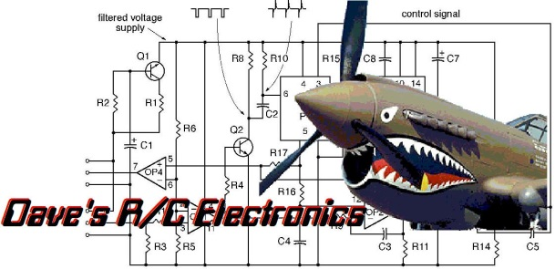

www.davesrce.com

sales@davesrce.com

(423) 544-1657

**SCAN HERE**