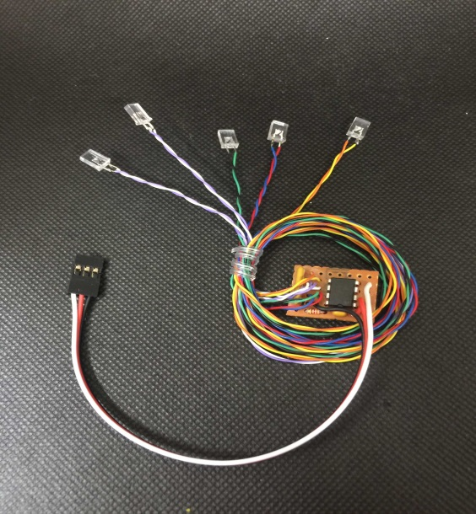

**FeatherLite Deluxe NavLights w/Strobe**

The FeatherLite series of Navigation Lights is designed to provide a lightweight, easy to install set of navigation lights for modelers who fly small, electric planes like park flyers and indoor foamies.  This series is especially intended for models made of flat sheets of foam insulation board, depron, or EPP foam sheets.  They incorporate our new 2x5x7mm rectangular LEDs, which are much easier to mount on a flat surface than the "standard" round 5mm LEDs normally used on Navigation Light sets, and provide a virtually 180 degree viewing angle. The circuit can be plugged into any channel on your receiver, either by itself or with a servo "wye". but will work best if plugged into a fully proportional channel such as channel 6 or above. Power is supplied by the receiver's battery or by the ESC/BEC, and current usage is very slight. No external battery is required.

The circuit has three modes, **1.** All lights off, **2.** Wingtip lights and strobe on, and **3.** All lights on. You can use the knob assigned to the channel of your choice to switch between the three modes, or you can program a series of mixes and assign them to a 3-position switch to toggle between the modes. The programmable mixes should be set to 0%, 50%, and 100%, or to -100%, 0%, and +100%, depending on the brand of your transmitter. Consult your transmitters manual for specific instructions on programming your transmitter.

Operation is simple and automatic. The rectangular LEDs can be glued directly to the surface of the wing, on either the top or the bottom, using CA or hot glue. I recommend that you consider attaching them to the wings bottom becase you will spend a large percentage of your time looking at the bottom of the wing. Route the wires as necessary to each LED, and tape them in place. Take care when handling the LED's wires as, to reduce weight, they are very small gauge and somewhat delicate. I recommend that you cover the wires once they are in place with a layer of thin tape to protect them from being pulled or damaged by landing or handling.

______________________________________________________________________________

***If you have any questions or problems, don’t hesitate to contact me. ENJOY!***

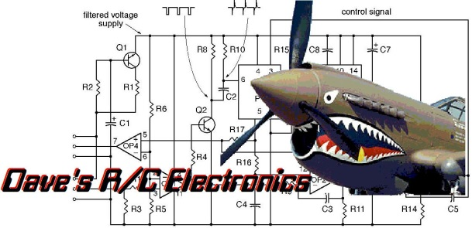 

www.davesrce.com

sales@davesrce.com

(423) 544-1657