**United States**

The [United States Environmental Protection Agency](https://en.wikipedia.org/wiki/United_States_Environmental_Protection_Agency) (EPA) has developed an Air Quality Index that is used to report air quality. This AQI is divided into six categories indicating increasing levels of health concern. An AQI value over 300 represents hazardous air quality and below 50 the air quality is good.[[10]](https://en.wikipedia.org/wiki/Air_quality_index#cite_note-aqi_basic-10)

|  |  |  |  |  |  |  |  |  |  |  |  |  |  |  |  |  |  |  |  |  |  |
| --- | --- | --- | --- | --- | --- | --- | --- | --- | --- | --- | --- | --- | --- | --- | --- | --- | --- | --- | --- | --- | --- |
| |  |  |  | | --- | --- | --- | | **Air Quality Index (AQI) Values** | **Levels of Health Concern** | **Colors** | | 0 to 50 | Good | Green | | 51 to 100 | Moderate | Yellow | | 101 to 150 | Unhealthy for Sensitive Groups | Orange | | 151 to 200 | Unhealthy | Red | | 201 to 300 | Very Unhealthy | Purple | | 301 to 500 | Hazardous | Maroon | |

The AQI is based on the five "criteria" pollutants regulated under the [Clean Air Act](https://en.wikipedia.org/wiki/Clean_Air_Act_%28USA%29_%281990%29): ground-level ozone, particulate matter, carbon monoxide, sulfur dioxide, and nitrogen dioxide. The EPA has established [National Ambient Air Quality Standards](https://en.wikipedia.org/wiki/National_Ambient_Air_Quality_Standards) (NAAQS) for each of these pollutants in order to protect public health. An AQI value of 100 generally corresponds to the level of the NAAQS for the pollutant.[[10]](https://en.wikipedia.org/wiki/Air_quality_index#cite_note-aqi_basic-10) The [Clean Air Act (USA) (1990)](https://en.wikipedia.org/wiki/Clean_Air_Act_%28USA%29_%281990%29) requires EPA to review its [National Ambient Air Quality Standards](https://en.wikipedia.org/wiki/National_Ambient_Air_Quality_Standards) every five years to reflect evolving health effects information. The Air Quality Index is adjusted periodically to reflect these changes.

**Computing the AQI**

The air quality index is a [piecewise linear function](https://en.wikipedia.org/wiki/Piecewise_linear_function) of the pollutant concentration. At the boundary between AQI categories, there is a discontinuous jump of one AQI unit. To convert from concentration to AQI this equation is used:[[34]](https://en.wikipedia.org/wiki/Air_quality_index#cite_note-34)

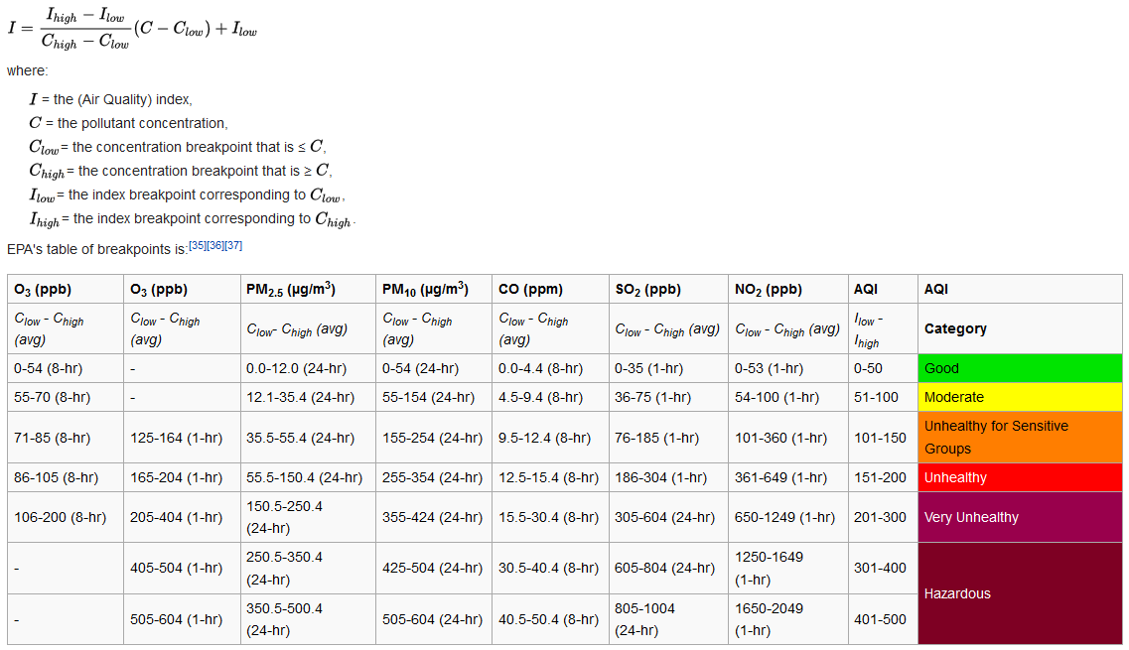

I = I h i g h − I l o w C h i g h − C l o w ( C − C l o w ) + I l o w {\displaystyle I={\frac {I_{high}-I_{low}}{C_{high}-C_{low}}}(C-C_{low})+I_{low}} Suppose a monitor records a 24-hour average fine particle (PM2.5) concentration of 12.0 micrograms per cubic meter. The equation above results in an AQI of:

50 − 0 12.0 − 0 ( 12.0 − 0 ) + 0 = 50 {\displaystyle {\frac {50-0}{12.0-0}}(12.0-0)+0=50} 

corresponding to air quality in the "Good" range. To convert an air pollutant concentration to an AQI, EPA has developed a calculator.[[38]](https://en.wikipedia.org/wiki/Air_quality_index#cite_note-38)

If multiple pollutants are measured at a monitoring site, then the largest or "dominant" AQI value is reported for the location. The ozone AQI between 100 and 300 is computed by selecting the larger of the AQI calculated with a 1-hour ozone value and the AQI computed with the 8-hour ozone value.

8-hour ozone averages do not define AQI values greater than 300; AQI values of 301 or greater are calculated with 1-hour ozone concentrations. 1-hour SO2 values do not define higher AQI values greater than 200. AQI values of 201 or greater are calculated with 24-hour SO2 concentrations.

Real time monitoring data from continuous monitors are typically available as 1-hour averages. However, computation of the AQI for some pollutants requires averaging over multiple hours of data. (For example, calculation of the ozone AQI requires computation of an 8-hour average and computation of the PM2.5 or PM10 AQI requires a 24-hour average.) To accurately reflect the current air quality, the multi-hour average used for the AQI computation should be centered on the current time, but as concentrations of future hours are unknown and are difficult to estimate accurately, EPA uses surrogate concentrations to estimate these multi-hour averages. For reporting the PM2.5, PM10 and ozone air quality indices, this surrogate concentration is called the [NowCast](https://en.wikipedia.org/wiki/Nowcast_%28Air_Quality_Index%29). The Nowcast is a particular type of weighted average that provides more weight to the most recent air quality data when air pollution levels are changing.[[39]](https://en.wikipedia.org/wiki/Air_quality_index#cite_note-39)[[40]](https://en.wikipedia.org/wiki/Air_quality_index#cite_note-40)