**DRIVING AUTOCAD 2020**

DRIVING AUTOCAD 2020 explains how to draw 4 engineering drawings.

AutoCAD is a 2D / 3D modeling computer aided drawing software.

I show you how to draw in 2D using AutoCAD.

You can download a free version of AutoCAD 2020 and use it for 30 days.

You download AutoCAD 2020 from the AutoCAD website.

If you want to use AutoCAD after the 30-day trial version ends you must pay AutoCAD $200.00 a month or $1610.00 a year to use its software.

After downloading the free 30-day trial version of AutoCAD 2020, open it.

Below is what AutoCAD 2020 looks like after you open it

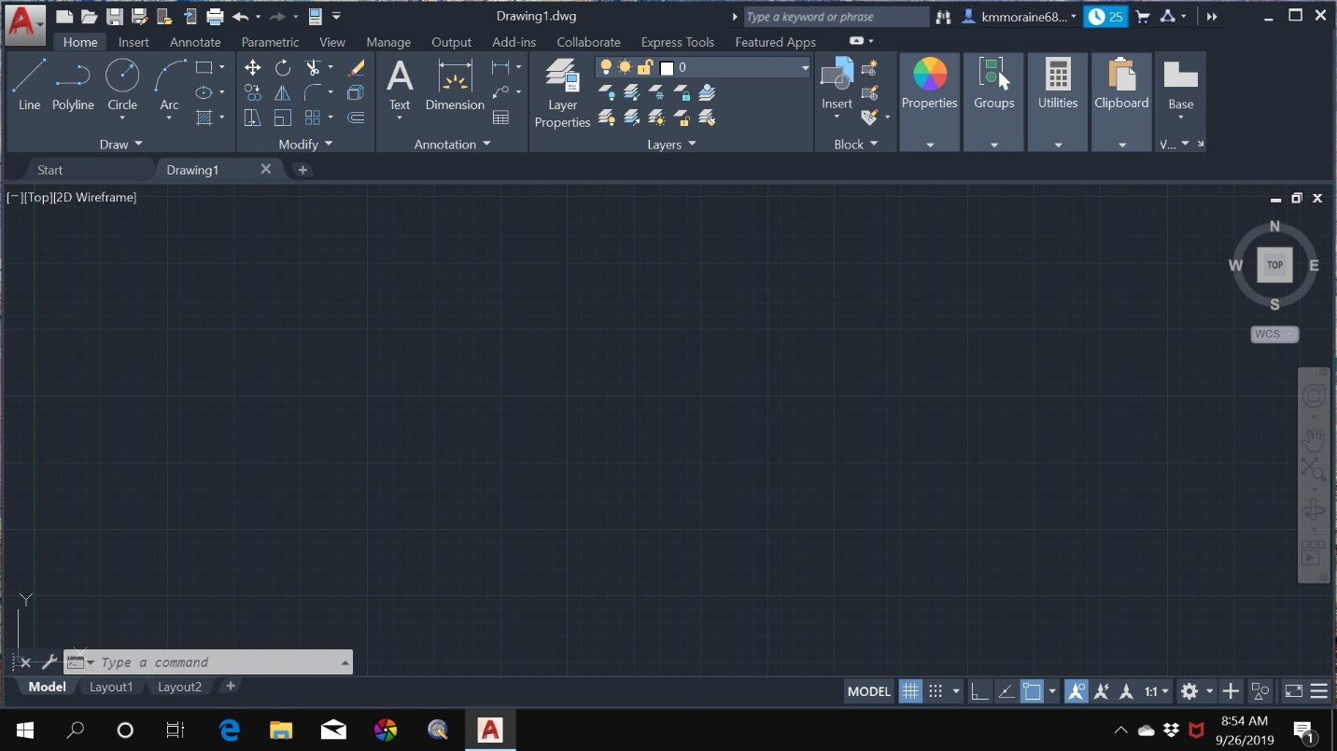

I use windows 10, a different operating system will display a screen that looks slightly different.

If you have a problem making one of my drawings click on the AutoCAD help button that’s located at the top of the screen. Watching an AutoCAD YouTube video or searching the web may help you know what to do.

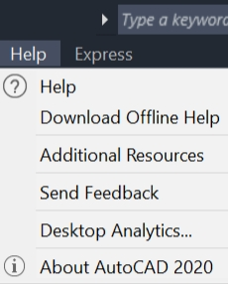

**MAKING A TEMPLATE**

Below is a picture of the **Command Line.**

The command line is located at the bottom of the screen.

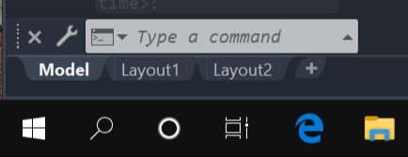

If there is something already typed in the command line press the Esc key to get rid of it.

Type **NEW** in the command line.

You may first have to click in the command line before the command line will accept what you type.

After you type the word **NEW,** there may be a couple second delay before the word **NEW** shows up in the command line.

After you see the word **NEW** in the command line press the enter key.

Double click on the acad.dwt file.

The acad.dwt file will open.

Type **UNITS** in the command line.

Press the enter key and the **Drawing Units** dialog box, shown below, will open.

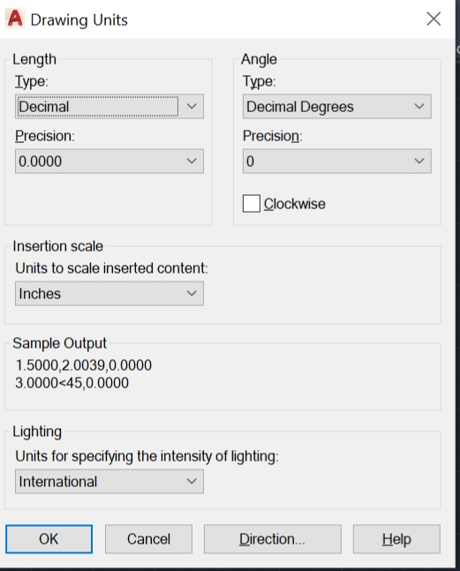

Set **Length Type:** to **Decimal**.

Set **Precision** **to .000** / **three decimal places**.

Set **Units** to **Inches.**

Click on **OK**.

Type **LIMITS** in the command line.

Press the enter key and the command line will look like the picture below.

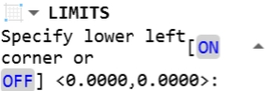

Press the enter key again and command line will look like the picture below.

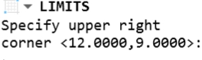

And once again press the enter key.

The **graphics screen size** has now been set to 12 inches by 9 inches.

You set the **Size Limits** based on the size of your drawing.

The drawings that you will be making are all smaller than the 12 by 9 inches.

AutoCAD **Limits Default** is 12 by 9 inches.

Type **ZOOM** in the command line.

Press the enter key.

Type **ALL** in the command line.

Press the enter key.

Doing this will zoom your drawing so it will fit the whole screen.

Press **F7** to turn the Drawing Grid Lines off.

You can leave the grid lines on if you want but I like them turned off.

Press the middle mouse wheel down and drag the X0, Y0 origin to approximately the middle of the screen.

Below is a picture of the X0, Y0 origin.

The center of the white square is the X0, Y0 origin location

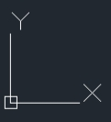

**MAKING THE TWO LAYERS**

Type **LAYER** in the command line.

Press the enter key and the **Layer Properties Manager** will display.

Clicking on the **Layer Properties** button that is located at the top of the screen will also open the **Layer Properties Manager.**

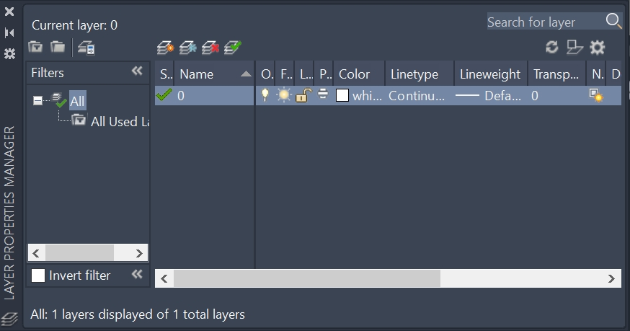**LAYER PROPERTIES MANAGER**

**MAKING THE OBJECT LINES LAYER**



Click on the **New Layer** button, it’s the second button from the left, the one with blue lines crisscrossing each other.

Type **OBJECT LINES** for the layer name.

Click on where it says **Color** and the **Select Color** window will open.

Click on **Index color:3 GREEN**

Click on **OK**.

**MAKING THE DIMENSIONS LAYER**

Click on the **New Layer** button.

Type **DIMENSIONS** for the layer’s name.

Click on where it says **Color** and the **Select Color** window will open.

Click on **Index color:2 YELLOW**

Click on **OK**.

**THE LAYER PROPERTIES MANAGER SHOULD NOW LOOK LIKE THIS**

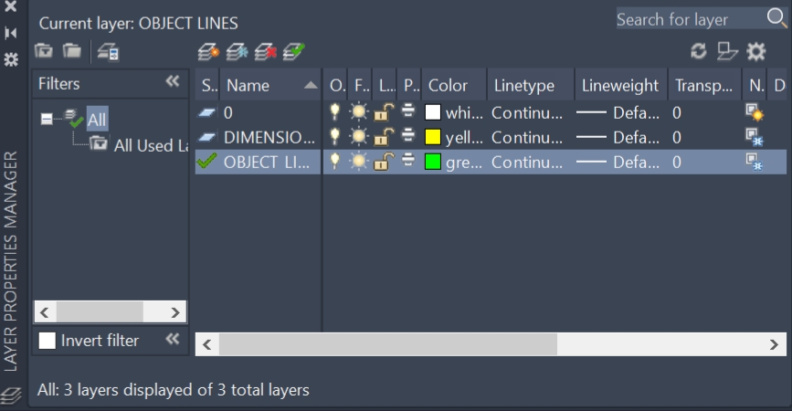

In the layer properties manager, you will see the **DIMENSIONS** layer and the **OBJECT** **LINES** layer that you made.

To close the Layer Properties Manager,left click on the little **white colored x** that is at the upper / left corner of the Layer Properties Manager.

Towards the top / left side of the screen, click on either the big red colored **A** or click **File.**

Click on **Save** **As**

Next to **File name:** type **AutoCAD Template**

Click **Save**

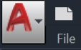

You have just made your AutoCAD Template that you will use to make all four drawings with.

Click on **File**, **File** is located at the top / left side of the screen, scroll down and click on **Open**.

Double click on the file that says AutoCAD Template.

After the AutoCAD Template opens you should not see the grid lines because the template that you are using for your drawings has the grid lines turned off.

Towards the top of the screen you will see a green colored square to the left of where it says OBJECT LINES**,** this means that OBJECT LINES is the active layer.

If DIMENSIONS is displayed, then open the layers window and click on OBJECT LINES to make OBJECT LINES the active layer.

The OBJECT LINES layer is the layer that you will be using most often.

The only time you want the dimension layer active is when you are placing dimensions on your drawing.

**TIPS TO HELP YOU USE AUTOCAD**

If your geometry does not get placed at the correct location on the screen the X, Y coordinates that you entered may be incorrect.

If the command line says **Type a command**, the command line is ready to have coordinates or commands typed into it. You do not need to click in the command line before entering coordinates or commands, although there may be times when you may need to click in the command before entering coordinates or commands. Pay attention to the command line to make sure that the information that you are typing is going into the command line. Paying close attention to the command line when using AutoCAD will help you use the software.

If you want to erase what's in the command line press the Esc key.

After you press the Esc key, you can type coordinates or commands and they will be placed in the command line.

Pressing the Esc key will end the current command that you are in.

If you make a mistake, pressing **Ctrl** **+** **Z** will undo the last command that you did and pressing **Ctrl** **+** **Y** will redo what you undid. You can also undo what you did by clicking on the arrow that points to the left. And you can bring back what you undid by clicking on the arrow that points to the right. These undo and redo arrows are located at the top of the screen.

If your geometry is the wrong color, you are on the wrong layer. You need to click on the OBJECT LINES layer. Once you’re on the object lines layer the geometry that you make will be green. If the geometry is white or yellow, you are either on the DIMENSIONS layer or the CONSTRUCTION layer.

If something on your drawing is incorrect then left click on it or drag a window over it so that it's highlighted. Press the delete button to remove it. Figure out what you did wrong and make the geometric shape / entity over again.

Drawing with 2D CAD software is a bit like writing a CNC program. Ten different people could write a CNC program to machine the same part. Each program could be written slightly different but still be able to machine the part correctly. The same can be said about using 2D CAD software. There are many ways to make a drawing and still have it come out correct.

If possible, use AutoCAD on your main computer and follow my instructions on how to make the drawing on a tablet or on another computer. This way you will not have to keep switching back and forth between AutoCAD and Microsoft Word on your main computer. It will make it much easier to make the drawing.

If possible, make a copy of the drawing on your printer so you can look at it while you are following my instructions on how to make it.

If you see a blue or green colored square window on the screen getting larger as you are moving the mouse and you want to get rid of it press the Esc key or left click.

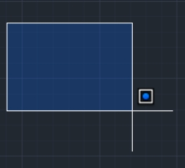

The drawings that I show you how to make have some radius dimensions on them. I sometimes double the radius value and use the diameter. I'm telling you this, so you don’t get lost trying to figure out what I’m doing.

**FIRST DRAWING**

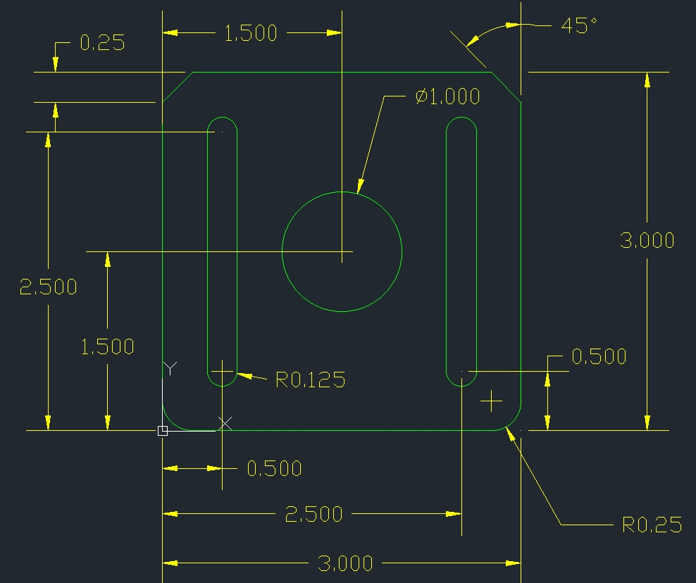

**MAKING THE 3" BY 3" INCH SQUARE**

Open your AutoCAD Template and make sure that the **OBJECT LINES** layer is highlighted on the layers list.

After opening the template, click on **File**, click on **Save** **As**, next to **File name:** type **FIRST DRAWING**, click **Save**.

The lower / left corner of the drawing is the X0, Y0 origin location.

Type **REC** in the command line

Press the enter key.

**REC** is the shortcut for the rectangle command.

Type 0,0

Press the enter key.

Type 3,3

Press the enter key.

Click on **Zoom Extends** button that’s located at the right side of the screen.

After clicking on zoom extends move the cursor to the middle of the 3” by 3” inch square and turn the middle mouse wheel towards you a bit to make the drawing a little smaller.

Another way to zoom your drawing so that it fits the whole screen is to double click the center mouse wheel.

**MAKING THE 1.00" INCH DIAMETER CIRCLE**

Type **CIR** in the command line, small caps will also work.

Press the enter key.

Type 1.5,1.5

Press the enter key.

Type .5

Press the enter key.

Press the Esc key to end the circle command.

**MAKING THE TWO CHAMFERS**

Type **CHA** in the command line.

Press the enter key.

Click on the word **Distance** in the command line.

Type .25

Press the enter key.

Type .25 again.

Press the enter key to repeat the chamfer command.

Click on the two lines that are located by the upper / left side of the drawing.

Press the enter key.

Click on the two lines that are located by the upper / right side of the drawing.

Press the Esckey to end the chamfer command.

**MAKING THE TWO .25” INCH RADIUS FILLETS**

Type **FIL** in the command line.

Press the enter key.

In the command line you will see the word **Radius**, click on the word **Radius**.

Type .25

Press the enter key.

Click on the two line by the bottom / left corner of the drawing to make the .25 fillet

Press the enter key to repeat the fillet command.

Click on the other two lines by the bottom / right side of the drawing to make the other .25” fillet.

Press theEsc key to end the fillet command.

**MAKING THE FOUR .25 INCH DIAMETER CIRCLES**

Type **CIR** in the command line

Press the enter key.

Type .5, .5

Press the enter key.

Type .125

Press the enter key.

Press the enter key again to make the first circle.

Type .5, 2.5

Press the enter key.

Press the enter key again to make the second circle.

Press the enter key.

Type 2.5, .5

Press the enter key.

Press the enter key again to make the third circle.

Press the enter key.

Type 2.5, 2.5

Press the enter key.

Press the enter key again to make the fourth circle.

Press the Esc key to end the circle command.

**MAKING THE 4 LINES / TANGENT TO THE .25” DIAMETER CIRCLES**

Turn on Object Snap**,** the Object Snap button is located at the bottom / right side of the screen.

**F3** turnsObject Snap on or off.

You will know whenObject Snap is turned on, the button will be highlighted in blue.

If you cannot get Object Snap to turn on you will first have to left click on the object snap settings down arrow to open the object snap settings window.

After the Object Snapsettingswindow opens, click on **Quadrant**.

To close the Object Snapsettings window, left click.



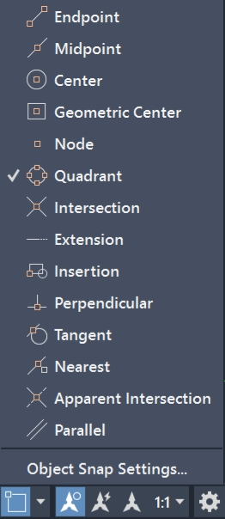

Left click on the **LINE** tool button that is located at the top / left side of the screen.

Move the cursor to the left side of the top / left .25” diameter circle.

When you see a **square cursor** appear, and the word **Quadrant,** click and move the line down to the left side of the bottom / left circle.

When you see the little square cursor appear, left click.

Press the enter key.

Press the enter key again to repeat the line command.

Use the same procedure to make the other 3 tangent lines.

When you are done making the 4 tangent lines press the Esc key to end the line command.

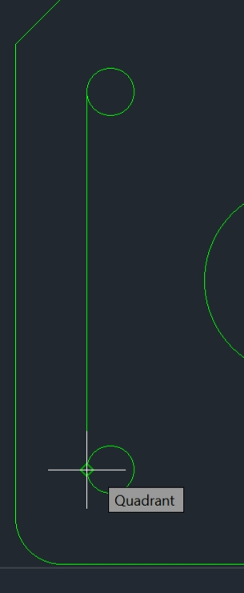

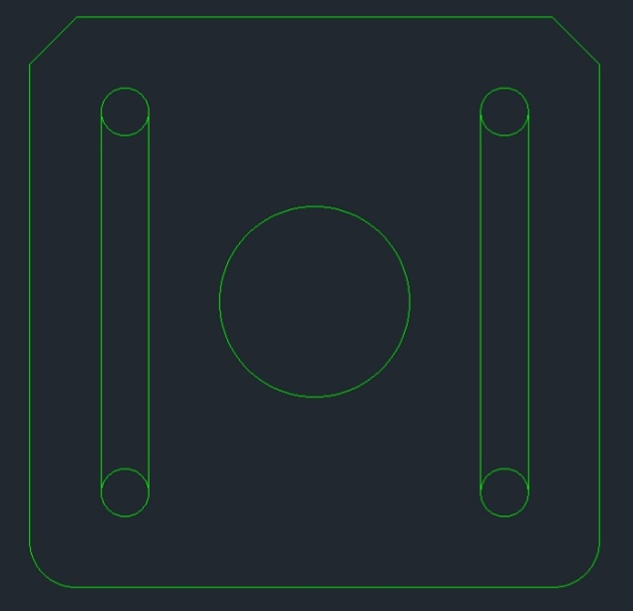

**TRIM THE FOUR .25” INCH DIAMETER CIRCLES**

Type **TRI** in the command line.

Press the enter key.

Press the enter key again.

Where you see the little white square cursor in the picture below is where you want to left click to trim that section of the circle.

Left click on the insides of all four .25” diameter circles and the inner arcs will be removed.

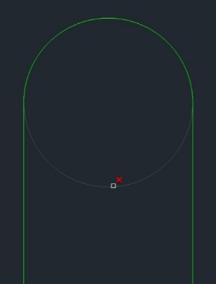

Press the Esc key to end the trim command.

**THE FINISHED DRAWING SHOULD LOOK LIKE THIS**

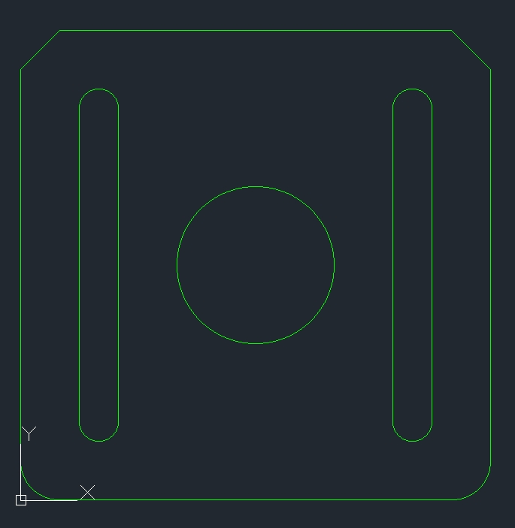

**SECOND DRAWING**

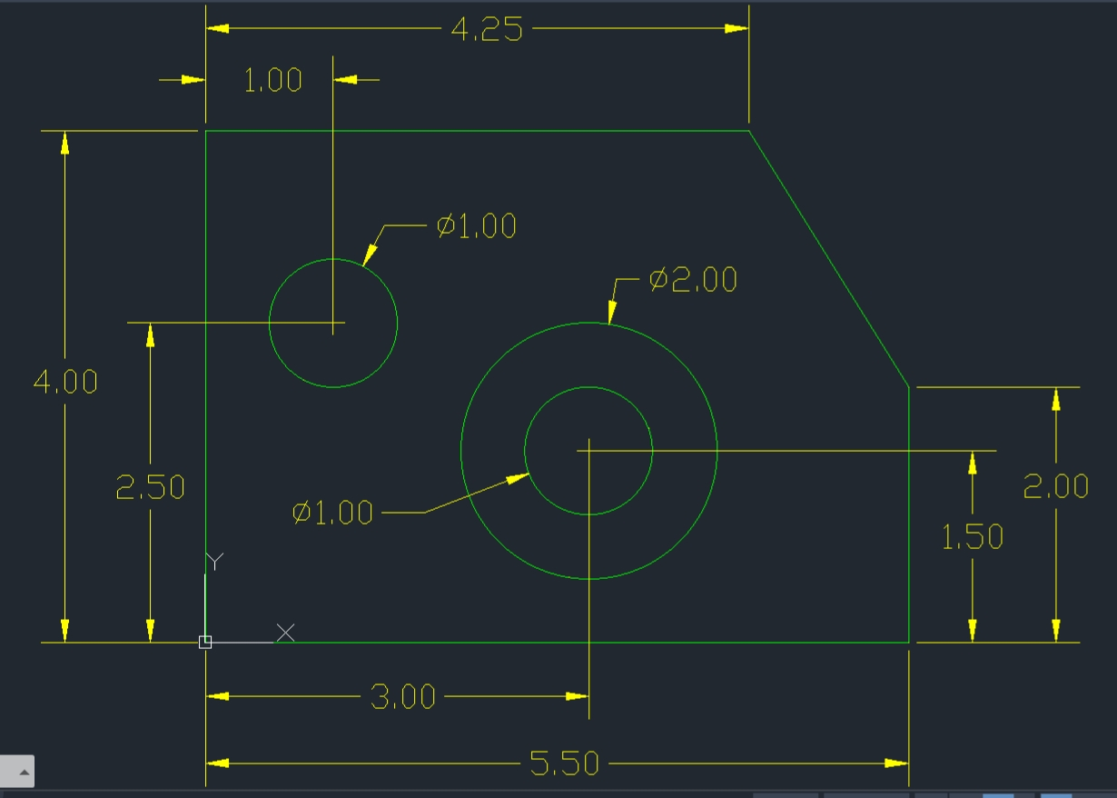

**MAKING THE OUTSIDE SHAPE**

Open your AutoCAD Template and make sure that the **OBJECT LINES** layer is highlighted on the layers list.

Click on **File**, click on **Save** **As**, next to **File Name:** type **SECOND DRAWING**, click **Save**.

The lower / left corner of the drawing is the X0, Y0 origin location.

You will be using **Direct Distance Entry** to draw the outside shape.

**Direct Distance Entry** means you move the cursor with the mouse in the direction that you want to make your line at. You then enter a distance, how long you want the line to be and press the enter key to make the line.

Turn on theSnap**.**

F9 turns the Snap on or off.

Turn on the Ortho/ F8 turns the Ortho on or off.

The Snapand theOrthobuttons are located at the bottom / right side of the screen, left click on them to turn them on or off. They will be highlighted in blue when they are turned on.

Click on the **LINE** tool button, the LINE tool button is located at the top / left side of the screen.

With the mouse, move the cursor to the X,0 Y,0 origin location, you will see that the line wants to snap to the X0, Y0 origin location, click to start the line at the X0, Y0 origin.

Move the cursor / vertical line upward so it is approximately a couple inches long.

Type 4

Press the enter key.

Move the cursor / line to the right by moving your mouse, make the horizontal line approximately a couple inches long.

Type 4.25

Press the enter key.

Press the Esc key to get out of the line command.

**YOUR DRAWING SHOULD LOOK LIKE THIS**

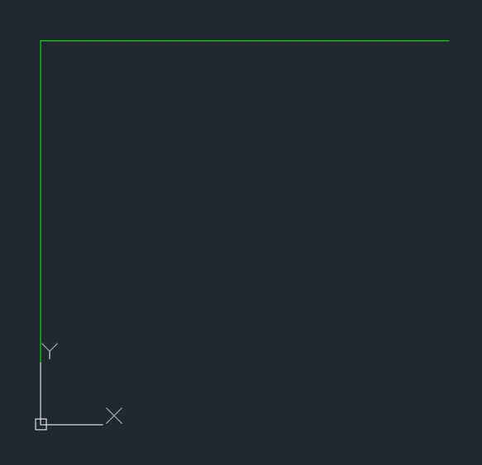

Type **LIN** in the command line.

Press the enter key.

Left click on the X0, Y0 origin location and move the cursor to the right so that the bottom horizontal line is approximately a couple inches long.

Type 5.5

Press the enter key.

Move the cursor up and make the vertical line approximately a couple inches long.

Type 2

Press the enter key.

Move the cursor to the Ortho button that’s located at the bottom / right side of the screen and click on it to turn Ortho off.

If the button is highlighted in blue, Ortho is still on.

Your line will follow you as you move the cursor to turn Orthooff, don’t worry, that’s ok.

Click on the Object Snapbutton to turn it on.

Next to the ObjectSnap button is an arrow that points down.

Left click on this arrow to open the ObjectSnapsettingswindow**.**

Another way of open the Object Snap settings window / dialog box, is to right click on the Object Snap button.

Click on the word **Endpoint**.

To close the ObjectSnapsettings window, left click.

Click the Snap button to turn it off, you want Snap turned off.

Move the cursor to the right side of the 4.25” horizontal line, when you see a green colored square, left click.

Press the Esc key to end the line command.

Click on the Zoom Extendsbutton that’s located at the right side of the screen or double click the center mouse wheel.

Move the cursor to the middle of your drawing and turn the middle mouse wheel toward you to make the drawing a little smaller.

**YOUR DRAWING SHOULD LOOK LIKE THIS**

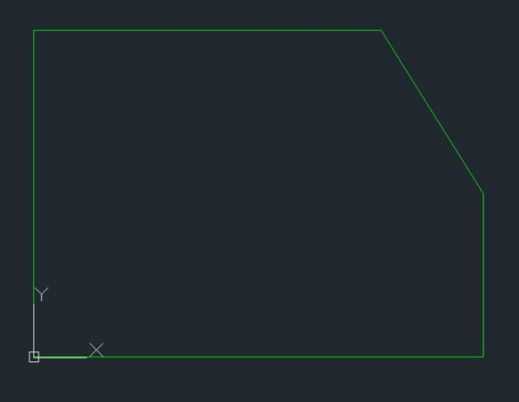

**MAKING THE TWO 1.00" DIAMETER CIRCLES AND THE ONE 2.00”**

Type **CIR** in the command line.

Press the enter key.

Type 1, 2.5

Press the enter key.

Type .5

Press the enter key.

The top / left 1.00" diameter circle has been made.

Press the enter key again to repeat the circle command.

Type 3, 1.5

Press the enter key.

You do not need to enter a radius value for this circle because it’s the same radius that you just used to make the first circle. The command line shows this previous radius value **<0.500>:**

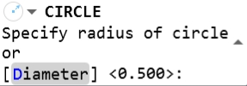

Press the enter key.

The second 1.00" diameter circle has been made.

Press the enter key to repeat the circle command.

Type 3,1.5

Press the enter key.

Type 1

Press the enter key.

The 2.00" diameter circle has been made.

Press the Esc key to end the circle command.

**THIRD DRAWING**

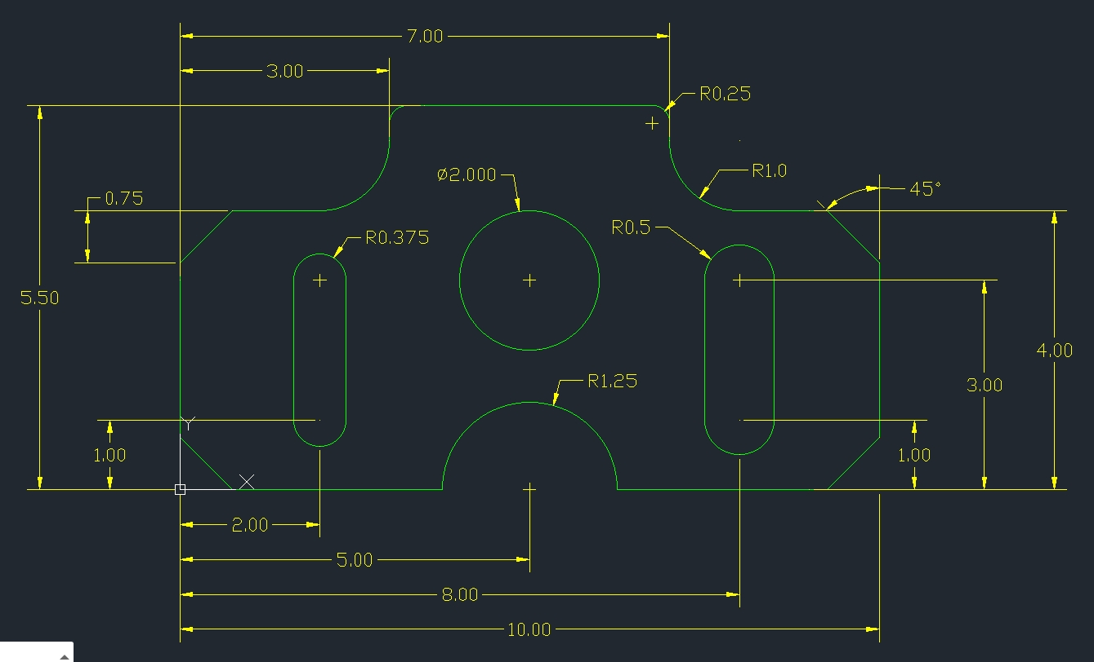

The lower / left corner of the drawing is the X0, Y0 origin location.

Open your AutoCAD Template and make sure that the **OBJECT LINES** layer is highlighted on the layers list.

After opening the template, click on **File**, click on **Save** **As**, next to **File Name:** type **THIRD DRAWING**, click **Save**.

**MAKING THE OUTSIDE SHAPE**

Click in the command line and type **LINE**

Press the enter key.

The command line will say **Specify** **first point:**

Type 0,0

Press the enter key

The command line will say **Specify** **next point** or [

Type 0,4

Press the enter key

Type 3,4

Press the enter key.

Type 3,5.5

Press the enter key.

Type 7,5.5

Press the enter key

Type 7,4

Press the enter key

Type 10,4

Press the enter key

Type 10,0

Press the enter key

Type 0,0 in the command line.

Press the enter key

Press theEsc key to end the line command.

**YOUR DRAWING SHOULD LOOK LIKE THIS**

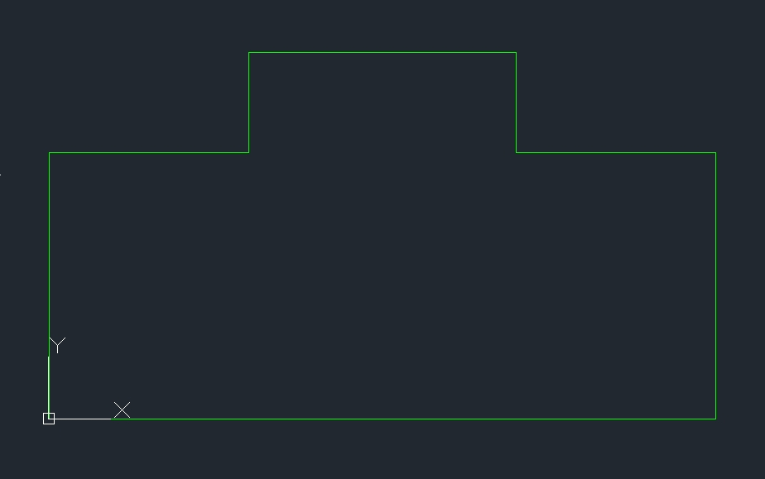

**MAKING THE FOUR .75 INCH CHAMFERS**

Click in the command line and type **CHAM**

Press the enter key

Click on the word **Distance** that’s in the command line.

Type .75 in the command line.

Press the enter key.

Press the enter key again.

Click on the 2 two lines by the corner where one of the chamfer needs to be made.

Press the enter key to repeat the chamfer command

Click on the two more lines where another chamfer needs to be made.

Press the enter key.

Use the same steps just mentioned to make the other two .75” by .75” chamfers.

Press the Esc key to end the chamfer command.

**MAKING THE TWO 1.00” INCH RADIUS FILLETS**

Type **FIL** in the command line.

Press the enter key.

One of the words that you will see in the command line is **Radius**.

Click on the word **Radius**

The command line will say **Specify fillet radius:**

Type **1**

Press the enter key

The command line will say **Select first object or [**

Click on the two lines where one of the 1.00” radius fillet is located at.

Press the enter key to repeat the fillet command.

Click on the other two lines where the other 1.00” radius fillet is at.

Press the Esc key to end the fillet command.

**MAKING THE TWO .25” INCH RADIUS FILLETS**

Type **FIL** in the command line.

Press the enter key.

One of the words that you will see in the command line is **Radius**.

Click on the word **Radius.**

The command line will say **Specify fillet radius**

Type.25

Press the enter key

The command line will say **Select first object or [**

Click on the two lines by one of the .25” radius fillets.

Press the enter key to repeat the fillet command.

Click on the other two lines by the other .25 radius fillet.

Press the Esc key to end the fillet command.

**MAKING THE 2.00" INCH DIAMETER CIRCLE**

Type **CIR** in the command line.

Press the enter key.

The command line will say **Specify center point for circle or**

Type 5,3

Press the enter key.

Type 1

You typed 1 because 1 is the radius of 2 inches.

AutoCAD uses the radius value when making circles.

Press the enter key.

Press the Esc key to end the circle command.

**MAKING THE TWO .75” INCH DIAMETER CIRCLES**

Type **CIR** in the command line.

Press the enter key.

Type 2,3

Press the enter key.

Type .375

Press the enter key.

Press the enter key again to repeat the circle command.

Type 2,1

Press the enter key.

Press the enter key again because you are still using the same radius value of .375

**MAKING THE TWO 1.00” INCH DIAMETER CIRCLES**

Type **CIR** in the command line.

Press the enter key.

Type 8,3

Press the enter key.

Type .5

Press the enter key.

Press the enter key to repeat the circle command.

Type 8,1

Press the enter key.

Press the enter key again because you are using .5 for the radius again.

**YOUR DRAWING SHOULD LOOK LIKE THIS**

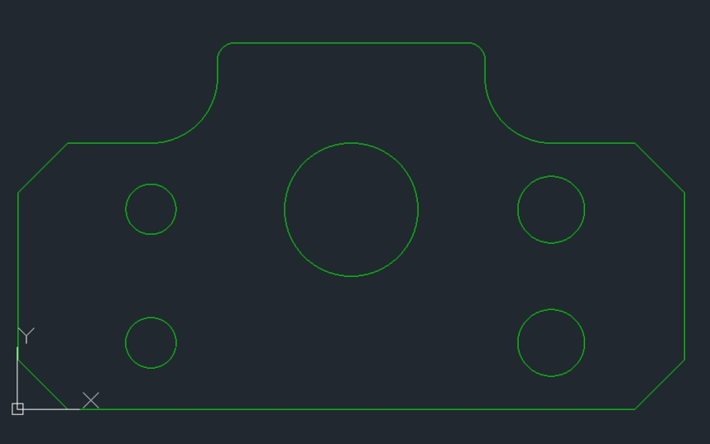

**PLACING THE 4 TANGENT / VERTICAL LINES ON THE TWO .750” DIAMETER CIRCLES AND ON THE TWO 1.00" DIAMETER CIRCLES**

Click on the **LINE** tool button that located by the top / left side of the screen.

Make sure **Object Snap is turned on and Quadrant is selected** from the Object Snap settings, drop down menu, as shown below.



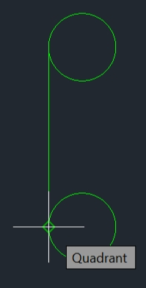Move the cursor to the left side of the top .75” inch diameter circle.

When you see a little square cursorappear and the word **Quadrant**, click and move the line down to the left side of the bottom .75” diameter circle.

You will again see the word **Quadrant** next to a little square shapedcursor, click to complete the first tangent line.

Press the Esckey to get out of the line command.

Press the enter key again to repeat the line command and follow the same procedures to complete the other three tangent lines.

**YOUR DRAWING SHOULD LOOK LIKE THIS**

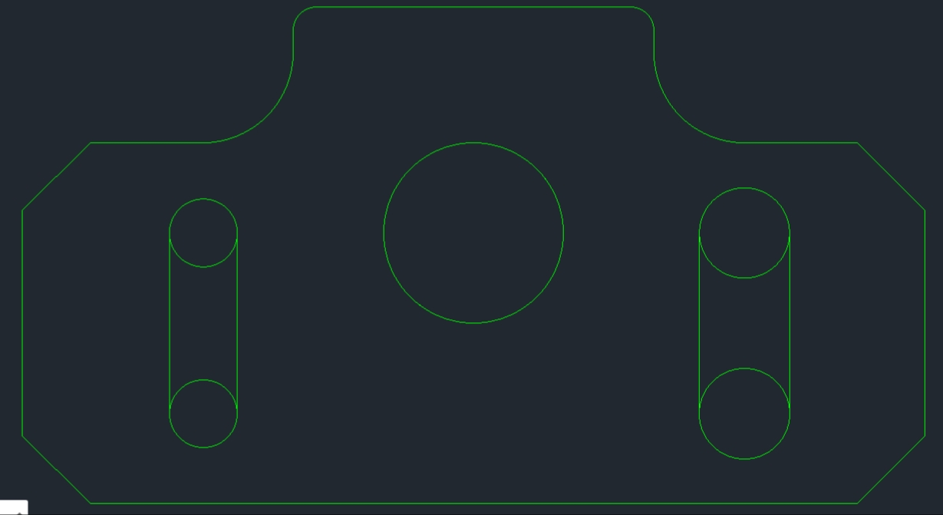

**TRIM THE 4 CIRCLES**

Type **TRI** in the command line.

Press the enter key.

Press the enter key again.

Move the little square cursor with the mouse to the inside arc of the .750’ diameter circles.

Left click and the inside arc of the circle will be removed.

Left click on the other three circles inside arcs to remove them.

Press the Esc key to end the trim command.

**MAKING THE 1.25” INCH RADIUS ARC**

Type **CIR** in the command line.

Press the enter key.

Type 5,0

Press the enter key.

Type 1.25

Press the enter key.

Press the Esc key to end the circle command.

**TRIM THE 1.25” INCH RADIUS ARC**

Type **TRI** in the command line.

Press the enter key.

Press the enter key again.

Move the little square cursor to the bottom of the 1.25” radius circle and click to remove the bottom part of the circle.

Move the little square cursor to the line that goes through the center of the circle and click to remove it.

Press the Esc key to end the trim command.

**YOUR COMPLETED DRAWING SHOULD LOOK LIKE THIS**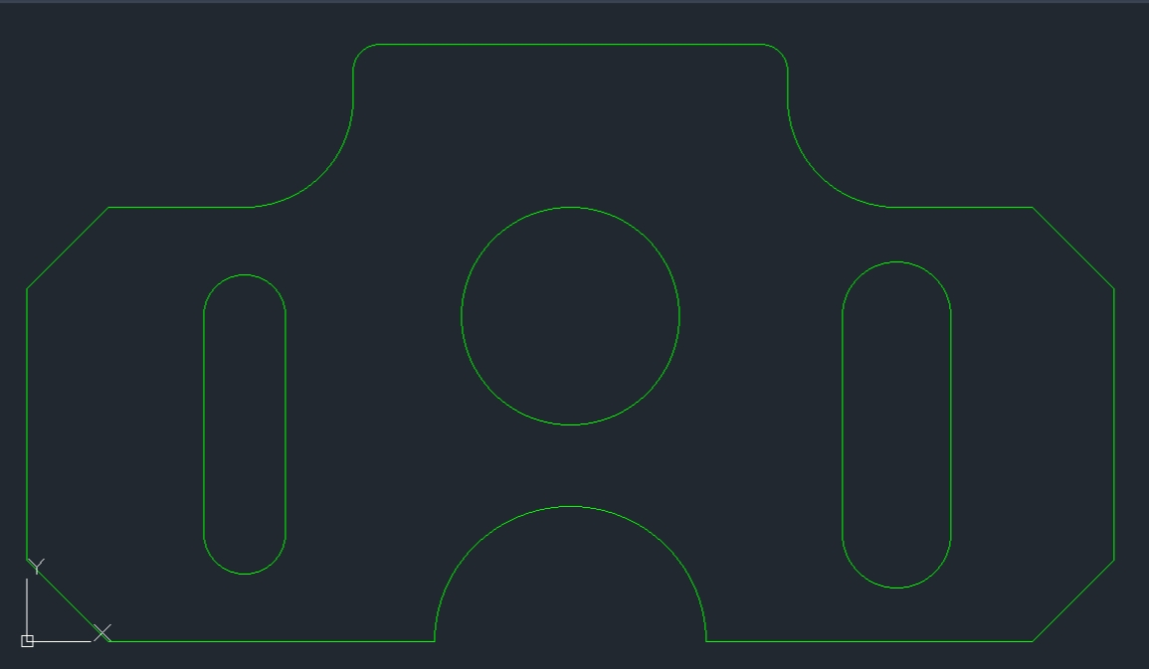

**FOURTH DRAWING**

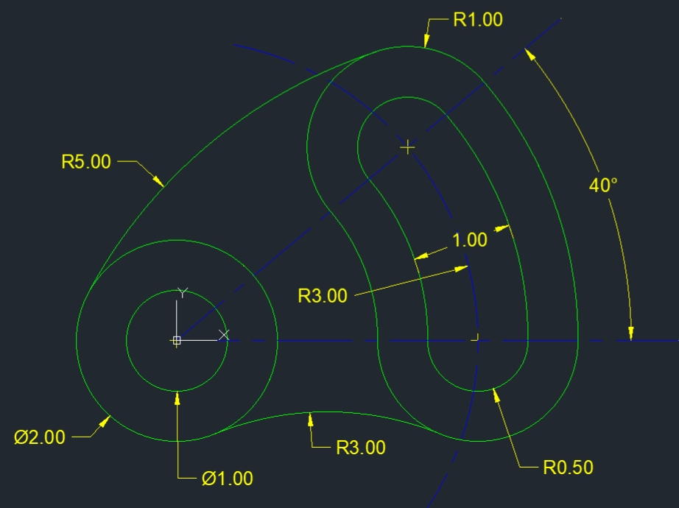

The center of the 1.00" and 2.00" diameter circles that are located at the left side of the drawing is the X0, Y0 origin location.

Open your AutoCAD Template and make sure that the OBJECT LINESlayer is highlighted on the layers list.

After opening the template, click on **File**, click on **Save** **As**, next to **File Name:** type **FOURTH DRAWING**, click **Save**.

**MAKING THE 1.00” and 2.00” INCH DIAMETER CIRCLES AT X0, Y0**

Type **CIR** in the command line.

Press the enter key.

Type 0,0

Press the enter key.

Type .5

Press the enter key.

Press the enter key again to repeat the line command.

Type 0,0

Press the enter key.

Type 1

Press the enter key.

**MAKING THE 1.00” INCH DIAMETER CIRCLE AT X3,0**

Press the enter key again to repeat the circle command.

Type 3,0

Press the enter key.

Type .5

Press the enter key.

Press the enter key again to repeat the circle command.

**MAKING THE OTHER 1.00” INCH DIAMETER CIRCLE**

Type **LIN** in the command line.

Press the enter key.

Type 0,0

Press the enter key.

Type **@3<40**

Press the enter key.

Press the Esc key to get out of the line command.

Type **CIRCLE** in the command line.

Press the enter key.

Turn on **Endpoint** by going into the **Object Snap settings** and clicking next to where it says **Endpoint**.

Click on the endpoint of the 3.00” long / forty-degree angled line.

Type .5

Press the enter key.

Click on the 3.00” long construction line and press the delete key.

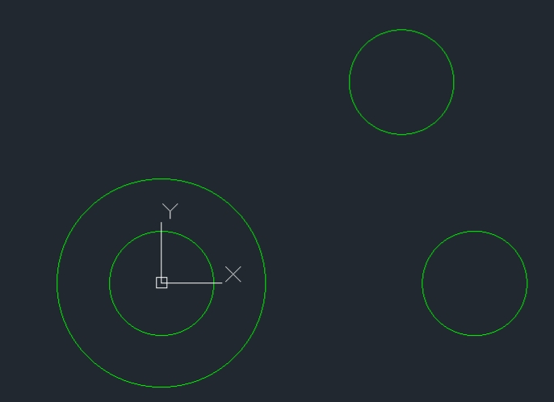**YOUR DRAWING SHOULD LOOK LIKE THIS**

**MAKING THE 5” INCH DIAMETER CIRCLE AT X0, Y0**

In the command line type **CIR**

Press the enter key.

Type 0,0

Press the enter key.

Type 2.5

Press the enter key

Press the Esc key to end the circle command.

**TRIMMING THE 5” INCH DIAMETER CIRCLE**

Type **TRI** in the command line.

Press the enter key.

Press the enter key again.

Click on part of the circle that isn't tangent to the two 1.00” diameter circles.

The white colored square is a good place to click at.

Press the Esc key to get out of the trim command.

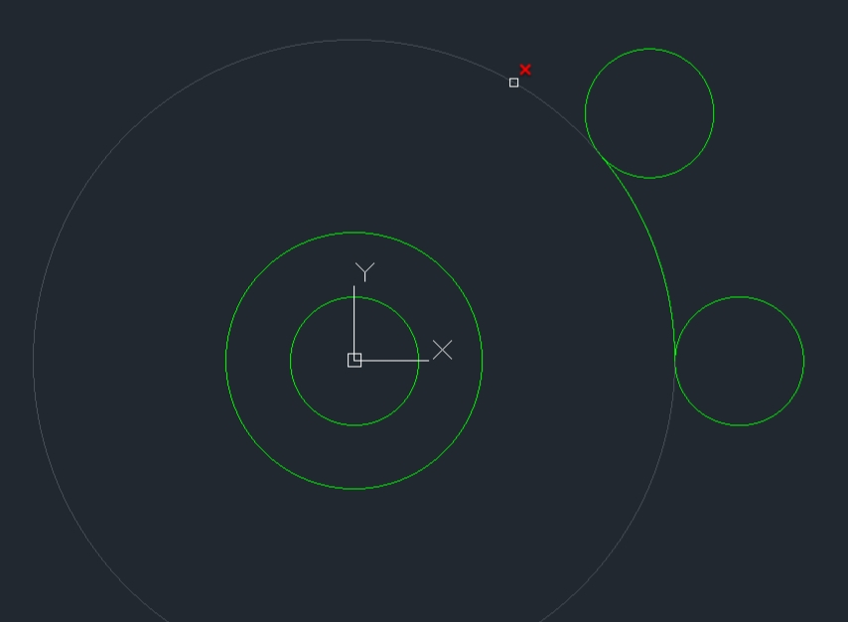

**MAKING THE 7” INCH DIAMETER CIRCLE AT X0, Y0**

In the command line type **CIR**

Press the enter key.

Type 0,0

Press the enter key.

Type 3.5

Press the enter key

Press the Esc key to end the circle command.

**TRIMMING THE 7” INCH DIAMETER CIRCLE**

Type **TRI** in the command line.

Press the enter key.

Press the enter key again.

The white colored square is a good place to click at.

Press the Esc key to get out of the trim command.

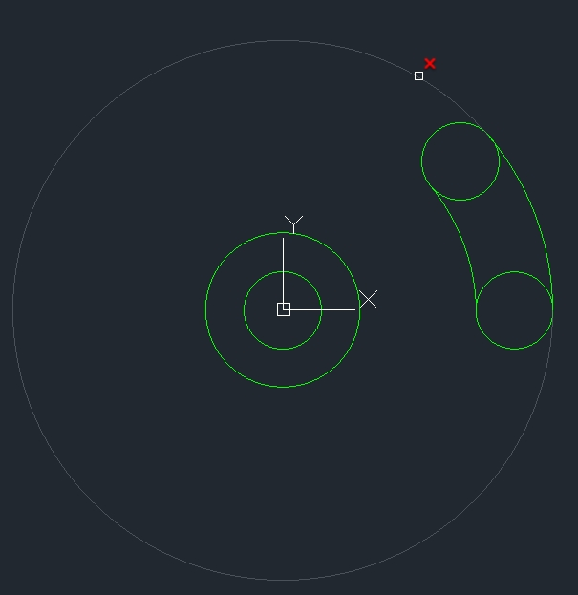

**YOUR DRAWING SHOULD LOOK LIKE THIS**

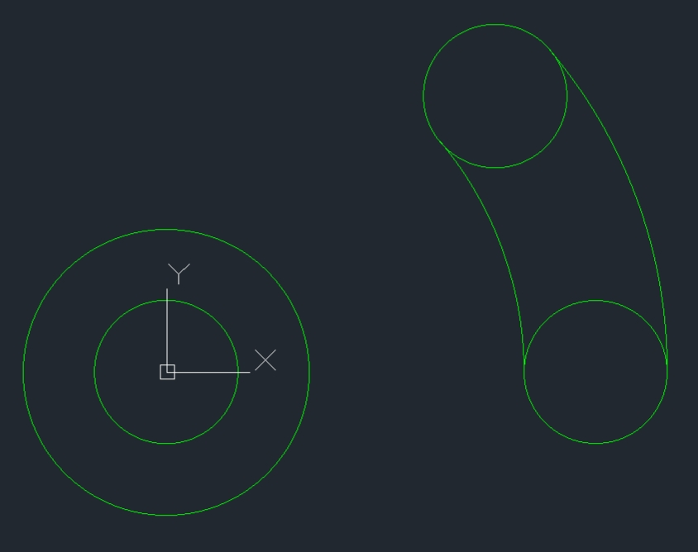

**TRIM THE 2 ARC SECTIONS OUT OF THE 1.00” WIDE SLOT**

Type **TRI** in the command line.

Press the enter key.

Press the enter key again.

Click by the white colored square and click on the other 1.00” diameter circle at approximately the same location as the first.

Press the Esc key to end the trim command.

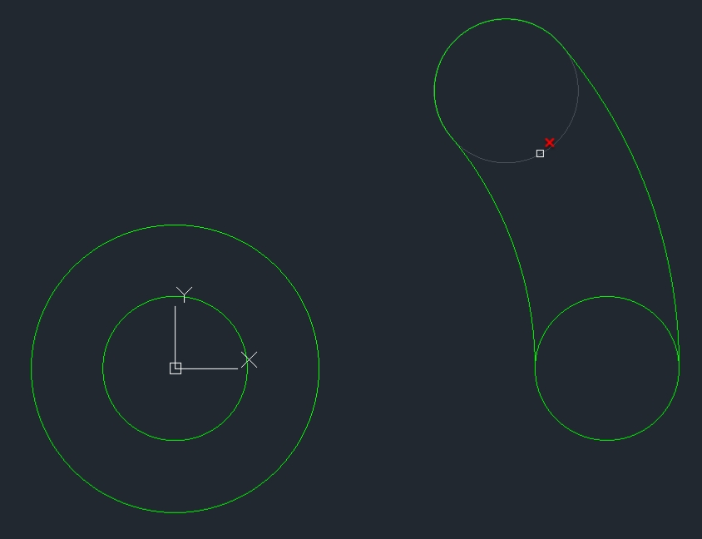

**YOUR DRAWING SHOULD LOOK LIKE THIS**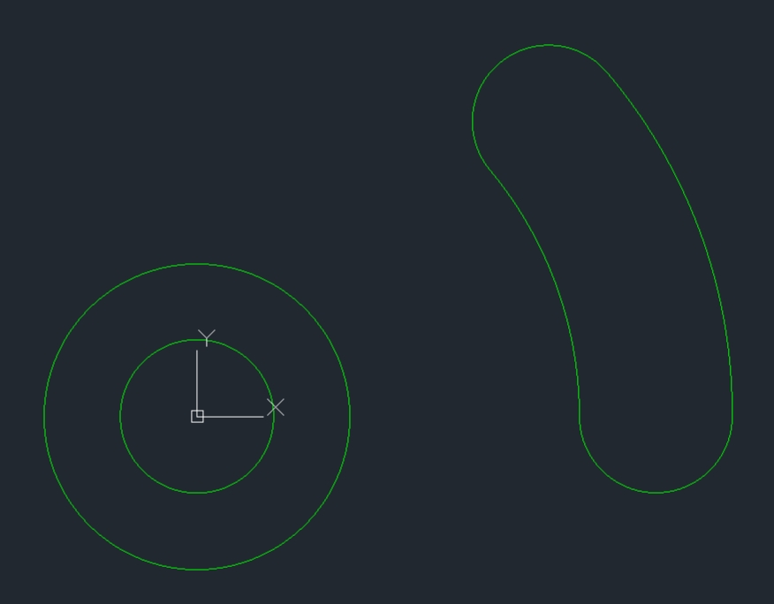

**MAKING THE TWO 2.00” INCH DIAMETER CIRCLE**

Type **CIR** in the command line.

Press the enter key.

Type 3,0

Press the enter key.

Type 1

Press the enter key.

Turn on **Object Snap**.

Go into the Object Snap settings and click **Center**.

Move the cursor to the center of the upper / 1.00” diameter arc.

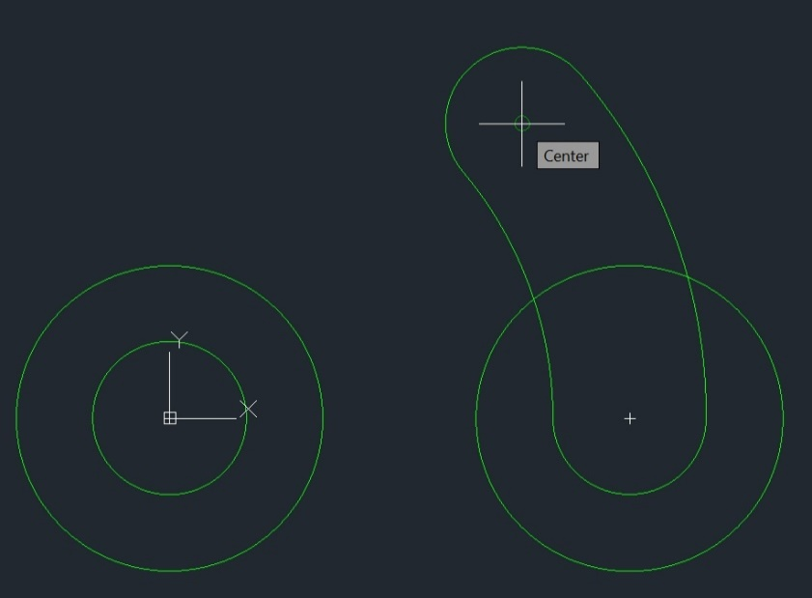

When you see the white crosshairs and the word **Center**, left click.

Press the enter key and the 2.00” diameter circle towards the top will be made.

**MAKING THE 4” INCH DIAMETER CIRCLE AT X0, Y0**

In the command line type **CIRCLE**

Press the enter key.

Type 0,0

Press the enter key.

Type 2

Press the enter key.

**TRIMMING THE 4” INCH DIAMETER CIRCLE**

Type **TRI** in the command line.

Press the enter key.

Press the enter key again.

The white colored square is a good place to click at.

Press the Esc key to get out of the trim command.

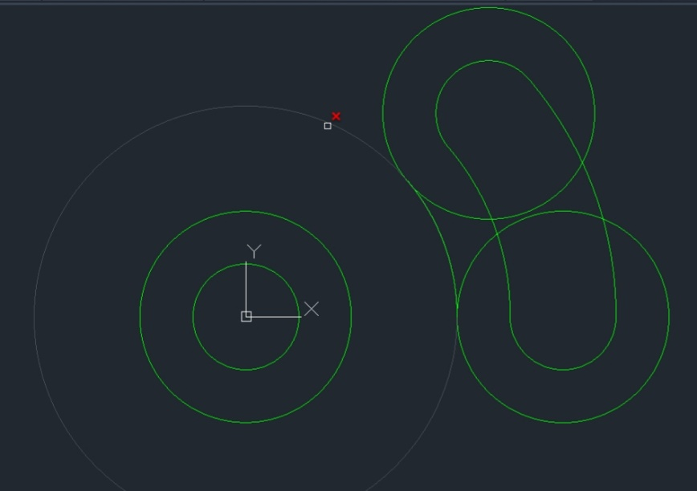

**MAKING THE 8” INCH DIAMETER CIRCLE AT X0, Y0**

In the command line type **CIRCLE**

Press the enter key.

Type 0,0

Press the enter key.

Type 4

Press the enter key.

Press the Esc key to end the circle command.

**TRIM THE 8.00” INCH DIAMETER CIRCLE**

Type **TRI** in the command line.

Press the enter key.

Press the enter key again.

Click on part of the circle that isn't tangent to the 8-inch diameter circle.

The white colored square is a good place to click at.

Press the Esc key to get out of the trim command.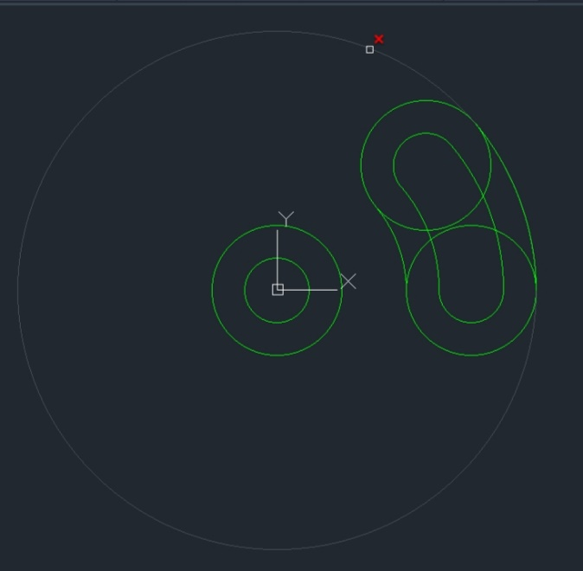

**Trim the 1.00” inch wide slot and the 2.00" diameter circles**

Type **TRI** in the command line.

Press the enter key.

Press the enter key again.

Click on the six arc sections that need to be removed.

Press the Esc key to end the trim command.

**YOUR DRAWING SHOULD LOOK LIKE THIS**

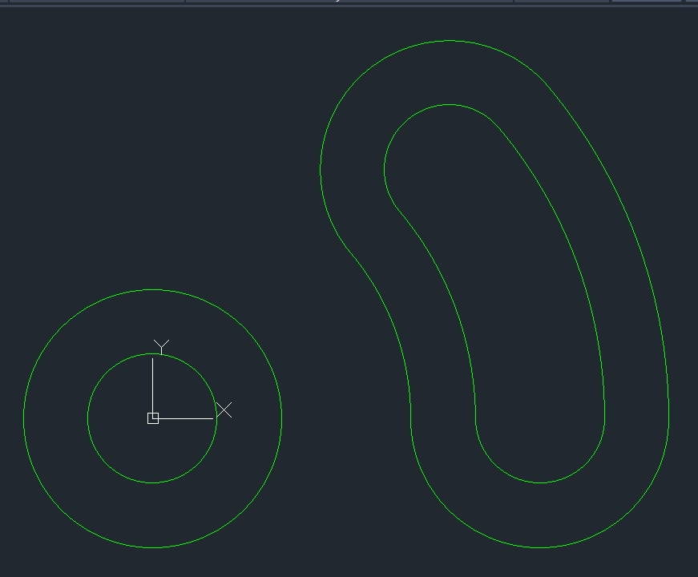

**MAKING THE 3.00” INCH RADIUS ARC AT THE BOTTOM**

Left click on the arrow that is located under the **CIRCLE** tool.

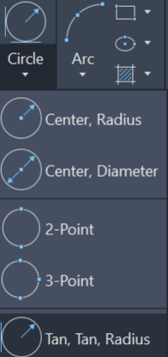Left click on **Tan, Tan, Radius**

The command will say **Specify point on object for first tangent of circle**

Click at the bottom of the 2.00” diameter circle that’s at the left side of the drawing.

The command line will say **Specify point on object for second tangent of circle**

Click on the 2.00" arc that’s located on the bottom / right side of the drawing.

The command line will say **Specify radius of circle**

Type 3 in the command line.

Press the enter key and a 3.00" radius will be made tangent to both 2.00" diameter circles.

**TRIM THE 3.00” INCH RADIUS CIRCLE**

Type **TRI** in the command line.

Press the enter key.

Press the enter key again.

Move the mouse / the little white colored square cursor to where I have it positioned on the picture below and then left click to trim the remainder of the 3.00” radius circle.

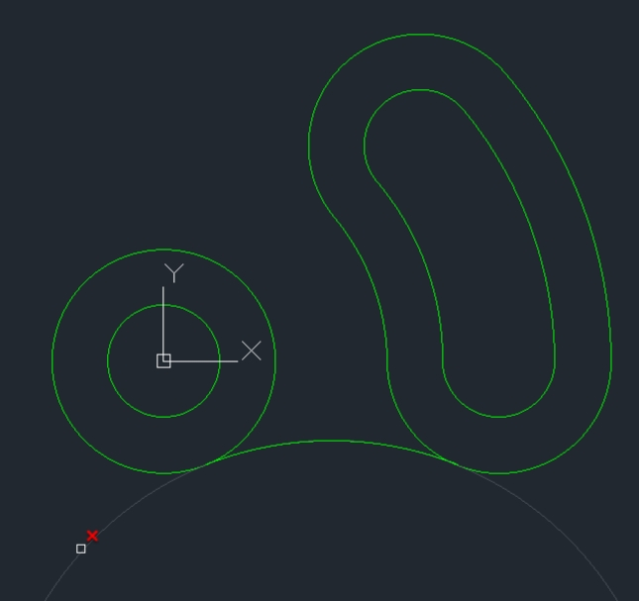**YOUR DRAWING SHOULD LOOK LIKE THIS**

**MAKING THE 5.00” INCH RADIUS CIRCLE**

Click on the little arrow that is located under the **CIRCLE** tool.

Click on **Tan, Tan, Radius**

Click at the 10 o'clock position on the 2.00” diameter circle that’s at the left side of the drawing.

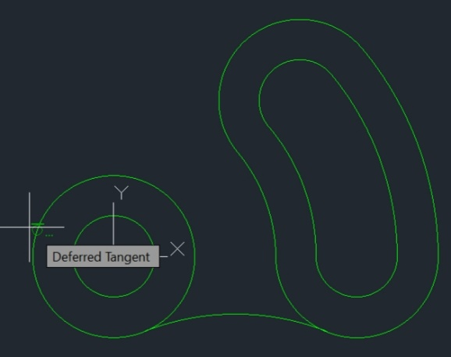

Click at the eleven o'clock position on the 2.00" diameter arc that’s located at the right side of the drawing.

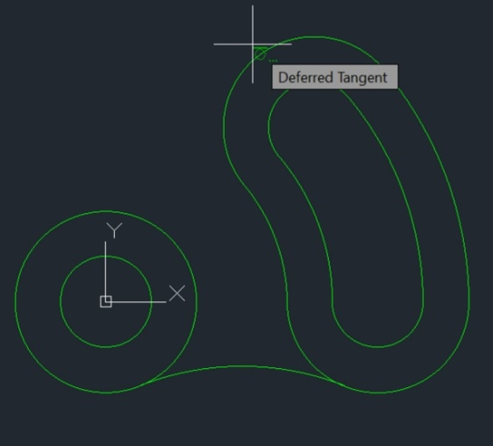

Type 5 in the command line.

Press the enter key and a 5.00" radius arc will be made tangent to the 2.00" diameter circle and the 2.00" diameter arc.

**TRIM THE 5.00” INCH RADIUS CIRCLE**

Type **TRI** in the command line.

Press the enter key.

Press the enter key again.

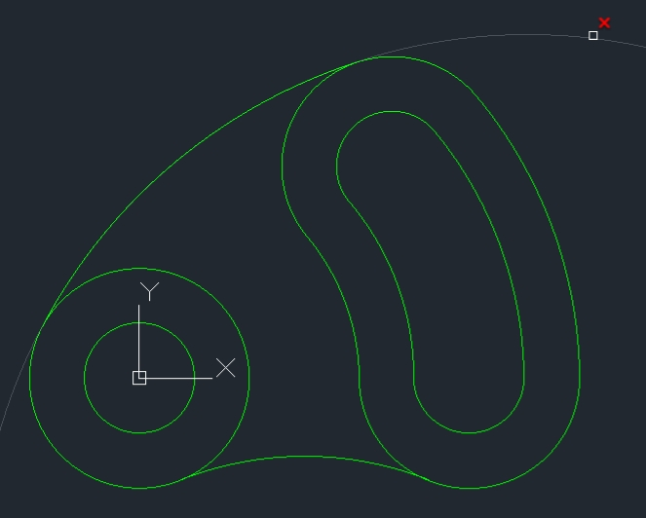Move the white colored square shaped cursor to where I have it positioned on the picture below and left click to remove the remainder of the 5.00” diameter circle.

**BELOW IS THE FINISHED DRAWING**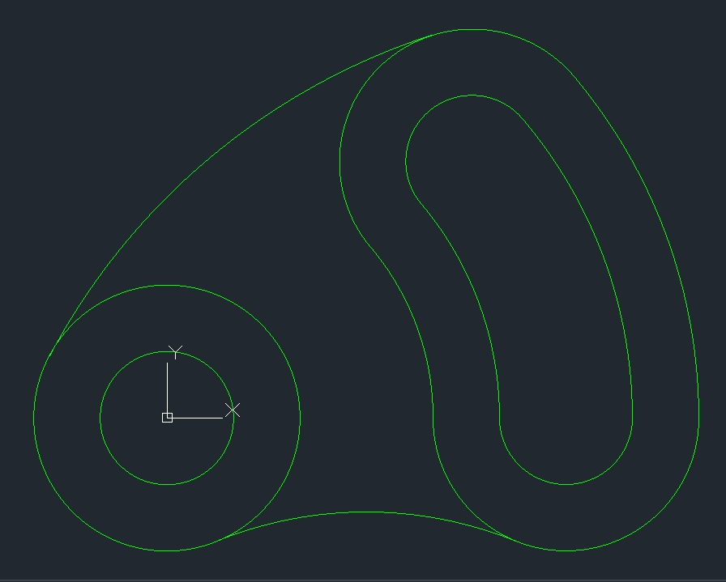

Below I explain how to insert a picture of the drawing that you are going to be making onto the drawing page / screen.

You may want to use this technique for the **THIRD** **DRAWING** and **FOURTH DRAWING** or for all the drawings.

It is not necessary to do this, but you may find it helpful.

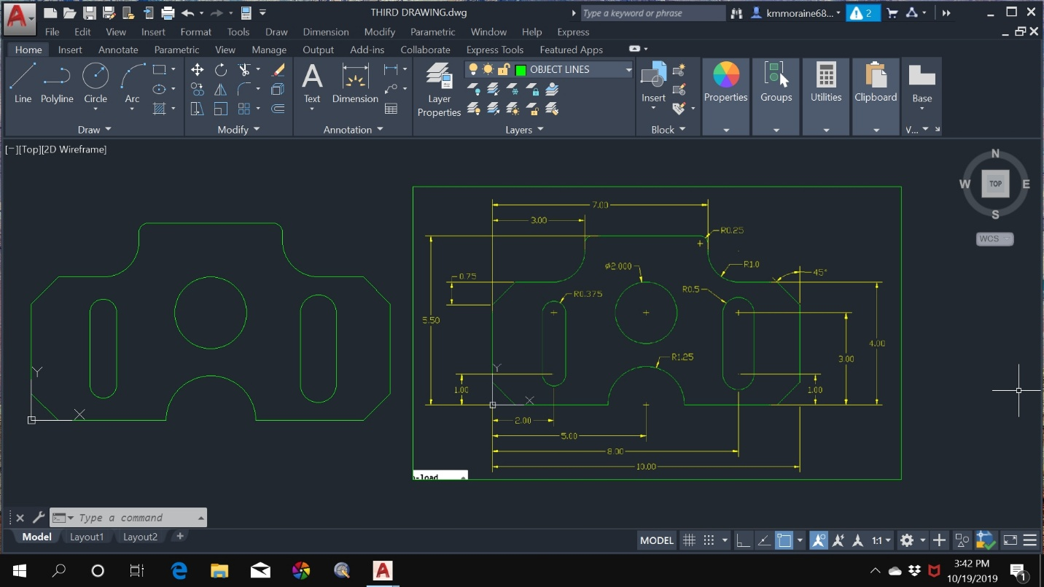

The drawing on the right side is **only a picture** of the drawing.

On the left side you can see that I completed the **THIRD DRAWING**, it is the drawing without the dimensions on it.

As you are making your drawing on the left side of screen you look at the picture that’s on the right side to see what the dimensions are.

On Pages 60, 61, 62 and 63 are pictures of all four drawings that you will be making.

If you want to save all four pictures of the drawings to either your Documents folder or your D drive / jump drive, right click on one of the pictures and the drop-down menu shown below will open.

Click on **Save as** **Picture**.

**Name the File** and click **Save**.

If you are going to draw the **THIRD DRAWING** the file name would be **THIRD DRAWING**.

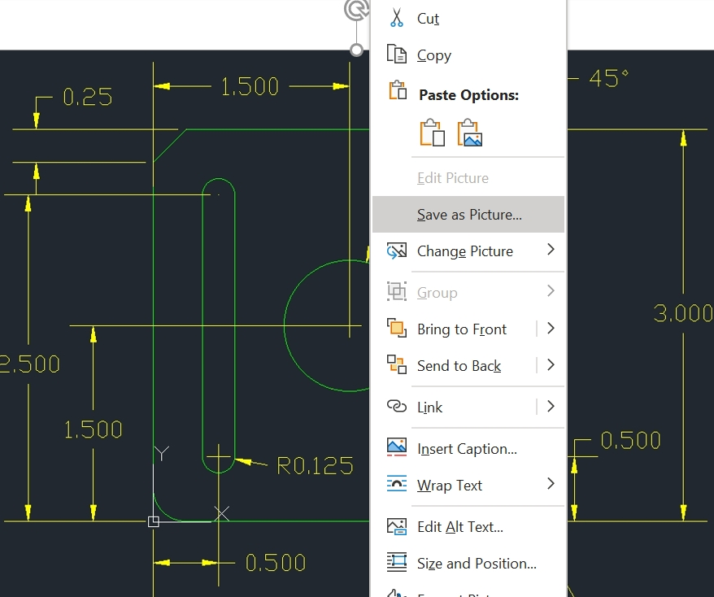

**TO INSERT A PICTURE OF THE DRAWING ONTO THE DRAWING SCREEN**

After you have saved all four pictures of the drawings, left click on the **Insert** **button,** the **Insert button** is located at the top of the screen.

A drop-down menu will open.

Scroll down and click on **Raster Image Reference**….

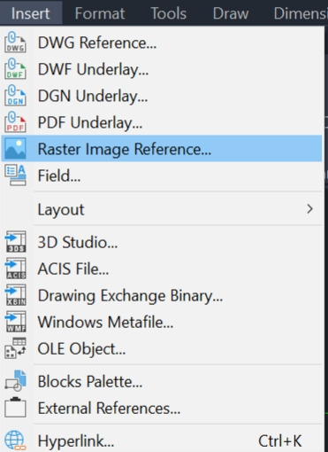

Double click on the picture that you are going to draw.

The **Attach Image** dialog box will open.

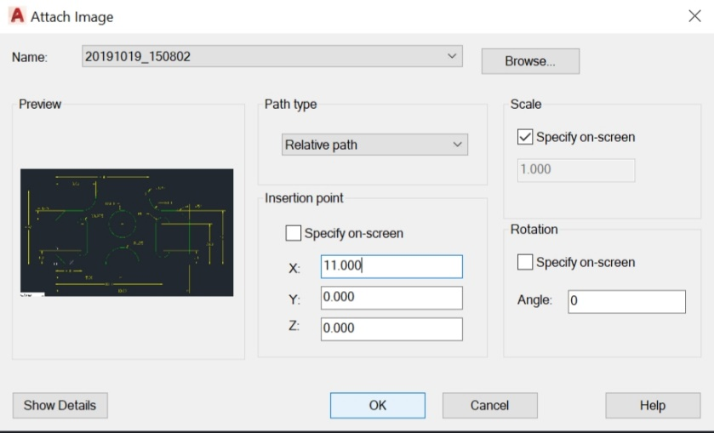

Remove the check mark from **Specify on-screen**

Change X: to 11.000

Click on **OK**

The **THIRD DRAWING** is 10 inches long, above you see that I made the **X value 11** **inches**. This will place the picture of the **THIRD DRAWING** 1 inch to the right side of the drawing that I’m going be creating. This will make it easy for you to see what the dimensions are.

Keep moving the mouse to the right until you have the drawing sized to how you want it sized and then click to lock the picture to the drawing page / screen.

To make the inserted picture bigger or to adjust its position, left click on the outside border to highlight it in blue.

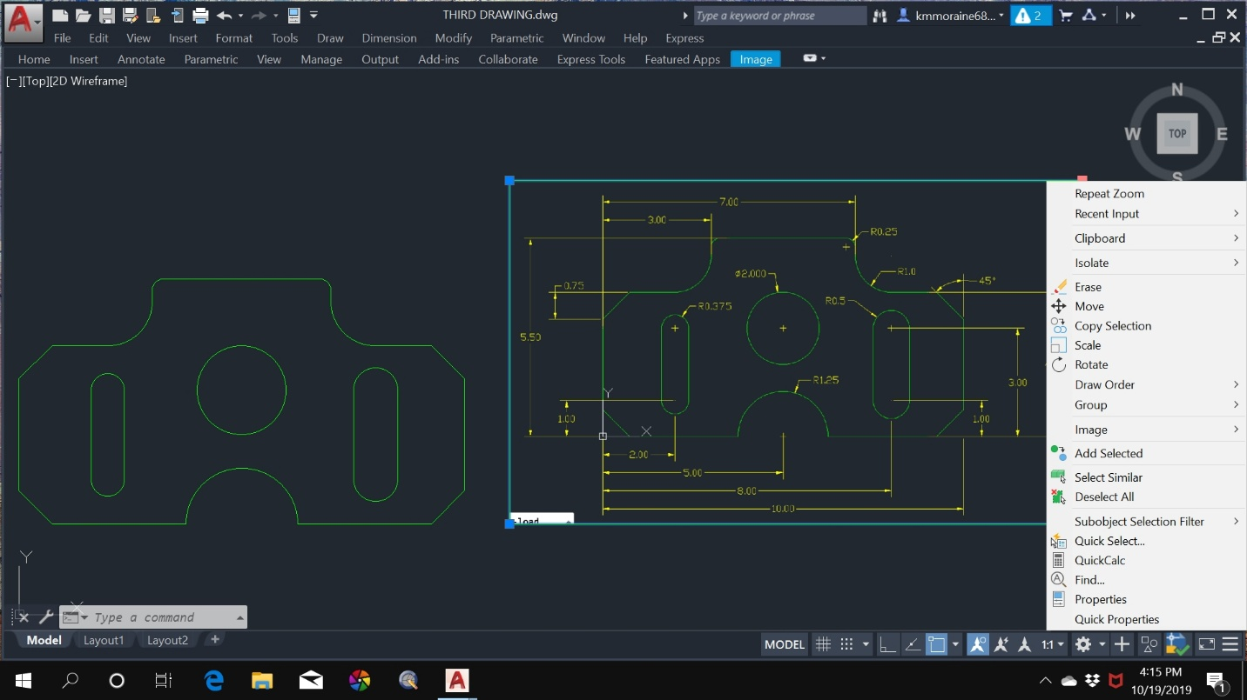

Right click on one of the four squares at the corners of the border and a menu will display.

To move the picture of the drawing to a different location on the screen, click on **Move** and follow the instructions in the command line.

To make the picture of the drawing larger or smaller in size, click on **Scale** and follow the instructions in the command line.









After the 30-day free trial version of AutoCAD runs out you can download the 30-day free trial version of AutoCAD LT. AutoCAD LT is strictly a 2D drawing software. After AutoCAD LT 30-day trial version ends you can pay $50 a month or $400 a year to continue using it. If you download AutoCAD LT, follow the same instructions that you used to make the AutoCAD drawings and you will be able to draw them with AutoCAD LT.

Written by:

Ken Maier

[kmmoraine6854@outlook.com](mailto:kmmoraine6854@outlook.com)